
Document is developed by HKRP Innovations LLP (HKRP) for Ministry of New and renewable Energy (MNRE) and Rajasthan Horticulture Development, Rajasthan under contract number 83368545
This document has been prepared on the basis set out in HKRP’s contract for ‘To develop state Portals and integrate that with National portal for monitoring and progress of Component B for PMKUSUM’ with Deutsche Gesellschaft fur Internationale Zusammenarbeit (GIZ) GmbH (“the Client”).

USER mANUAL

PM-KUSUM: Rajasthan State Solar Energy Data Management Platform (Component – B)

Table of Contents

1. INTRODUCTION TO PM-KUSUM SCHEME 10
2. SEDM PURPOSE & VISION 11
3. WELCOME PAGE 12
4. SIGN IN ON SEDM PLATFORM 24
5. HOME PAGE 26
6. USER PROFILE PAGE 27
7. CHANGE PASSWORD 30
8. REGISTER NEW STATE IMPLEMENTING AGENCY (SIA) & EMPANELLED AGENCY (EA) 32
9. SETTING MODULE 33
9.1. REGISTRATION OF EMPANELLED AGENCY (EA) 34
9.2. REGISTRATION OF STATE IMPLEMENTING AGENCY (SIA) 40
10. USER ROLE MANAGEMENT 45
10.1 REGISTER NEW USER 46
11. MASTER SETTINGS (CONFIGURATIONS) 75
11.1. REGISTRATION OF TENDER 76
11.2. EA RATE CARD 81
11.3. REGISTRATION OF EA STORE SUB LOCATION 87
11.4. REGISTRATION OF MANUFACTURER DETAILS 91
11.5. REGISTRATION OF PRODUCT DETAILS 97
11.6. REGISTRATION OF TENDER CHECKLIST 102
11.7. REGISTRATION OF TENDER CHECKLIST DETAILS 108
11.8. AUDIT TRAIL 113
12. APPLICATION WORKFLOW STAGES 117
13. CONSUMER/FARMER APPLICATION REGISTRATION 118
14. FEASIBLE APPLICATION 151
15. FARMER SHARE RECEIVED 155
16. ORDER PLACED TO EMPANELLED AGENCY (EA) 157
17. ASSET TEST REPORT CREATION BY EA 159
18. LOT CREATION & UPDATING PDI STATUS 168
19. INSTALLATION AND COMMISSION (I&C) DONE 182
19.1 ASSET SERIAL NO. AND IMEI NUMBER MAPPING 183
19.2 INSTALLATION & COMMISSION DONE (I&C) 188
20. INSTALLATION & COMMISSION (I&C) VERIFICATION 194
21. PCR (PROJECT COMPLETION REPORT) 200
22. LIVE MONITORING 207
23. PERFORMANCE ANALYSIS 218
24. SUMMARY 226
25. CONSUMER/FARMER MANAGEMENT ANALYSIS 234
26. SCHEME PROGRESS 241
26.1 SCHEME PROGRESS REPORT 242
26.2 BULK PROGRESS MAPPING 252
27. ASSET TRACKING & REPLACEMENT 261
28. SIGN OUT 271
29. SUPPORT TEAM CONTACT DETAILS 273
ANNEXURE-I (SITE SURVEY DONE) 274
ANNEXURE-II (IMEI NUMBER REGISTRATION) 283

Figures
Figure 1 Welcome Page 12
Figure 2 Frequently Asked Questions (FAQs) 13
Figure 3 Hindi Selected 14
Figure 4 Tamil Selected 15
Figure 5 Component – B District Wise Details 16
Figure 6 PM-KUSUM Component - B District Wise Status Report 17
Figure 7 Installers 19
Figure 8 Track Application 20
Figure 9 Application Entered To Track Application 20
Figure 10 Track Application Report 21
Figure 11 Notice 22
Figure 12 Important Documents 22
Figure 13 Contact Us 23
Figure 14 Sign In Page 24
Figure 15 Sign In screens 25
Figure 16 Home Page 26
Figure 17 User Profile Information box 28
Figure 18 Change Password 30
Figure 19 Modules 32
Figure 20 Setting Module 33
Figure 21 Empanelled Agency Tab 34
Figure 22 Empanelled Agency Tab Dashboard 34
Figure 23 CSV of Empanelled Agency Details 35
Figure 24 New Empanelled Agency Details 36
Figure 25 State Implementing Agency Tab 40
Figure 26 State Implementing Agency Tab Dashboard 40
Figure 27 CSV of State Implementing Agency Details 41
Figure 28 New State Implementing Agency Details 42
Figure 29 User Role Module 45
Figure 30 Add User Button on User Role Dashboard 46
Figure 31 Add User Form 50
Figure 32 User Information 51
Figure 33 Module Roles 57
Figure 34 Consumer Functionality 58
Figure 35 Scheme Progress Functionality 60
Figure 36 Site Survey Functionality 61
Figure 37 Asset Functionality 63
Figure 38 Live Monitoring Functionality 65
Figure 39 Device Registration Functionality 66
Figure 40 Complaint Sub Modules 67
Figure 41 User Role Dashboard 68
Figure 42 Change Password Screen 69
Figure 43 Assign Farmer Rights 70
Figure 44 User Role Module Selection Screen 74
Figure 45 Setting Module 75
Figure 46 Tender Tab 76
Figure 47 Tender Tab Dashboard 77
Figure 48 CSV of Tender Details 78
Figure 49 New Tender Details 79
Figure 50 EA Rate Card Tab 81
Figure 51 EA Rate Card Dashboard 82
Figure 52 CSV of EA Rate Card Details Figure 83
Figure 53 New EA Rate Card Details 84
Figure 54 EA Store Sub Location Tab 87
Figure 55 EA Store Sub Location Dashboard 88
Figure 56 CSV of EA Store Sub Location Details 89
Figure 57 New EA Store Sub Location Details 90
Figure 58 Manufacturer Tab 91
Figure 59 Manufacturer Tab Dashboard 92
Figure 60 CSV of Manufacturer Details 93
Figure 61 New Manufacturer Details 94
Figure 62 Product Tab 97
Figure 63 Product Tab Dashboard 98
Figure 64 CSV of Product Details 99
Figure 65 New Product Details 100
Figure 66 Tender Checklist Tab 102
Figure 67 Tender Checklist Tab Dashboard 103
Figure 68 CSV of Tender Checklist 104
Figure 69 New Checklist Details 105
Figure 70 Tender Checklist Detail Tab 108
Figure 71 Select Tender Checklist Template 109
Figure 72 Tender Checklist Template Dashboard 109
Figure 73 CSV of Tender Checklist Template 110
74 New Tender Checklist Details 111
Figure 75 Audit Tab 113
Figure 76 Audit Tab Filters 114
Figure 77 Audit Dashboard (Applied Filters) 115
Figure 78 Audit Details – CSV File 116
Figure 79 Details 118
Figure 80 Select District 118
Figure 81 District List 119
Figure 82 Add Farmer Button 119
Figure 83 Add farmer Form 120
Figure 84 Application & Consumer Details 121
Figure 85 Communication & Location Details 123
Figure 86 Irrigation Details 125
Figure 87 Pump Details 127
Figure 88 Solar Details 128
Figure 89 Agriculture Details 129
Figure 90 Financial & Commercial Details 130
Figure 91 Other Details 131
Figure 92 Loan Details 133
Figure 93 Bank Details 134
Figure 94 List of Document Attached 135
Figure 95 Detail Dashboard 136
Figure 96 Consumer Detail Data Columns (i) 136
Figure 97 Consumer Detail Data Columns (iI) 137
Figure 98 Consumer/Farmer Detail Dashboard 140
Figure 99 Confirmation Screen to Delete All Updated Consumer/Farmer Application Status 141
Figure 100 Filter 1 Solution & Empanelled Agency 141
Figure 101 Filter 2 Empanelled Agency 141
Figure 102 District Survey Summary Details CSV 142
Figure 103 Download data Filters Screen 142
Figure 104 Details dashboard csv file (i) 143
Figure 105 Details dashboard csv file (ii) 143
Figure 106 Details dashboard Excel file (i) 144
Figure 107 Details dashboard Excel file (ii) 144
Figure 108 Details dashboard Excel file (iii) 145
Figure 109 Details dashboard PDF 146
Figure 110 Show / Hide columns filter 147
Figure 111 Scheme Progress report for Consumer/Farmer 148
Figure 112 Site Survey Detail of Consumer/Farmer 149
Figure 113 Details 151
Figure 114 Details Dashboard 151
Figure 115 Site Survey Details 152
Figure 116 Application Accept button 153
Figure 117 Application Hold-Reject Button 153
Figure 118 Reason for Application Hold/Reject 153
Figure 119 Farmer Application Flow Chart 154
Figure 120 Details 155
Figure 121 Updated Farmer Share Received 156
Figure 122 Details 157
Figure 123 Details Dashboard 157
Figure 124 Assign EA to the Consumer/Farmer. 158
Figure 125 Updated Order Place to EA 158
Figure 126 Test Report 159
Figure 127 Asset Test Report 160
Figure 128 Add Asset Test Report 162
Figure 129 Set Report 166
Figure 130 Individual Report 167
Figure 131 Lot Management Option 168
Figure 132 Lot Creation Button 169
Figure 133 Lot Form 170
Figure 134 Select Input/CSV Dropdown 174
Figure 135 Entering Comma Separated Asset Serial Nos. 174
Figure 136 Serial No. CSV Format Button 175
Figure 137 Serial No CSV File 175
Figure 138 Filters to Fetch Out Consumer/Farmer’s Application Numbers 175
Figure 139 Add Asset box 176
Figure 140 Next Button 176
Figure 141 Pump Checklist 177
Figure 142 Solar Panel Checklist 178
Figure 143 Pump Controller Checklist 180
Figure 144 Structure Checklist 180
Figure 145 Checklist & Document Submit Button 181
Figure 146 Status Updated 181
Figure 147 Asset Mapping By EA Option 183
Figure 148 Asset Mapping in Bulk 183
Figure 149 Asset Mapping Format 184
Figure 150 Save as CSV (Comma Delimited) 184
Figure 151 Asset Mapping by EA Dashboard 185
Figure 152 Consumer Info Tab 186
Figure 153 Individual Asset Mapping 187
Figure 154 IMEI Replacement 187
Figure 155 I & C Photos 188
Figure 156 I&C Status box 189
Figure 157 Insurance Policy 189
Figure 158 Asset Details 190
Figure 159 Real-time Dashboard 192
Figure 160 View History 193
Figure 161 Asset Mapping By SNA Option 194
Figure 162 Asset Mapping by SNA Dashboard 195
Figure 163 Consumer info Tab 196
Figure 164 Site Inspection Checklist 198
Figure 165 Installation Report Upload Screen 199
Figure 166 Project Completion Report 206
Figure 167 Live Monitoring Dashboard Option 207
Figure 168 Live Monitoring Dashboard 208
Figure 169 Consumer Details (i) 209
Figure 170 Consumer Details (ii) 209
Figure 171 Update RMS Latitude - Longitude 210
Figure 172 Invalid Parameters of Green Box of Live Monitoring Dashboard 213
Figure 173 Coimbatore District Solar Pump Statistics 214
Figure 174 Broad View of Consumer/Farmer of Selected District 215
Figure 175 Consumer/Farmer Solar Pump Statistics 216
Figure 176 Real Time View of the Consumer/Farmer 217
Figure 177 State level performance analysis 219
Figure 178 District Statistics 222
Figure 179 Broad View of Consumer/Farmer of Selected District 223
Figure 180 Consumer/Farmer Solar Pump Statistics 224
Figure 181 Real Time View of the Consumer/Farmer 225
Figure 182 Consumer/Farmer Management Summary option selected on Consumer/Farmer Dashboard 226
Figure 183 EA selection option in ‘Select EA’ filter 229
Figure 184 Capacity options in ‘Select Capacity’ filter 230
Figure 185 Applied filter: Sri Savitir Solar Pvt Ltd (EA), AC-7.5HP, Submersible Pumps (Waterfilled Motors) 230
Figure 186 Individual application stage 231
Figure 187 District-wise summary of Applications Received for various pump models report 231
Figure 188 Show / Hide columns filter 232
Figure 189 Using the filter “Show / hide columns” to display only selected columns 232
Figure 190 Using “Search” filter to list down all entries for District = Chennai 233
Figure 191 The view of downloaded CSV/Excel file 233
Figure 192 Consumer/Farmer Management Analysis option selected on Consumer/Farmer Dashboard 234
Figure 193 Consumer/Farmer Analysis Dashboard 234
Figure 194 Filter Applied: Application Received 235
Figure 195 Filter Applied: Feasible Application 236
Figure 196 Filter Applied: Application Received 236
Figure 197 Filter options for Analysis graphs 237
Figure 198 Consumer/Farmer Analysis - Pie Chart 237
Figure 199 Consumer/Farmer Analysis – Funnel chart 237
Figure 200 Filter Applied: Shakti Pumping 238
Figure 201 Consumer/Farmer Analysis - Filter options 238
Figure 202 Map View 239
Figure 203 Filter Applied: Installation & Commission, Tata Power Solar Systems Ltd 240
Figure 204 Consumer/Farmer Analysis statistics for district-wise location 240
Figure 205 MIS Reports 242
Figure 206 Yearly Progress Summary – Tabular view 243
Figure 207 Yearly Progress Summary – Chart view 244
Figure 208 District Progress Summary- tabular view 245
Figure 209 District Progress Summary – Chart view 246
Figure 210 Capacity wise Progress Summary – Tabular view 247
Figure 211 Capacity wise Progress Summary – chart view 248
Figure 212 Empanelled Agency Progress Summary – Tabular view 249
Figure 213 Empanelled Agency Progress Summary – Chart view 250
Figure 214 Gender Wise Report – Tabular View 251
Figure 215 Bulk Progress Mapping Dashboard 252
Figure 216 Site Survey Done CSV File Upload 254
Figure 217 Site Survey Bulk Upload Format 254
Figure 218 Order to EA CSV File Upload 255
Figure 219 Order Placed to EA Bulk Upload Format 255
Figure 220 Farmer Share Received CSV File Upload 256
Figure 221 Site Survey Bulk Upload Format 256
Figure 222 Bulk Progress Update Form 257
Figure 223 PDF output 258
Figure 224 Excel/CSV output 259
Figure 225 Consumer List 260
Figure 226 Site Location Dashboard 262
Figure 227 Asset History 263
Figure 228 location history 263
Figure 229 Field Service Engineer Dashboard 263
Figure 230 EA Service Store Inspection 264
Figure 231 EA Store 264
Figure 232 Status Update pop-up box 265
Figure 233 Transfer pop-up box 265
Figure 234 Create pop-up box 266
Figure 235 SIA Lab 266
Figure 236 SIA Store 266
Figure 237 Asset dashboard filter – asset type 267
Figure 238 ASSET DASHBOARD FILTER – sub location 267
Figure 239 ASSET DASHBOARD FILTER – ASSET status 267
Figure 240 Asset Mapping By EA Option 268
Figure 241 Asset Mapping by EA Dashboard 269
Figure 242 IMEI Replacement Button 269
Figure 243 IMEI No. Replacement By Generating New IMEI No. 270
Figure 244 IMEI No. Replacement from Registered IMEI Nos. 270
Figure 245 Logout 271
Figure 246 Home Selected 271
Figure 247 Sign out 272
Figure 248 Welcome Page of Site Survey Mobile Application 274
Figure 249 Sign In Box 275
Figure 250 Select Component and Application No 276
Figure 251 Consumer Site Survey Details 278
Figure 252 Key Points of Site Survey Details 280
Figure 253 Get Current Location Button 281
Figure 254 Latitude-Longitude 281
Figure 255 Logout Button 282
Figure 256 Device Registration 283
Figure 257 IMEI Bulk Upload 283
Figure 258 IMEI No. CSV Format 284
Figure 259 Upload IMEI No. CSV 284
Figure 260 Add New Device Registration Button 285
Figure 261 Add Device Registration 285

Table 1 Glossary
Abbreviation | Full Form
CSV file | Comma-separated values file
DO | District Officer
DISCOM | Distribution Company
EA | Empanelled Agency
I&C | Installation and Commission
IMEI | International Mobile Equipment Identity
MNRE | Ministry of New and Renewable Energy
PCR | Project Completion Report
PDF | Printed Document Format
PDI | Pre-Dispatch Inspection
PM-KUSUM | Pradhan Mantri Kisan Urja Suraksha evam Utthaan Mahabhiyan
RMS | Remote Monitoring System
SEDM | Solar Energy Data Management
SIA | State Implementing Agency
SNA | State Nodal Agency (SIA)
SI | System Integrator
HO | Head Office

Table 2 URL links
Module | URL link
PMKUSUM Web Application | https://pmkusum.tn.gov.in
PMKUSUM Web API | https://pmkapi.tn.gov.in

Table 3 MINIMUM EQUIMENT REQUIRED TO ACCESS STATE SEDM PLATFORM:
Description | Recommended Specifications
Processor | Intel Dual Core or Higher
Processor Speed | 3.2 GHz
RAM | 4 GB or Higher
Operating System | Windows
Browser | Google chrome / Mozilla Firefox
Internet Speed | 4 Mbps or Higher

Release History

Version | Date (dd-Mon-yyyy) | Released by
1.2 | 06-Sept-2021 | JINIL VYAS

- INTRODUCTION TO PM-KUSUM SCHEME
Pradhan Mantri Kisan Urja Suraksha evam Utthaan Mahabhiyan (PM-KUSUM) scheme was initiated by Government of India and launched by the Ministry of New and Renewable Energy (MNRE) to provide farmers with renewable as well as feasible energy sources for electricity and irrigation. PM-KUSUM Yojana got its administrative approval in March 2019 and guidelines were framed in July 2019. The scheme aims towards the installation of solar pumps and grid-connected solar panels in nationwide farmlands, in order to de-dieselize and solarise the agricultural sector.
PM-KUSUM scheme plans to add solar renewable capacity of 30.8 GW by 2022 with the total central financial support of INR 34,035 Crore including installation and service charges to the implementing agencies.
The Scheme consists of three components:
- Component A: 10,000 MW of Decentralized Ground Mounted Grid Connected Renewable Power Plants of individual plant size up to 2 MW.
- Component B: Installation of 20 lakh standalone Solar Powered Agriculture Pumps of individual pump capacity up to 7.5 HP.
- Component C: Solarisation of 15 Lakh Grid-connected Agriculture Pumps of individual pump capacity up to 7.5 HP.
In State, the scheme will be run under the supervision of the Central Government's subordinate Ministry of New and Renewable Energy.
This scheme is especially for the farmers, which is also being added as an important effort towards increasing the income of the farmers.

The Central Government's PM-KUSUM Yojana has been launched in State, which will bring prosperity in the lives of farmers. This scheme has been implemented with the objective of saving electricity during agricultural operations, reducing the electricity expenditure of farmers and promoting solar energy.

- SEDM PURPOSE & VISION
The Solar Energy Data Management (SEDM) Platform has been developed to serve the vision of One Nation – One Solar for PM-KUSUM scheme.
The primary features of SEDM:
- A single platform to monitor various Solar PV based plants and pumps installed under PM-KUSUM scheme in State.
- Stand-alone Solar Pumps, Grid Connected Solar Pumps, Distributed Solar Plants.
- A single platform for multiple stakeholders
- Farmers, Empanelled Agencies (EA), State Implementing Agency (SIA) SIA, DISCOM, MNRE,
- A single platform to undertake multiple processes under PM KUSUM scheme like
- Consumer/Farmer Registration, DBT Integration, Project Process Management, Asset Management, Complaints Management.

- A single platform to remotely monitor plants and pumps by connecting to multiple devices such as
- Pump controllers, Drivers, Energy meters, Inverters, Combiner boxes etc.

- WELCOME PAGE
Upon opening the State SEDM portal, all users (registered/unregistered) land on the welcome page of the portal.
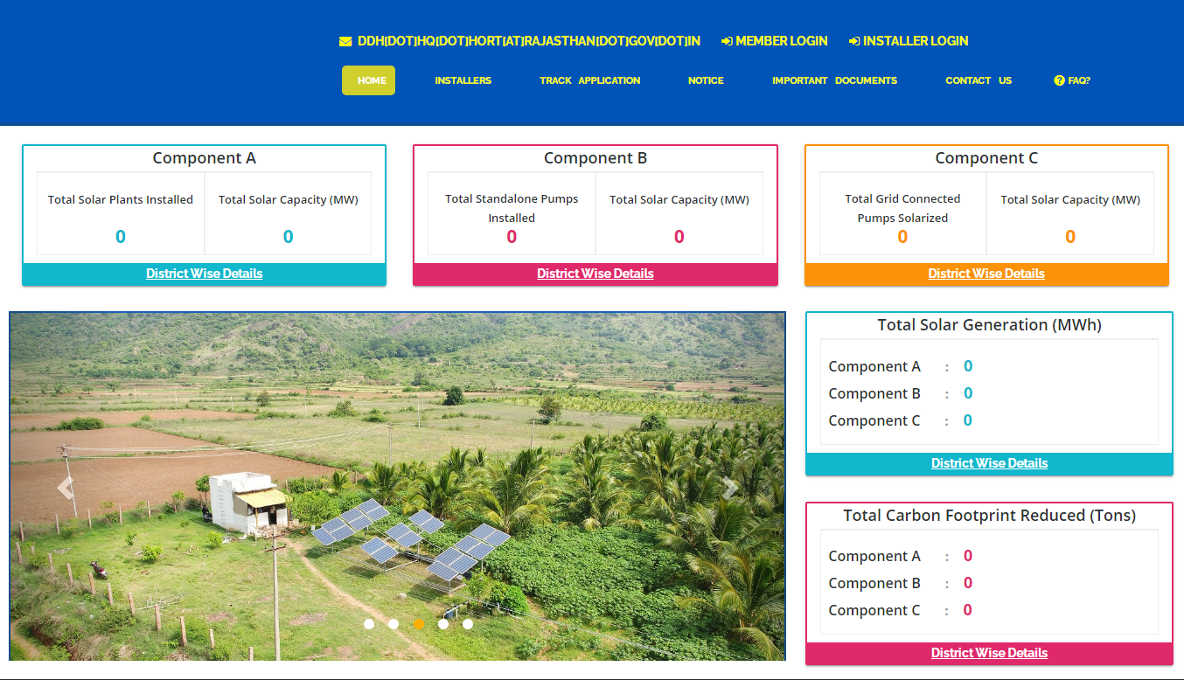
Figure 1 Welcome Page

- On the welcome page’s heading, there is a provision of “Frequently Asked Questions (FAQs)” provided (as highlighted in red in above Figure 1). Below are the frequently asked questions, as shown in Figure 2.

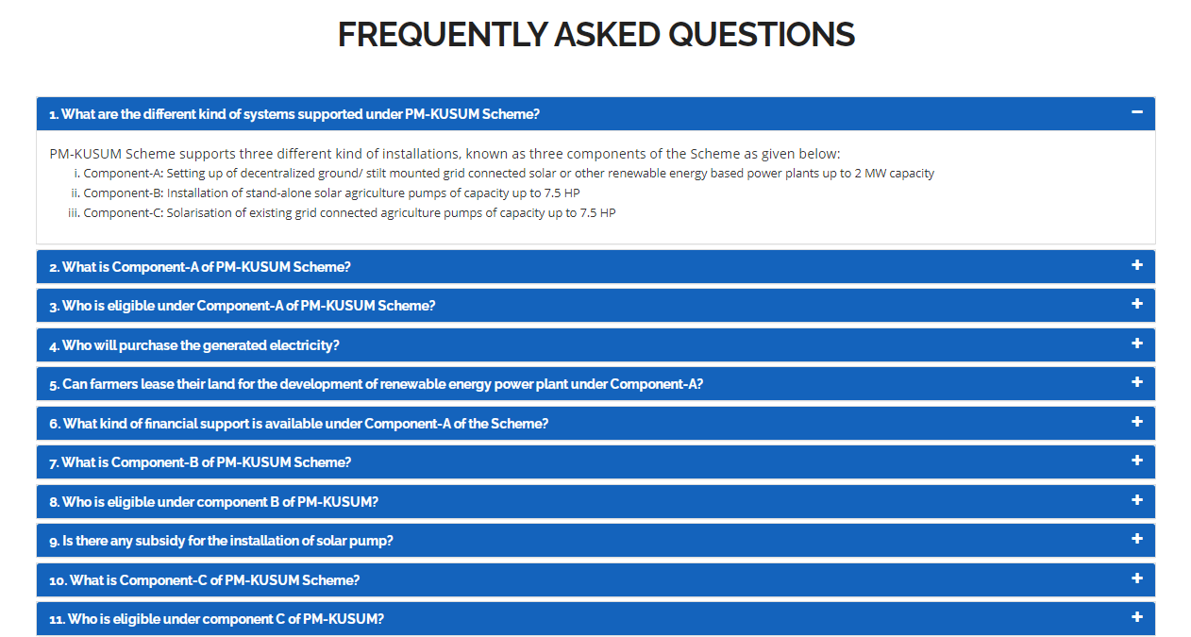
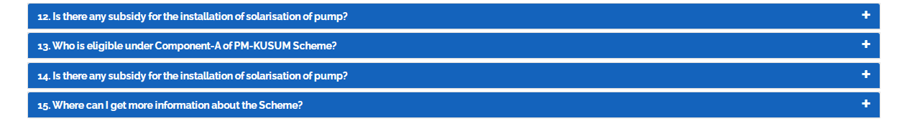

Figure 2 Frequently Asked Questions (FAQs)

- The provision of language is selection is also there on the “Welcome Page” in which default selection will be of “English” language (highlighted in yellow in Figure 1). After selection of different language, corresponding output are shown below in Figure 3 and Figure 4.

- Selected – Hindi

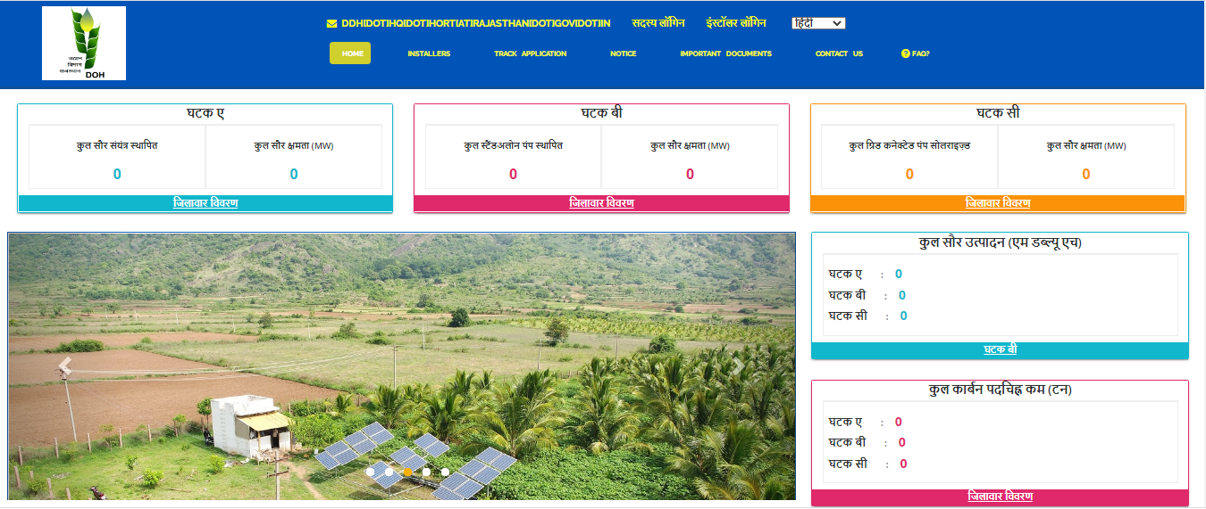
Figure 3 Hindi Selected

- Selected – Tamil

Figure 4 Tamil Selected

- On the welcome page, there are 5 indicators among which 3 depicting the components of PM-KUSUM scheme along with the cumulative figures of total solar plants and pumps installed and their capacity and other two depicts Total Solar Generation (MWh) and Total Carbon Footprint Reduced (Tons) (as shown in Figure 1).
- To get a detailed view of the capacity installed under each component, click on the ‘District Wise Details’ tab under each component (as shown in below Figure 5 the blue box), which will generate a detailed report in tabular form.(refer Figure 6)

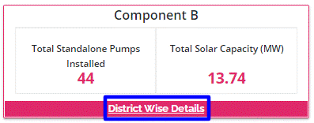
Figure 5 Component – B District Wise Details

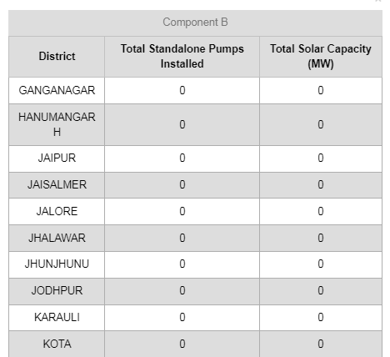
Figure 6 PM-KUSUM Component - B District Wise Status Report

- District Wise Details provide the view of total installed Standalone Pumps and its capacity against Districts of State.
- Such report can be also seen without login into the SEDM Portal.

- “INSTALLERS” tab will give the details of all Empanelled Agency who has been empanelled by SIA for supply of standalone solar pumps. (as shown in the below Figure 7)
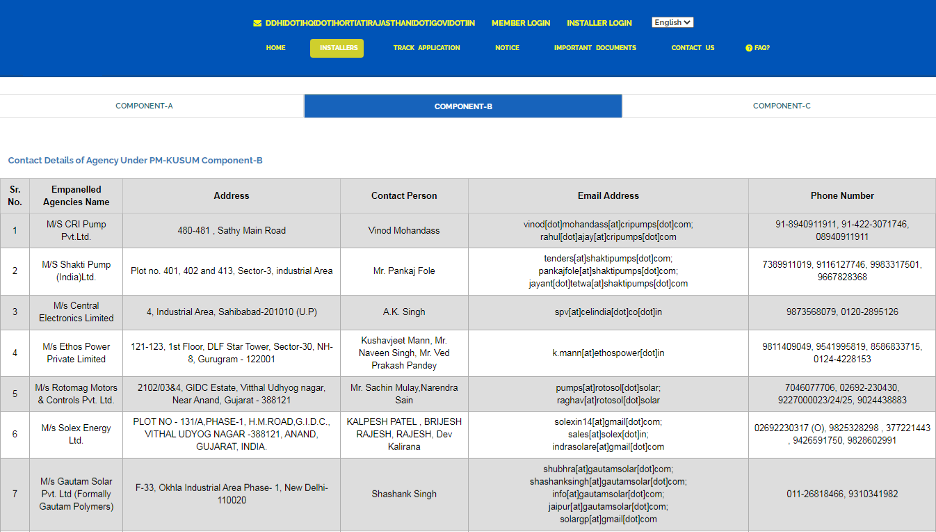
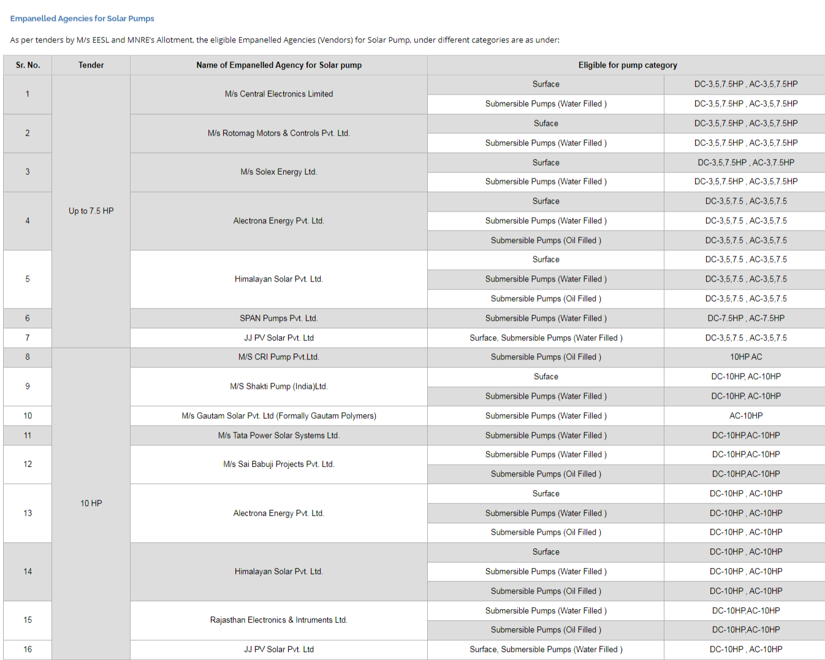

Figure 7 Installers

- “TRACK APPLICATION” tab provides the facility of tracking the Farmer Application by entering Application number or Consumer/Farmer Mobile No (as shown in Figure 8 in red box)

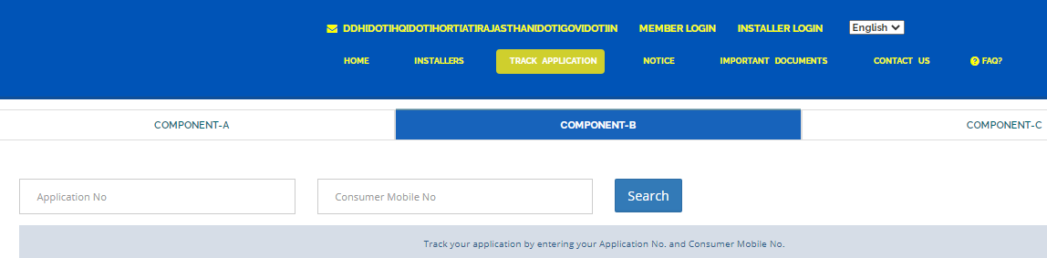

Figure 8 Track Application

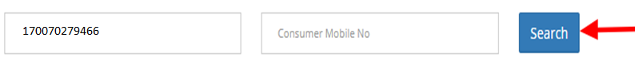

Figure 9 Application Entered To Track Application

- When user enter Application no. or Consumer/Farmer Mobile no. and click on “Search” button, below report (Figure 10) will be shown.
- The completed status will have date on which status was completed.

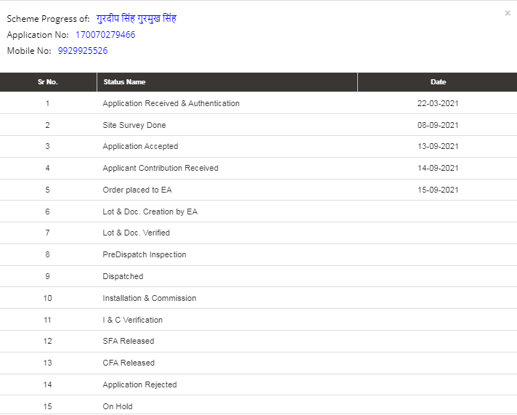
Figure 10 Track Application Report

- “NOTICE” tab displays list of notices related to PM KUSUM scheme. (as shown in Figure 11)
- Uploaded Notices can be taken out manually.

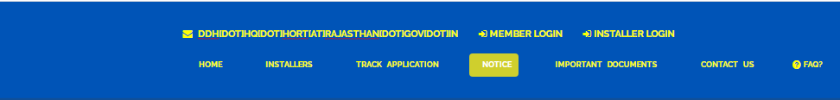
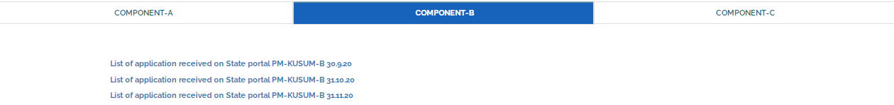

Figure 11 Notice

- “IMPORTANT DOCUMENTS” tab displays list of documents that are vital for the PM KUSUM scheme. (as shown in Figure 12)
- Uploaded Documents can be taken out manually.

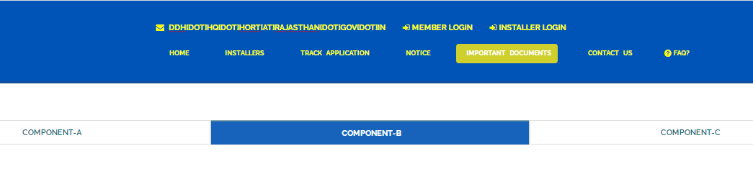
Figure 12 Important Documents

- “CONTACT US” tab displays list of all Nodal officers of Districts for PM KUSUM Component-B. (as shown in Figure 13)

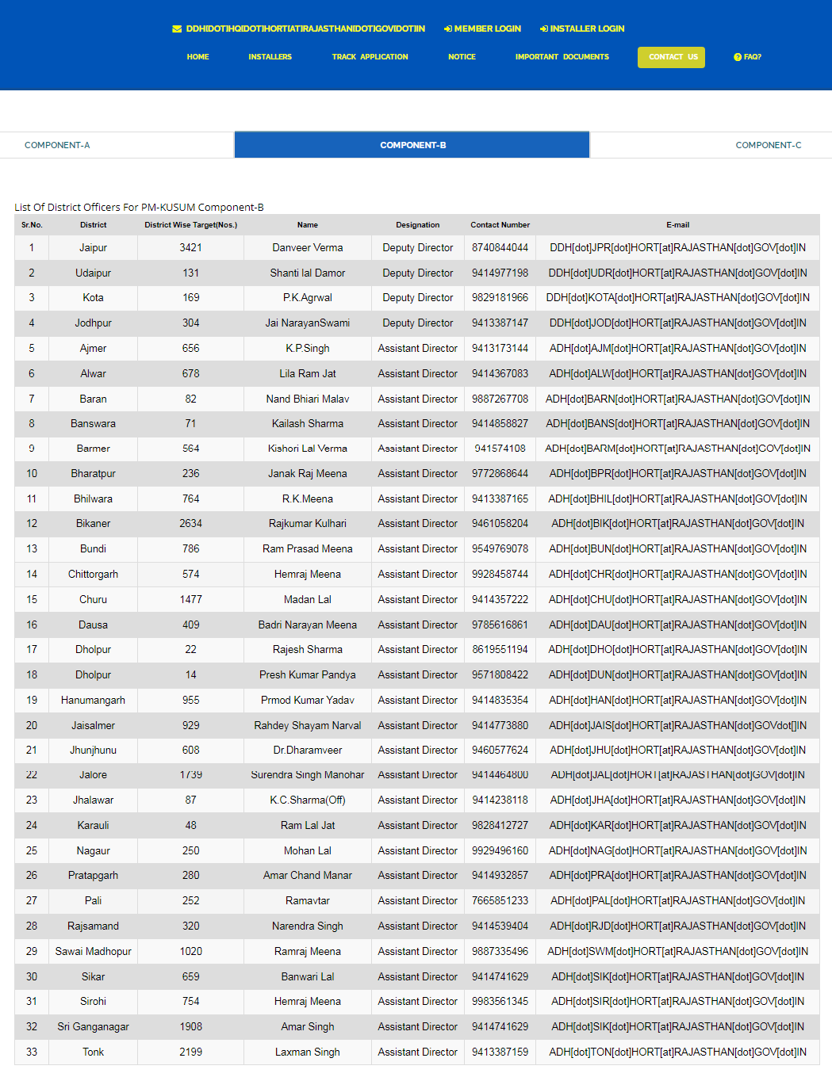

Figure 13 Contact Us

- SIGN IN ON SEDM PLATFORM
- To log in onto the SEDM portal, users can click on the “MEMBER LOGIN OR INSTALLER LOGIN” option on the Welcome Page.(highlighted in red in Figure 14)

Role | Login Option
Head Officer | MEMBER LOGIN
District Officer
Empanelled Agency | INSTALLER LOGIN

- Such login options will be visible to all users including HO, DISCOM, SDN and EA.

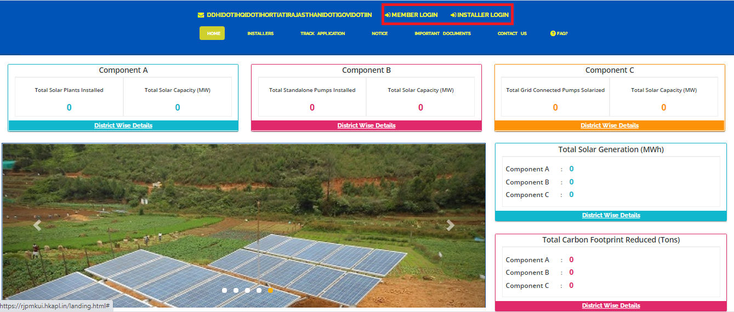
Figure 14 Sign In Page
- By clicking on the login options, it will show a pop-up box where the user must enter his username, password and the captcha code to sign in into their account.
- The user will be provided the credentials via email if the email gateway is configured.
- NOTE: If email gateway is not configured then Organization admin can share credentials manually. (click User Role for more details)

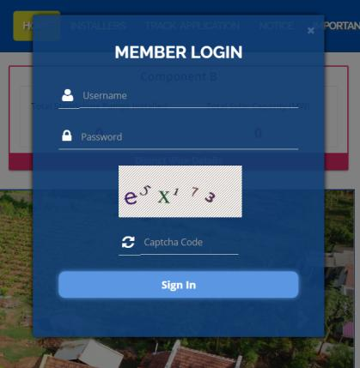  Member Login pop-up for State Implementing Agency | 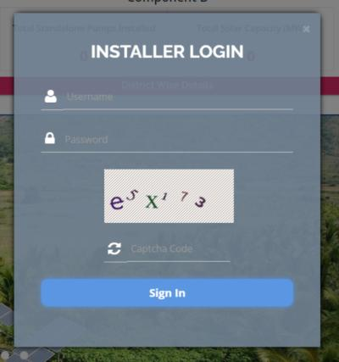  Installer Login pop-up for Empanelled Agency
Figure 15 Sign In screens

- HOME PAGE

- After the user successfully logs in to the SEDM portal it lands on the Home Page screen.
On the Home Page, users can select any of the 1 components to view the required Consumer/Farmer details, asset management, application tracking, performance analysis, etc.
- Component A: Distributed Solar PV
- Component B: Off Grid Solar Pump
- Component C: Grid Connected Solar Pump

- Navigation Steps: -
1. Sign in on the State SEDM Portal
2. Click on ‘Off Grid Solar Pump’ icon on the Home Page as shown in the Figure 16 to access the Component-B of PM-KUSUM Scheme.

- Users having rights to access of related components (A, B, C) only will be allowed to navigate through.
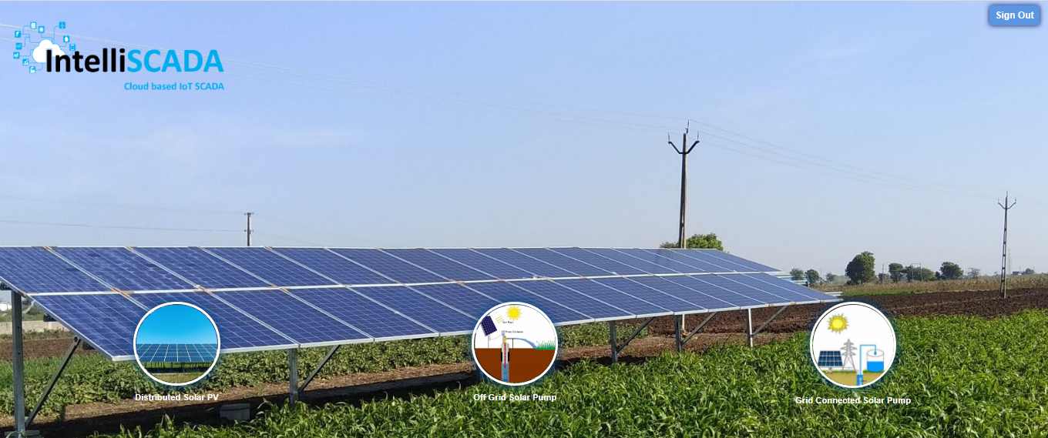
Figure 16 Home Page

- USER PROFILE PAGE

- The users can view their profile information by clicking on the ‘user’ icon image in the top right corner (highlighted in red in below Figure 17) on this manual is for Component B le bar and then selecting the ‘My Profile’ option.
- Navigation Steps: -
1. Sign in on the State SEDM Portal
2. Click on the ‘User’ icon on the Title Bar of the SEDM Portal Dashboard

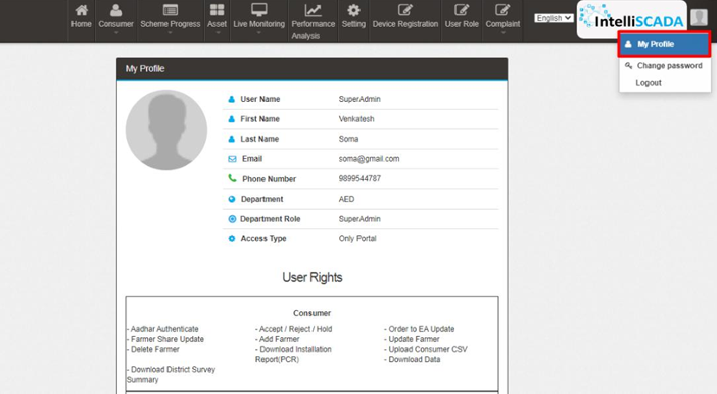
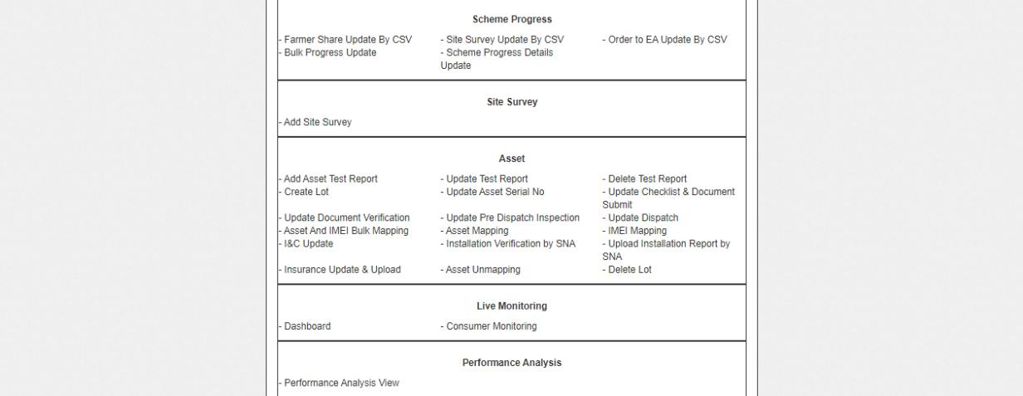
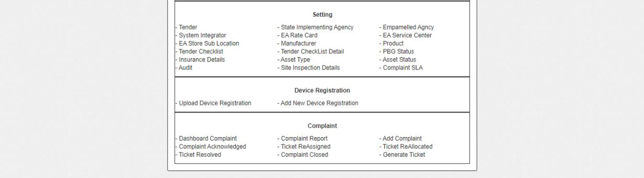
Figure 17 User Profile Information box

- The following details are listed under ‘My Profile’ template card:
- Username
- First Name
- Last Name
- Email
- Phone Number
- Department
- Department Role
- Access Type
- User Rights

- If the user wishes to change any details or sees a discrepancy in his details, he can contact the SEDM support team for required modifications.

- Ctrl + Click here “Support Team” for Support Team Contact details.

- CHANGE PASSWORD

- The users can change their account password by clicking on the ‘user’ icon image in the top right corner on the title bar and then selecting the ‘Change Password’ option.
- Navigation Steps: -
1. Sign in on the State SEDM Portal
2. Click on the ‘User’ icon on the Title Bar of the SEDM Portal Dashboard
3. Click on the ‘Change Password’ option from the drop-down menu

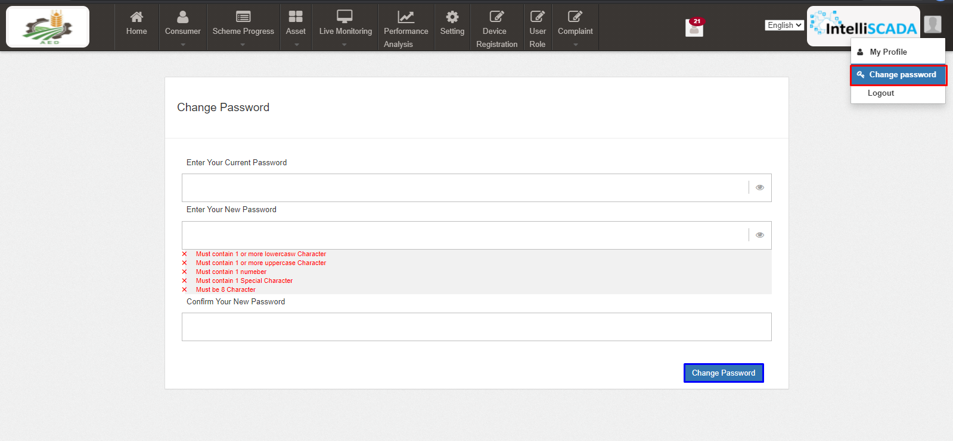
Figure 18 Change Password

- The users can change their password by entering the current password, a new password and re-entering the new password to confirm it in the mentioned text fields. Then click on the ‘Change Password’ button to complete the process.

- Your New Password box and Confirm Your New Password box must have same password inputs otherwise an error will occur i.e. Please enter the same password as entered New Password

Note: Users should make sure their passwords are strong and secure as per below mentioned validations to avoid any untoward activities or misuse of their credentials by any other party.
- Length must be of minimum 8 characters
- 1 or more lowercase character
- 1 or more uppercase character
- 1 special character
- 1 or more numbers

- REGISTER NEW STATE IMPLEMENTING AGENCY (SIA) & EMPANELLED AGENCY (EA)

- SIA will be shared Super Admin credential that can have access to all the three Components i.e. Distributed Solar PV (Component A), Off Grid Solar Pump (Component B) and Grid Connected Solar Pump (Component C) and also can have access to all the below mentioned 9 modules of portal:
- Consumer
- Scheme Progress
- Asset
- Live Monitoring
- Performance Analysis
- Setting
- Device Registration
- User Role
- Complaint

Figure 19 Modules

- Super Admin can register new State Implementing Agency (SIA) and Empanelled Agency (EA) in “Setting” module.

- SETTING MODULE

- New Empanelled Agency & State Implementing Agency can be registered in “Setting” module.

- Navigation Step :-
- Sign in on the State SEDM Portal
- Click on the Setting Module

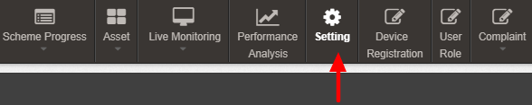

Figure 20 Setting Module

9.1. REGISTRATION OF EMPANELLED AGENCY (EA)

- Super Admin can register New Empanelled Agency by clicking on “Empanelled Agency” tab as pointed in below Figure 21.
- Empanelled Agencies registered with National SEDM Platform (https://pmkusum.mnre.gov.in) can only be registered in State SEDM Platform.
- Contact Support Team to get in touch with MNRE.

- Navigation Step :-
- Sign in on the State SEDM Portal
- Click on the Setting Module
- Click on Empanelled Agency Tab

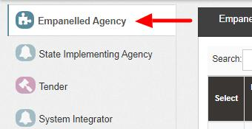
Figure 21 Empanelled Agency Tab
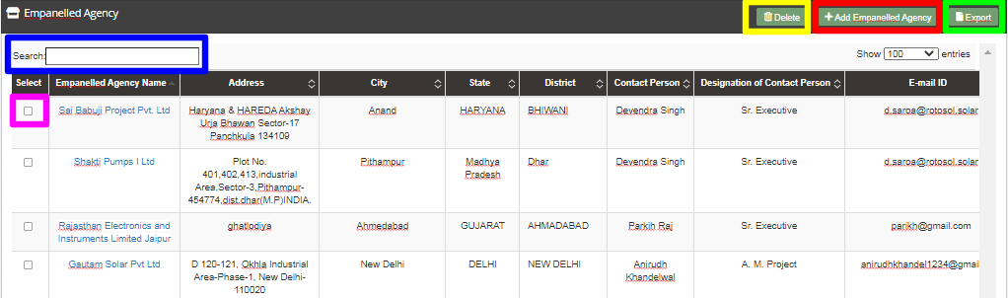

Figure 22 Empanelled Agency Tab Dashboard

Table 4 EMPANELLED AGENCY DASHBOARD DESCRIPTION
Action | Functionality | Highlighted Colour | Type | Description
Search | Search Empanelled Agency | Blue | Text Box | Enter input to explore Empanelled Agency details
Delete | Delete Empanelled Agency | Yellow | Button | Select check box (highlighted in pink) and click on delete button to Delete Empanelled Agency details. This will be a soft delete wherein, all the data related to EA will still be stored in Database
Add Empanelled Agency | Register new Empanelled Agency | Red | Button | Register new Empanelled Agency by clicking on Add Empanelled Agency button
Export | CSV file for Empanelled Agency details | Green | Button | Download CSV file of Empanelled Agency details

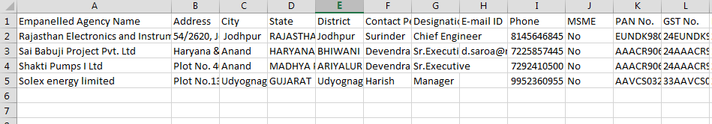
Figure 23 CSV of Empanelled Agency Details

- User can register new Empanelled Agency by clicking on “Add Empanelled Agency” button. (highlighted in red in Figure 22)
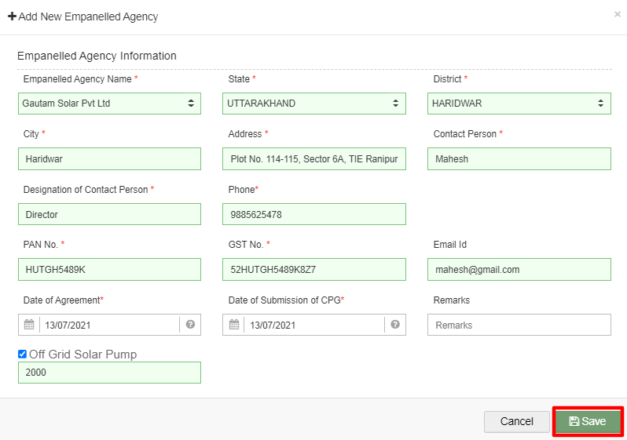
Figure 24 New Empanelled Agency Details

Table 5 EMPANELLED AGENCY REGISTRATION FIELDS DESCRIPTION
Field | Input | Drop Down Options | Mandatory Field | Sample Values | Description | Validations
Empanelled Agency Name | Drop Down | - Sai Babuji Project Pvt. Ltd.  - Gautam Solar Pvt. Ltd.  - CRI Pumps Pvt. Ltd.  - Shakti Pumps Ltd.  - Solex Energy Ltd.  - Junna Solar System Pvt. Ltd. |  | Gautam Solar Pvt Ltd | Select EA as per the requirement. | -
State | Drop Down | - STATE  - GUJARAT  - HARYANA  - TRIPURA |  | STATE | Selection of relevant state. | -
District | Drop Down | - ARIYALUR  - UDAYARPALAYAM  - TAMBARAM  - CENTRAL CHENNAI  - SOUTH CHENNAI  - NORTH CHENNAI |  | ARIYALUR | Select district according to the selected State. | -
City | Text | - |  | Haridwar | - | -
Address | Text | - |  | Plot No. 114-115, Sector 6A, Ranipur | - | -
Contact Person | Text | - |  | Mahesh | - | -
Designation of Contact Person | Text | - |  | Director | - | -
Phone | Numerical | - |  | 9310341987 | Contact no of Empanelled Agency | - Must be of 10 digits only
PAN No. | Numerical | - |  | FDESF5224A | PAN No of Empanelled Agency | - Must be of 10 characters only  - First five characters should be any upper case alphabets  - Next four characters should be any number from 0 to 9  - The last (tenth) character should be any upper case alphabet  - It should not contain any white space
GST No. | Text | - |  | 24FDESF5224A 1ZP | GST no of Empanelled Agency | - It must be of 15 digits only  - First two digits should be the state code  - Next ten digits should be the PAN number of the person or business entity  - The thirteenth is alpha-numeric digit (1-9 or A-Z)  - The fourteenth digit will be the alphabet “Z” by default  - The last digit should be any number (1-9)
E-mail ID | Email | - | - | ri@gmail.com | Email Id of Empanelled agency | It must contain :  - Alphabets (a-z) in lower case only  - Digits (0-9) (non mandatory)  - Printable characters ( ! # $ % & ’ * + - / = ? ^ _ ` { } | ~ )  - Symbol “@”  - Domain name (gmail , gov , yahoo)  - A period (.)  - Sub domain name (co.in , com , org)
Date of Agreement | Date | - |  | 19/05/2021 | Date on which agreement was done | -
Date of Submission of CPG | Date | - |  | 19/05/2021 | Date on which CPG was submitted | -
Remarks | Text | - | - | - | Remarks if any | -
Component | Radio Button | - |  | Off Grid Solar Pump | Select the relevant component | -

- After filling all the details, user has to click on the “Save” button (highlighted in red in Figure 24) to register New Empanelled Agency.

9.2. REGISTRATION OF STATE IMPLEMENTING AGENCY (SIA)

- Registering New State Implementing Agency (SIA)

- Super Admin can register New State Implementing Agency by clicking on “State Implementing Agency” tab as pointed in below Figure 25.
- State Implementing Agencies registered with National SEDM platform (https://pmkusum.mnre.gov.in)
- Contact Support team to get in touch with MNRE.

- Navigation Step :-
- Sign in on the State SEDM Portal
- Click on the Setting Module
- Click on State Implementing Agency Tab
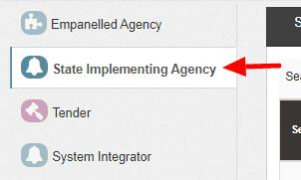
Figure 25 State Implementing Agency Tab

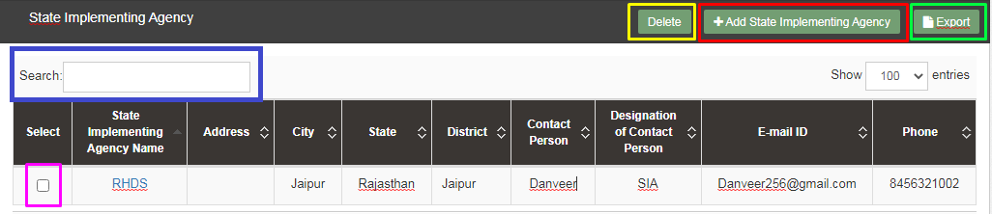
Figure 26 State Implementing Agency Tab Dashboard

Table 6 STATE IMPLEMENTING AGENCY DASHBOARD DESCRIPTION
Action | Functionality | Highlighted Colour | Type | Description
Search | Search State Implementing Agency | Blue | Text Box | Enter input to explore State Implementing Agency details
Delete | Delete State Implementing Agency | Yellow | Button | Select check box (highlighted in pink) and click on delete button to Delete State Implementing Agency details. This will be a soft delete wherein, all the data related to SIA will still be stored in Database
Add State Implementing Agency | Register new State Implementing Agency | Red | Button | Register new State Implementing Agency by clicking on Add State Implementing Agency button
Export | CSV file for State Implementing Agency details | Green | Button | Download CSV file of State Implementing Agency details,

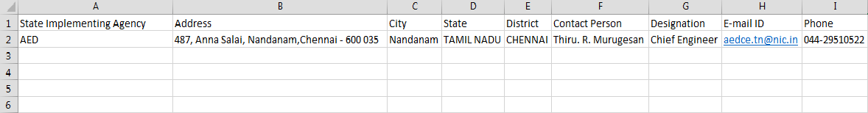

Figure 27 CSV of State Implementing Agency Details

- User can register new State Implementing Agency by clicking on “Add State Implementing Agency” button. (highlighted in red in Figure 26)

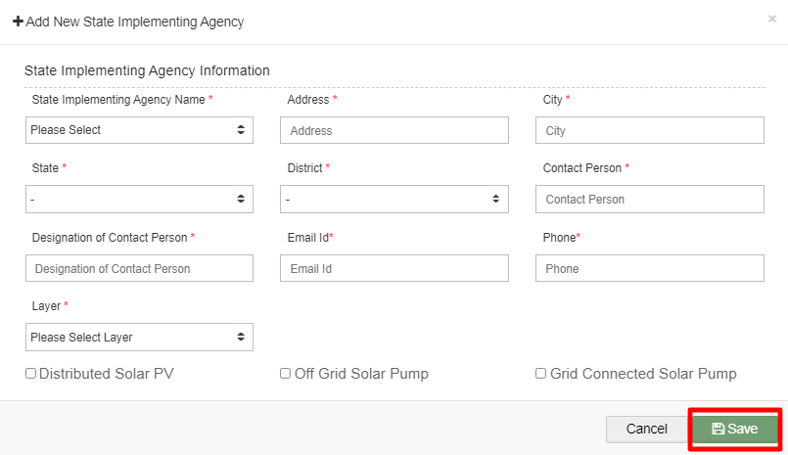
Figure 28 New State Implementing Agency Details

Table 7 STATE IMPLEMENTING AGENCY REGISTRATION FIELDS DESCRIPTION
Field | Input | Drop Down Options | Mandatory Field | Sample Values | Description | Validations
State Implementing Agency Name | Drop Down | - STATE IMPLEMENTING AGENCY  - HAREDA  - TREDA  - GUVNL |  | STATE IMPLEMENTING AGENCY | Select SIA as per the requirement. | -
Address | Text | - |  | 487, Anna Salai, Nandanam, Chennai, State – 600 035 | - | -
City | Text | - |  | Nandanam | - | -
State | Drop Down | - STATE  - GUJARAT  - HARYANA  - TRIPURA |  | STATE | Selection of relevant state. | -
District | Drop Down | - ARIYALUR  - UDAYARPALAYAM  - TAMBARAM  - CENTRAL CHENNAI  - SOUTH CHENNAI  - NORTH CHENNAI |  | ARIYALUR | Select district according to the selected State. | -
Contact Person | Text | - |  | Jatinder Singh | - | -
Designation of Contact Person | Text | - |  | SIA | - | -
E-mail id | Email | - | - | jatinder@gmail.com | - | It must contain :  - Alphabets (a-z) in lower case only  - Digits (0-9) (non mandatory)  - Printable characters ( ! # $ % & ’ * + - / = ? ^ _ ` { } | ~ )  - Symbol “@”  - Domain name (gmail , gov , yahoo)  - A period (.)  - Sub domain name (co.in , com , org)
Phone | Numerical | - |  | 8856235521 | - | - Must be of 10 digits only
Layer | Drop Down | - District wise  - Discom wise |  | District Wise | Selection is to be chosen based on scheme tracking as per district flow or as per discom flow | -
Component | Radio Button | - |  | Off Grid Solar Pump | - | -

- After filling all the details, user has to click on the “Save” button (highlighted in red in Figure 28) to register New State Implementing Agency.
- After registering Empanelled Agency (EA) and State Empanelled Agency (SIA), Super Admin can now create users and assign roles to the users.

- USER ROLE MANAGEMENT

- User Role Management

- User Role Management module facilitates the creation of users of SIA/EA with assignment of roles.
- Furthermore, it also provides the functionality to the Organization Admin of registering the new users of the corresponding Organization with access rights.
- After registering the Empanelled Agency and State Implementing Agency details, Super Admin can now register new users and assign roles through User Role module.

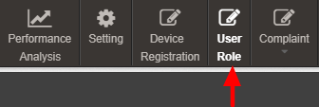

Figure 29 User Role Module

10.1 REGISTER NEW USER

- Register New User

- To register new user, Super Admin has to click on the “Add User” button (pointed in below Figure 30).
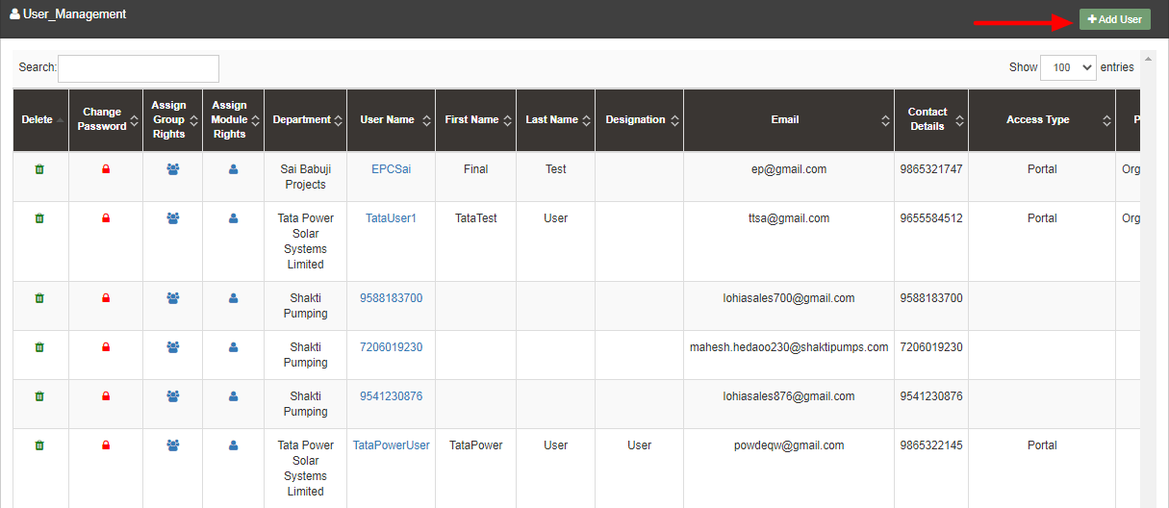

Figure 30 Add User Button on User Role Dashboard

- To register new user, user has to enter two types of following details :
- User Information
- Module Roles

- Add User
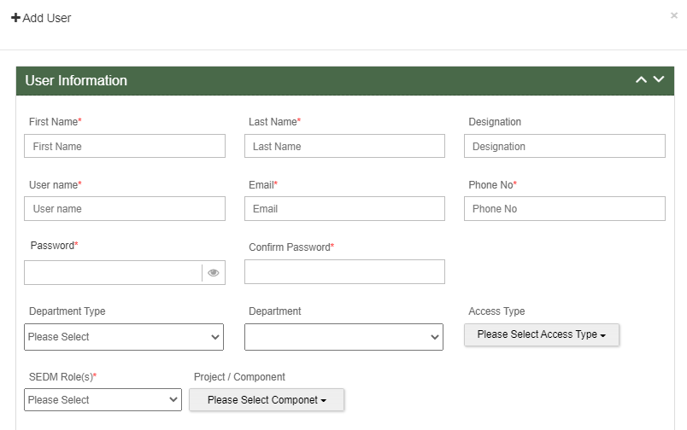
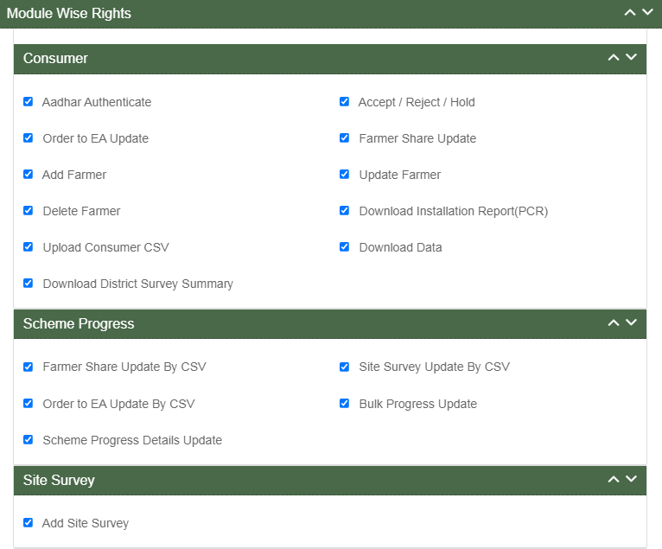

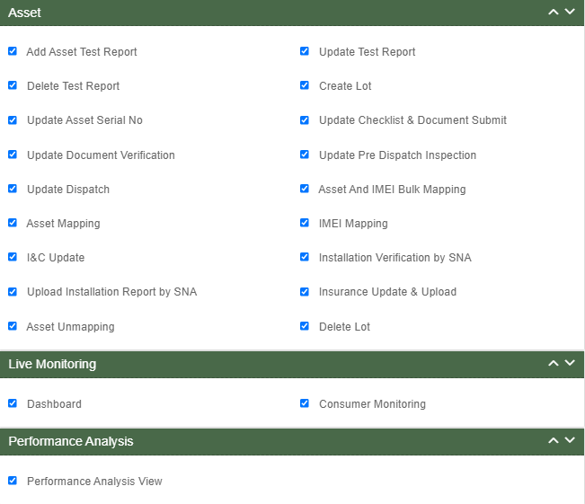
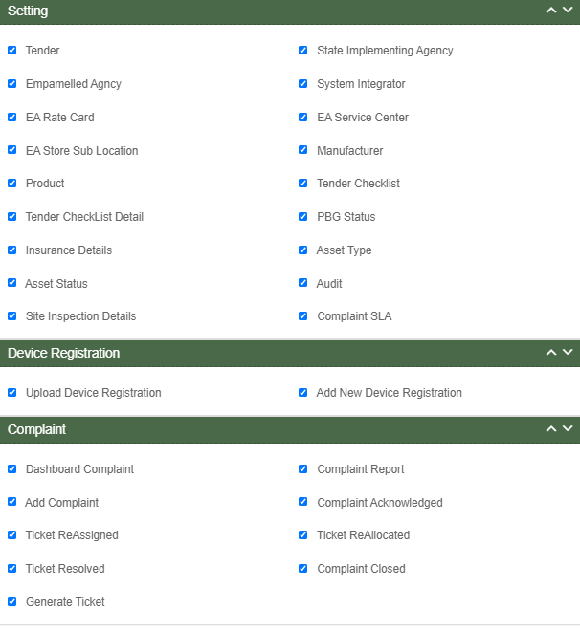

Figure 31 Add User Form

- User Information

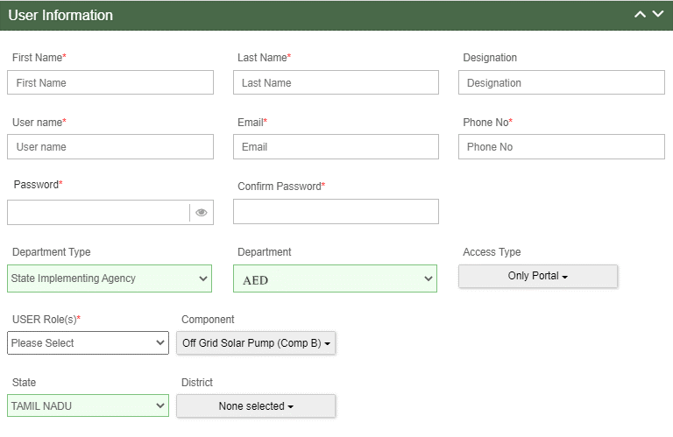
Figure 32 User Information

Table 8 NEW USER REGISTRATION FIELDS DESCRIPTION

Field | Input | Drop Down & Check Box Options | Mandatory Field | Sample Values | Description | Validations
First Name | Text | - |  | Ram | Input first name of the user | -
Last Name | Text | - |  | Sharma | - | -
Designation | Text | - | - | EPC | - | -
Username | Text | - |  | ramsharma | - | -
Email | Email | - |  | ram@gmail.com | - | It must contain :  - Alphabets (a-z) in lower case only  - Digits (0-9) (non mandatory)  - Printable characters ( ! # $ % & ’ * + - / = ? ^ _ ` { } | ~ )  - Symbol “@”  - Domain name (gmail , gov , yahoo)  - A period (.)  - Sub domain name (co.in , com , org)
Phone No | Numerical | - |  | 7458748588 | - | - Must be of 10 digits only
Password | Password | - |  | Ram@123 | - | - Length must be of minimum 8 characters  - 1 or more lowercase character  - 1 or more uppercase character  - 1 special character  - 1 or more numbers
Confirm Password | Password | - |  | Ram@123 | - | - Length must be of minimum 8 characters  - 1 or more lowercase character  - 1 or more uppercase character  - 1 special character  - 1 or more numbers
Department Type | Drop Down | - State Implementing Agency  - Empanelled Agency  - System Integrator |  | Empanelled Agency | Selection of relevant Department as per the requirement. System Integrator is a separate Empanelled agency who installs RMS system separately as required in GJ
Department | Drop Down | - Sai Babuji Project Pvt. Ltd.  - Gautam Solar Pvt. Ltd.  - CRI Pumps Pvt. Ltd.  - Shakti Pumps Ltd.  - Solex Energy Ltd.  - Junna Solar System Pvt. Ltd. |  | Gautam Solar Pvt. Ltd. | Selection of relevant department according to the selected department type. | -
Access Type | Drop Down | - Only Configuration  - Only Portal  - Only Mobile Application |  | Only Portal | Selection of relevant access type as per the requirement. (refer Table 9 ACCESS TYPE DROP DOWN) | -
User Role(s) | Drop Down | - Super Admin  - Organization Admin  - User |  | Super Admin | Selection of relevant user role as per the requirement. Only Super Admin can create new Super Admin user. | -
State | Drop Down | - STATE  - GUJARAT  - HARYANA  - TRIPURA |  | STATE | Selection of relevant state.  This shall be loaded on the basis of Layer. | -
District | Drop Down | - ARIYALUR  - UDAYARPALAYAM  - TAMBARAM  - CENTRAL CHENNAI  - SOUTH CHENNAI  - NORTH CHENNAI |  | ARIYALUR | Select district according to the selected State.  This shall be loaded on the basis of Layer. | -
Project / Component | Drop Down | - Distributed Solar PV – A  - Off Grid Solar Pump – B  - Grid Connected Solar Pump –C |  | Off Grid Solar Pump – B | Selection of PM-KUSUM Scheme Component | -

Department Type Drop Down | Department Type | Description | Department Drop Down | Description
- State Implementing Agency  - Empanelled Agency  - System Integrator | State Implementing Agency | Selecting this option indicates that the new user will belong from the State Implementing Agency department type. | - STATE IMPLEMENTING AGENCY  - JREDA  - GUVNL  - PEDA | By selecting SIA will provide SIA list to process further as shown in Department Drop Down.
 | Empanelled Agency | Selecting this option indicates that the new user will belong from the Empanelled Agency department type. | - Sai Babuji Project Pvt. Ltd.  - Gautam Solar Pvt. Ltd.  - CRI Pumps Pvt. Ltd.  - Shakti Pumps Ltd.  - Solex Energy Ltd.  - Junna Solar System Pvt. Ltd. | By selecting EA will provide EA list to process further as shown in Department Drop Down.
 | System Integrator | Selecting this option indicates that new user will belong from the System Integrator department type. | - HKRP  - ABCD | By selecting System Integrator will provide System Organization list to process further as shown in Department Drop Down.

Table 9 ACCESS TYPE DROP DOWN

Access Type Drop Down | Option Name | Description
- Only Configuration  - Only Portal  - Only Mobile Application | Only Configuration | This option gives writes to user to access configuration.
 | Only Portal | This option gives writes to user to access Portal.
 | Only Mobile Application | This option gives writes to user to access Mobile Application

Table 10 USER ROLE DROPDOWN

User Role Drop Down | Role | Access | User Creation | Specifications
- Super Admin  - Organization Admin  - User | Super Admin | This user has access of every module of State SEDM Platform. | This user can create “Organization Admin” & “User” and also can provide access to any of all modules. | This user can only register Tender, State Implementing Agency (SIA) and Empanelled Agency (EA).
 |  |  |  | This user can create other Super Admin of SIA only and not of EA.
 | Organization Admin | This user has access to the modules that Super Admin provided. | This user can create other “Organization Admin” and “User” and can provide access to those modules only that he have access of. | This user can create one or more “User” for its own Organization only.
 | User | This user has access to the modules that Super Admin or Organization Admin provided. | This user can neither create any user nor can provide any access. | This user cannot register State Implementing Agency (SIA) & Empanelled Agency (EA) and cannot create any “User”.

- Module Roles

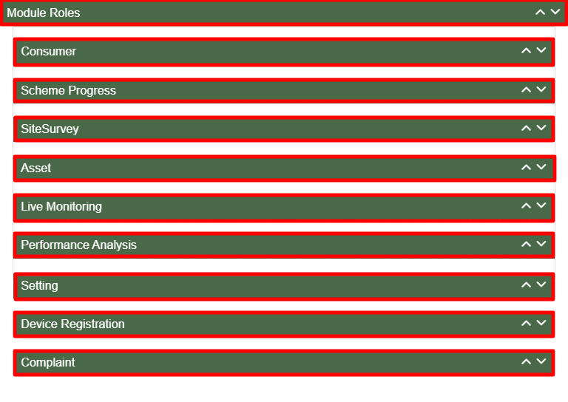

Figure 33 Module Roles

- User has to click anywhere in the red highlighted boxes (as shown in the above Figure 33) to open up the module to provide the access of Functionality to the existing user.
- After opening the module, user has to select the Check Box (highlighted in red in below Figure 34) to choose the access of Functionality for the new user.
- Following are the Functionality, whose access can be decided by the Super Admin / Organization Admin for the new users or existing users :

- Consumer Functionality

Figure 34 Consumer Functionality

Table 11 Consumer Functionality
Consumer Functionality Name | Description
Aadhaar Authenticate | Selecting this Functionality will provide the access to update the consumer/farmer application status “Aadhaar Authentication”.
Accept / Reject / Hold | Selecting this Functionality will provide the access to accept or reject or hold the consumer/farmer application.
Order to EA Update | Selecting this Functionality will provide the access to assign the Empanelled Agency to the consumer/farmer application.
Farmer Share Update | Selecting this Functionality will provide the access to update the consumer/farmer application status “Farmer Share Received”.
Add Farmer | Selecting this Functionality will provide the access to register the new consumer/farmer application.
Update Farmer | Selecting this Functionality will provide the access to amend the consumer/farmer application details.
Delete Farmer | Selecting this Functionality will provide the access to delete the consumer/farmer application.
Download Installation Report (PCR) | Selecting this Functionality will provide the access to download the of the consumer/farmer application.
Upload Consumer CSV | Selecting this Functionality will provide the access to upload the “.csv” file for consumer/farmer application registration in bulk.
Download Data | Selecting this Functionality will provide the access to download the excel file of the data of all consumer/farmer applications.
Download District Survey Summary | Selecting this Functionality will provide the access to download district survey summary report.

- Scheme Progress

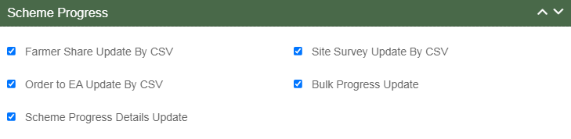

Figure 35 Scheme Progress Functionality

Table 12 Scheme Progress Functionality
Scheme Progress Functionality Name | Description
Farmer Share Update by CSV | Selecting this Functionality will provide the access to update the consumer/farmer application status “Farmer Share Received” in bulk by uploading a CSV file.
Site Survey Update by CSV | Selecting this Functionality will provide the access to update the consumer/farmer application status “Site Survey Done” in bulk by uploading a CSV.
Order to EA Update by CSV | Selecting this Functionality will provide the access to assign the Empanelled Agency to the consumer/farmer application in bulk by uploading a CSV file.
Bulk Progress Update | Selecting this Functionality will provide the access to update any consumer/farmer application status in bulk, using this right user can only update the status and will not be able to update the farmer data.
Scheme Progress Details Update | Selecting this Functionality will provide the access to update the date of previous updated consumer/farmer application status.

- Site Survey Functionality

Figure 36 Site Survey Functionality

Table 13 Site Survey Functionality

Site Survey Functionality Name | Description
Add Site Survey | Selecting this Functionality will provide the access to Site Survey Mobile Application update the consumer/farmer application status “Site Survey” via Site Survey.

- Asset Functionality

Figure 37 Asset Functionality

Table 14 Asset Functionality
Asset Functionality Name | Description
Add Asset Test Report | Selecting this Functionality will provide the access to add the asset test report.
Update Test Report | Selecting this Functionality will provide the access to update the Asset test report.
Delete Test Report | Selecting this Functionality will provide the access to delete the asset test report.
Create Lot | Selecting this Functionality will provide the access to create the Asset Lot & document.
Update Asset Serial Number | Selecting this Functionality will provide the access to update the asset serial number in Lot.
Update Checklist & Document Submit | Selecting this Functionality will provide the access to update the status “Lot & Document Submitted” of the consumer/farmer applications.
Update Document Verification | Selecting this Functionality will provide the access to update the status “Document Verified” of the consumer/farmer applications.
Update Pre Dispatch Inspection | Selecting this Functionality will provide the access to update the status “Pre Dispatch Inspection” of the consumer/farmer applications.
Update Dispatch | Selecting this Functionality will provide the access to update the status “Dispatched” of the consumer/farmer applications.
Asset & IMEI Bulk Mapping | Selecting this Functionality will provide the access to map the asset serial numbers and IMEI numbers with the consumer/farmer in bulk by uploading a CSV file.
Asset Mapping | Selecting this Functionality will provide the access to map the asset serial numbers with the consumer/farmer individually.
IMEI Mapping | Selecting this Functionality will provide the access to map the IMEI numbers with the consumer/farmer individually
I&C Update | Selecting this Functionality will provide the access to update the status “Installation & Commission Done” of the consumer/farmer applications.
Installation Verification by SNA | Selecting this Functionality will provide the access to update the status “Installation & Commission Verification” of the consumer/farmer applications.
Upload Installation Report by SNA | Selecting this Functionality will provide the access to upload the Installation Report
Insurance Update and Upload | Selecting this Functionality will provide the access to upload the Insurance details like Insurance number and Insurance Policy Document
Asset Unmapping | Selecting this Functionality will provide the access to unmap the asset serial numbers and IMEI numbers from the consumer/farmer.
Delete Lot | Selecting this Functionality will provide the access to delete the created lot.

- Live Monitoring Functionality

Figure 38 Live Monitoring Functionality

Table 15 Live Monitoring Functionality
Live Monitoring Functionality Name | Description
Dashboard | Selecting this Functionality will provide the access Live Monitoring Dashboard
Consumer Monitoring | Selecting this Functionality will provide the access of consumer monitoring in which user can monitor RMS data, map individual Asset Serial no. and IMEI nos., update I&C Done status and I&C Verification and Insurance

- Device registration Functionality

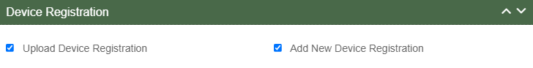

Figure 39 Device Registration Functionality

Table 16 Device Registration Functionality

Device Registration Functionality Name | Description
Upload Device Registration | Selecting this Functionality will provide the access to register Device IMEI numbers in bulk by uploading a CSV file.
Add New Device Registration | Selecting this Functionality will provide the access to register a Device IMEI number.

- Complaint Sub Modules

Figure 40 Complaint Sub Modules

Table 17 Complaint Functionality

Complaint Sub Module Name | Description
Dashboard Complaint | Selecting this sub module will provide the access to the Complaint Dashboard
Add Complaint | Selecting this sub module will provide the access to register a new complaint
Ticket Reassigned | Selecting this sub module will provide the access to reassign the ticket to user within the organization
Ticket Resolved | Selecting this sub module will provide the access to update the Complaint Status “Resolved”
Generate Ticket | Selecting this sub module will provide the access to generate the ticket for a complaint
Complaint Report | Selecting this sub module will provide the access to the Complaint Reports
Complaint Acknowledge | Selecting this sub module will provide the access to update the Complaint Status “Acknowledge”
Ticket Reallocated | Selecting this sub module will provide the access to reallocate the ticket to organization (SIA / EA)
Complaint Closed | Selecting this sub module will provide the access to close the complaint

- User has to select the check box corresponding to the Functionality as shown in above figures.
- After selection of the Functionality, Super Admin can create new user role and can also provide access to modules and Functionality to the new user. (Refer “User Role” drop down in New User Registration form - Figure 32)

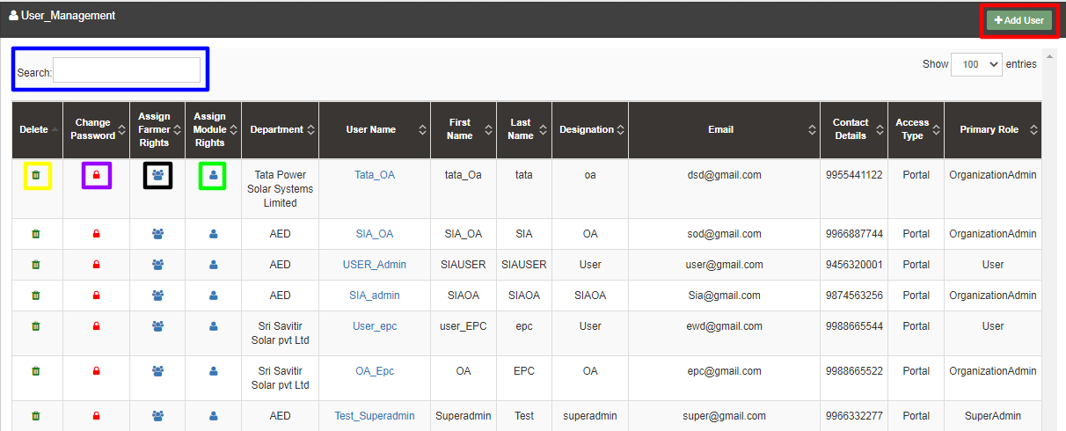

Figure 41 User Role Dashboard

Table 18 USER ROLE DASHBOARD DESCRIPTION
Action | Functionality | Highlighted Colour | Type | Description
Search | Search User | Blue | Text Box | Enter input to explore User details
Add User | Create New User | Red | Button | Create New User by clicking on Add User button
Delete Icon | Delete User | Yellow | Icon Button | Click on delete green icon button to Delete User details
Change Password Icon | Change Password | Purple | Icon Button | Click Change password red icon to change password
Assign Farmer Rights | Farmer wise Access | Black | Icon Button | This functionality will provide access to the user to view the data of RMS system of allowed/mapped farmers
Assign Module Rights | Edit Module Rights | Green | Icon Button | Using this option organization admin can modify User Rights.

- Change Password

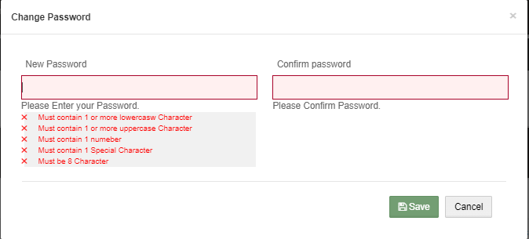

Figure 42 Change Password Screen

- User has to enter “New password” and “Confirm password” as shown in above Figure 42.

- Assign Farmer Rights

- By clicking on the icon of “Assign Farmer Rights” (highlighted in black in Figure 41), Super Admin / Organization admin can provide access to the user to view the data of RMS System mapped with the selected farmers. (window screen for the same shown below in Figure 43)

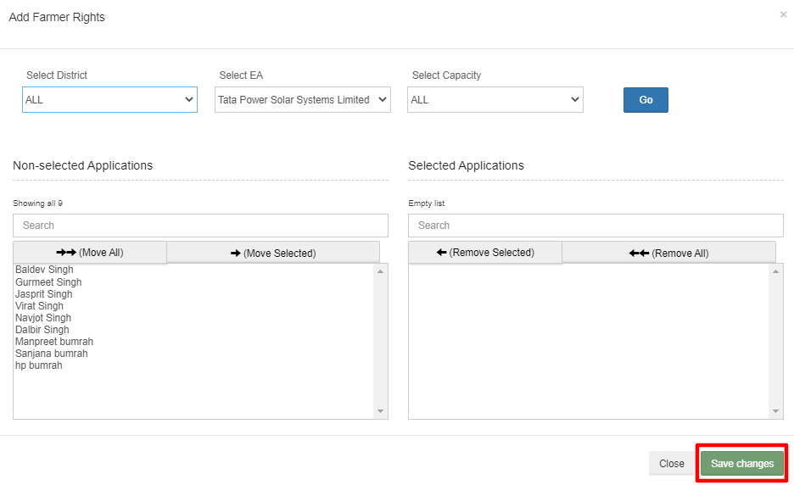

Figure 43 Assign Farmer Rights

- By moving farmer from Non-Selected Applications to Selected Applications, that particular user will get the access to view the RMS data of the selected farmers.
- User can update the module and Functionality access of any particular existing user by clicking on the user icon. (highlighted in green in Figure 41)
- After clicking on user icon, a Screen will occur for the editing the access of the Functionality. (as shown in below Figure 44)
Figure 44 User Role Module Selection Screen

- MASTER SETTINGS (CONFIGURATIONS)

- SIA with Super Admin credentials can add or update several following settings :
- Tender Registration
- EA Rate Card
- Manufacturer Registration
- Product Registration
- Tender Checklist
- Tender Checklist Details

- These settings can be performed in the “Setting” module.

- Navigation Step :-
- Sign in on the State SEDM Portal
- Click on the Setting Module

Figure 45 Setting Module

11.1. REGISTRATION OF TENDER

- Registering New Tender
- Super Admin can register New Tender by clicking on “Tender” tab as pointed in below Figure 46.
- New Tender will belong from either of three components i.e. Distributed Solar PV - A, Off Grid Solar Pump - B and Grid Connected Solar Pump - C.

- Navigation Step :-
- Sign in on the State SEDM Portal
- Click on the Setting Module
- Click on Tender Tab

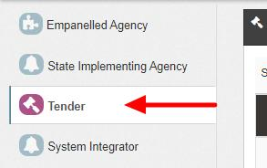

Figure 46 Tender Tab

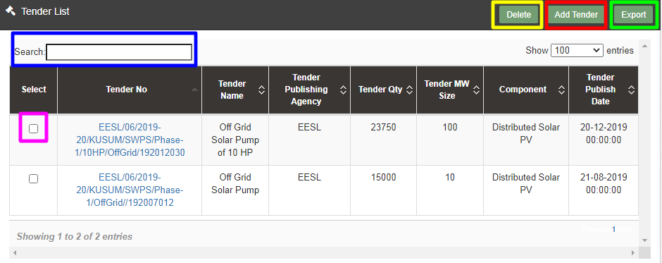

Figure 47 Tender Tab Dashboard

Table 19 TENDER DASHBOARD EXPLANATION
Action | Functionality | Highlighted Colour | Type | Description
Search | Search Tender | Blue | Text Box | Enter input to explore Tender details
Delete | Delete Tender | Yellow | Button | Select check box (highlighted in pink) and click on delete button to Delete Tender details
Add Tender | Register new Tender | Red | Button | Register new Tender by clicking on Add Tender button
Export | CSV file for Tender details | Green | Button | Download CSV file of Tender details

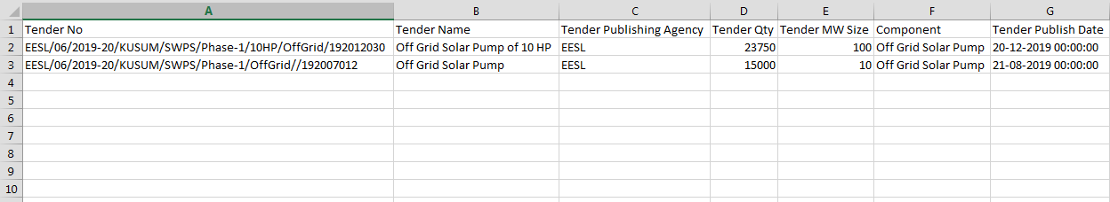

Figure 48 CSV of Tender Details

- User can register new Tender by clicking on “Add Tender” button. (highlighted in red in Figure 47)

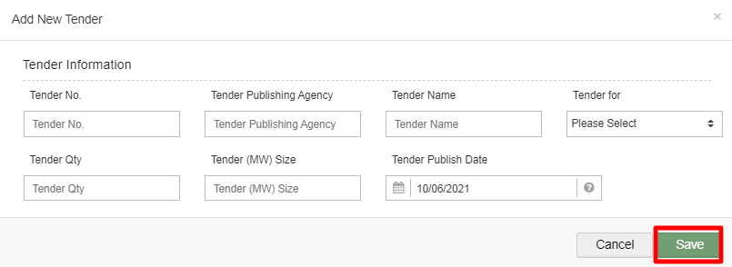

Figure 49 New Tender Details

Table 20 TENDER REGISTRATION FIELDS DESCRIPTION
Field | Input | Drop Down & Check Box Options | Mandatory Field | Sample Values | Description
Tender No. | Numerical | - |  | EESL/06/2019-20/KUSUM/SWPS/Phase-1/10HP/OffGrid/192012030 | -
Tender Publishing Agency | Text | - |  | EESL | -
Tender Name | Text | - |  | Off Grid Solar Pump of 10 HP | -
Tender for | Drop Down | - Distributed Solar PV  - Off Grid Solar Pump  - Grid Connected Solar Pump |  | Distributed Solar PV | Selection of relevant Tender as per the requirement.
Tender Qty | Numerical | - |  | 23750 | -
Tender (MW) Size | Numerical | - |  | 100 | -
Tender Publish Date | Date | - |  | 22/12/2019 | -

- After filling all the details, user has to click on the “Save” button (highlighted in red in above Figure 49) to register New Tender.

11.2. EA RATE CARD

- EA Rate Card includes Central/State/Farmer Contribution as the subsidy to the Farmer’s total cost of the Solar Pump.
- It gives information of the total cost of the Solar Pump in “Rs.” and in “%” divided between Central Government, State Government and the Consumer/Farmer.
- Super Admin can update these information in the “Setting” module.

- Navigation Step :-
- Sign in on the State SEDM Portal
- Click on the Setting Module
- Click on EA Rate Card Tab

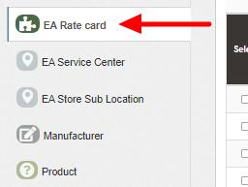

Figure 50 EA Rate Card Tab

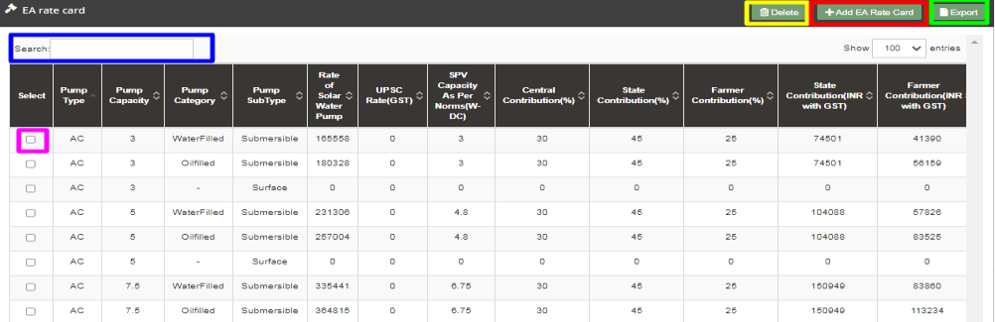

Figure 51 EA Rate Card Dashboard

Table 21 EA RATE CARD DASHBOARD EXPLANATION
Action | Functionality | Highlighted Colour | Type | Description
Search | Search EA Rate Card | Blue | Text Box | Enter input to explore EA Rate Card details
Delete | Delete EA Rate Card | Yellow | Button | Select check box (highlighted in pink) and click on delete button to Delete EA Rate Card details
Add EA Rate Card | Add new EA Rate Card | Red | Button | Register new EA Rate Card by clicking on Add EA Rate Card Sub Location button
Export | CSV file for EA Rate Card details | Green | Button | Download CSV file of EA Rate Card details

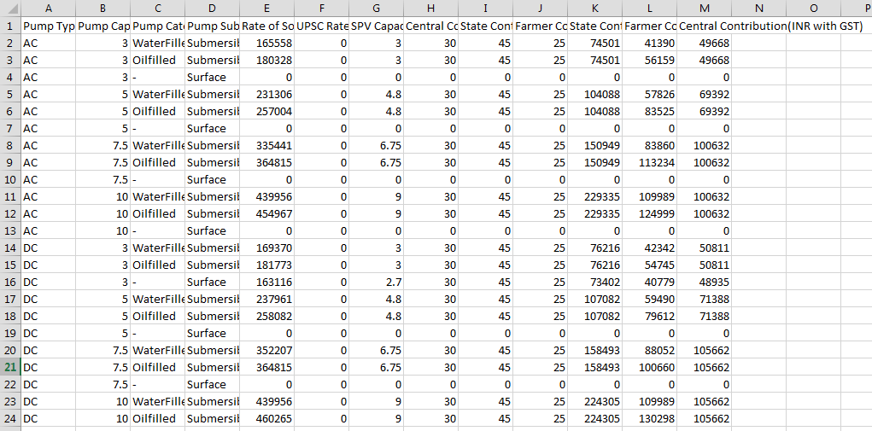
Figure 52 CSV of EA Rate Card Details Figure

- User can add new EA Rate Card by clicking on “Add EA Rate Card” button. (highlighted in red in Figure 51)
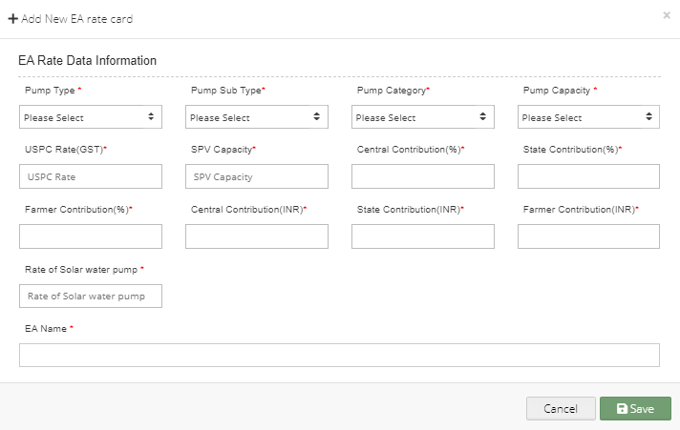
Figure 53 New EA Rate Card Details

Table 22 EA RATE CARD REGISTRATION FIELDS DESCRIPTION
Field | Input | Drop Down & Check Box Options | Mandatory Field | Sample Values | Description
Pump Type | Text | - AC  - DC |  | AC | Selection of the Pump Type
Pump Sub Type | Drop Down | - Submersible  - Surface |  | Submersible | Selection of the Pump Sub Type
Pump Category | Drop Down | - Oil Filled  - Water Filled |  | Water Filled | Selection of the Pump Category
Pump Capacity | Drop Down | - 1 HP  - 2 HP  - 3 HP  - 5 HP  - 7.5 HP  - 10 HP |  | 5 HP | Selection of the Pump Capacity
USPC Rate (GST) | Numerical | - |  | 0 | -
SPV Capacity | Numerical | - |  | 3 | -
Central Contribution (%) | Numerical | - |  | 30 | -
State Contribution (%) | Numerical | - |  | 45 | -
Farmer Contribution (%) | Numerical | - |  | 25 | -
Central Contribution (INR) | Numerical | - |  | 49668 | -
State Contribution (INR) | Numerical | - |  | 74501 | -
Farmer Contribution (INR) | Numerical | - |  | 41930 | -
Rate of Solar Water Pump | Numerical | - |  | 16558 | -
EA Name | Drop Down | - Sai Babuji Project Pvt. Ltd.  - Gautam Solar Pvt. Ltd.  - CRI Pumps Pvt. Ltd.  - Shakti Pumps Ltd.  - Solex Energy Ltd.  - Junna Solar System Pvt. Ltd. |  | Sai Babuji Project Pvt. Ltd | Selection of the relevant Empanelled Agency

- After filling all the details, user has to click on the “Save” button (highlighted in red in above Figure 53) to register New EA Rate Card.

11.3. REGISTRATION OF EA STORE SUB LOCATION

- EA Store Sub Location is the location of the Empanelled Agency where the assets are inspected and stored.
- Super Admin can register EA Store Sub Location Details by clicking on “EA Store Sub Location” tab as pointed in below Figure 54.
- SIA with Super Admin credentials needs to be collect the store location details from Empanelled agencies and then register the store sub-location details here.

- Navigation Step :-
- Sign in on the State SEDM Portal
- Click on the Setting Module
- Click on EA Store Sub Location Tab

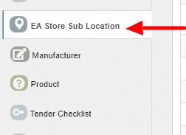

Figure 54 EA Store Sub Location Tab

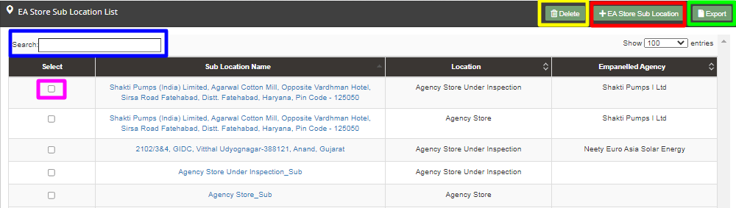

Figure 55 EA Store Sub Location Dashboard

Table 23 EA STORE SUB LOCATION DASHBOARD EXPLANATION
Action | Functionality | Highlighted Colour | Type | Description
Search | Search EA Store Sub Location | Blue | Text Box | Enter input to explore EA Store Sub Location details
Delete | Delete EA Store Sub Location | Yellow | Button | Select check box (highlighted in pink) and click on delete button to Delete EA Store Sub Location details
Add EA Store Sub Location | Register new EA Store Sub Location | Red | Button | Register new EA Store Sub Location by clicking on Add EA Store Sub Location button
Export | CSV file for EA Store Sub Location details | Green | Button | Download CSV file of EA Store Sub Location details

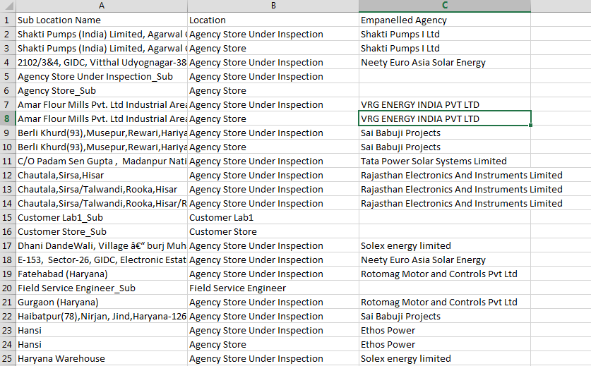

Figure 56 CSV of EA Store Sub Location Details

- User can register new EA Store Sub Location by clicking on “Add EA Store Sub Location” button. (highlighted in red in Figure 55)

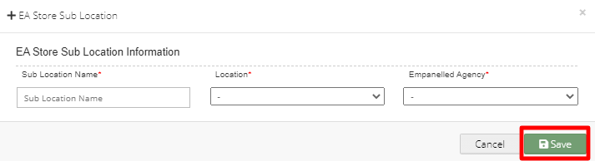
Figure 57 New EA Store Sub Location Details

Table 24 EA STORE SUB LOCATION REGISTRATION FIELDS DESCRIPTION
Field | Input | Drop Down & Check Box Options | Mandatory Field | Sample Values | Description
Sub Location Name | Text | - |  | Agency Store Sub | -
Location | Drop Down | - Field Service Engineer  - Agency Store Under Inspection  - Agency Store  - Manufacturer Store  - Manufacturer Service |  | Agency Store Under Inspection | Selection of relevant Location
Empanelled Agency | Drop Down | - Sai Babuji Project Pvt. Ltd.  - Gautam Solar Pvt. Ltd.  - CRI Pumps Pvt. Ltd.  - Shakti Pumps Ltd.  - Solex Energy Ltd.  - Junna Solar System Pvt. Ltd. |  | Gautam Solar Pvt. Ltd. | Selection of relevant Empanelled Agency

- After filling all the details, user has to click on the “Save” button (highlighted in red in above Figure 57) to register New EA Store Sub Location.

11.4. REGISTRATION OF MANUFACTURER DETAILS

- Super Admin can register Manufacturer Details by clicking on “Manufacturer” tab as pointed in below Figure 58.
- Manufacturer registration serves the purpose as the manufacturer of the assets i.e. Solar Pump, Solar Panel, Pump Controller, Structure, RMS, etc.
- Manufacturer need to be added while creation of Asset Test Report along with the product details which will be further used in Lot creation. (click here to know more)

- Navigation Step :-
- Sign in on the State SEDM Portal
- Click on the Setting Module
- Click on Manufacturer Tab

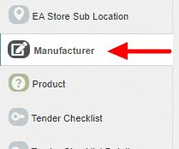

Figure 58 Manufacturer Tab

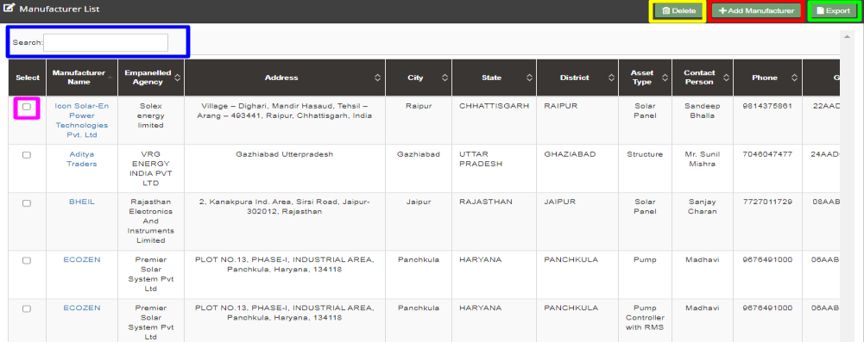

Figure 59 Manufacturer Tab Dashboard

Table 25 MANUFACTURER DASHBOARD EXPLANATION
Action | Functionality | Highlighted Colour | Type | Description
Search | Search Manufacturer | Blue | Text Box | Enter input to explore Manufacturer details
Delete | Delete Manufacturer | Yellow | Button | Select check box (highlighted in pink) and click on delete button to Delete Manufacturer details
Add Manufacturer | Register new Manufacturer | Red | Button | Register new Manufacturer by clicking on Add Manufacturer button
Export | CSV file for Manufacturer details | Green | Button | Download CSV file of Manufacturer details

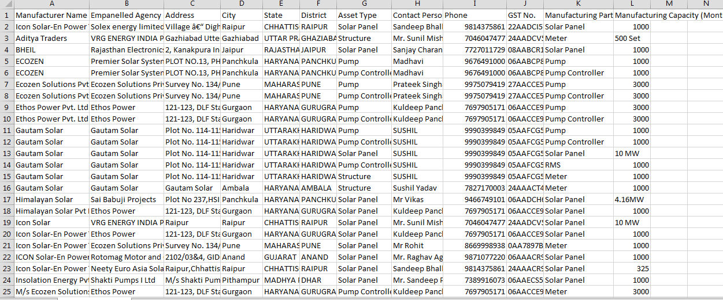
Figure 60 CSV of Manufacturer Details
- User can register new Manufacturer by clicking on “Add Manufacturer” button. (highlighted in red in Figure 59)

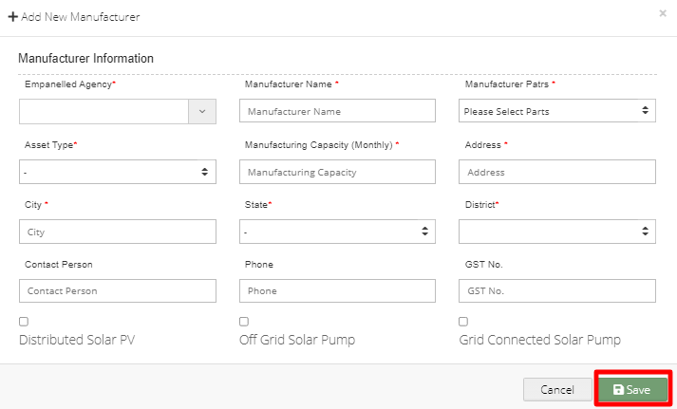

Figure 61 New Manufacturer Details

Table 26 MANUFACTURER REGISTRATION FIELDS DESCRIPTION
Field | Input | Drop Down & Check Box Options | Mandatory Field | Sample Values | Description | Validations
Empanelled Agency | Drop Down | - Sai Babuji Project Pvt. Ltd.  - Sri Savitri Solar Pvt. Ltd.  - Gautam Solar Pvt. Ltd.  - CRI Pumps Pvt. Ltd.  - Shakti Pumps Ltd.  - Solex Energy Ltd.  - Junna Solar System Pvt. Ltd. |  | Sri Savitri Solar Pvt. Ltd. | Selection of relevant Empanelled Agency | -
Manufacturer name | Text | - |  | M/s. Sri Savitr Solar Pvt. Ltd. | - | -
Manufacturer Parts | Drop Down | - Solar Panel  - Inverter  - Pump Controller  - Pump  - RMS  - Meter |  | Solar Panel | Selection of the manufacturer parts of the assets | -
Asset Type | Drop Down | - Pump  - Solar Panel  - Pump Controller with RMS  - Structure |  | Solar Panel | Selection of relevant asset type that the manufacturer is manufacturing. | -
Manufacturer Capacity (Monthly) | Numerical | - |  | 320 | - | -
Address | Text | - |  | Plot No. 34/1, Survey No. 374, CIE Phase II, Gandhinagar | - | -
City | Text | - |  | Hyderabad | - | -
State | Drop Down | - STATE  - GUJARAT  - HARYANA  - TRIPURA  - TELANGANA |  | TELANGANA | Selection of the relevant State from where the manufacture belong from | -
District | Drop Down | - ARIYALUR  - HYDERABAD  - UDAYARPALAYAM  - TAMBARAM  - CENTRAL CHENNAI  - SOUTH CHENNAI  - NORTH CHENNAI |  | HYDERABAD | Selection of the relevant district from where the manufacture belong from | -
Contact Person | Text | - |  | Mr.Sudhir Kant Gir | - | -
Phone | Numerical | - |  | 9949033677 | - | - Must be of 10 digits only
GST No. | Text | - |  | 36AAQCS0838P4Z7 | - | - It must be of 15 digits only  - First two digits should be the state code  - Next ten digits should be the PAN number of the person or business entity  - The thirteenth is alpha-numeric digit (1-9 or A-Z)  - The fourteenth digit will be the alphabet “Z” by default  - The last digit should be any number (1-9)
Component | Radio Button | - Distributed Solar PV (A)  - Off Grid Solar Pump (B)  - Grid Connected Solar Pump (C) |  | Off Grid Solar Pump | - | -

- After filling all the details, user has to click on the “Save” button (highlighted in red in above Figure 61) to register New Manufacturer.

11.5. REGISTRATION OF PRODUCT DETAILS

- Product details corresponding to Manufacturer and Empanelled Agency need to be added while creation of Asset Test Report which will be further added in Lot creation. (click here to know more)
- Super Admin can register new Product Details by clicking on “Product” tab as pointed in below Figure 62.

- Navigation Step :-
- Sign in on the State SEDM Portal
- Click on the Setting Module
- Click on Product Tab

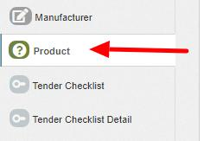
Figure 62 Product Tab

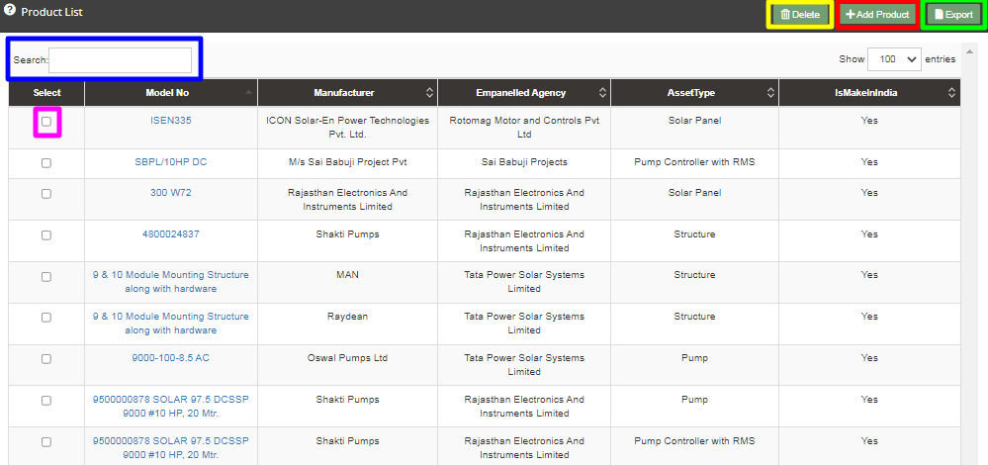

Figure 63 Product Tab Dashboard

Table 27 PRODUCT DASHBOARD EXPLANATION
Action | Functionality | Highlighted Colour | Type | Description
Search | Search Product | Blue | Text Box | Enter input to explore Product details
Delete | Delete Product | Yellow | Button | Select check box (highlighted in pink) and click on delete button to Delete Product details
Add Product | Register new Product | Red | Button | Register new Product by clicking on Add Product button
Export | CSV file for Product details | Green | Button | Download CSV file of Product details

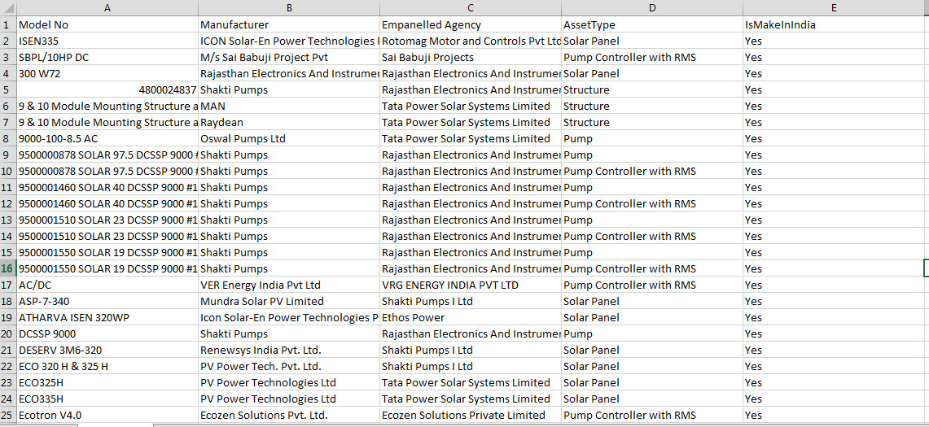
Figure 64 CSV of Product Details

- User can register new Product by clicking on “Add Product” button. (highlighted in red in Figure 63)

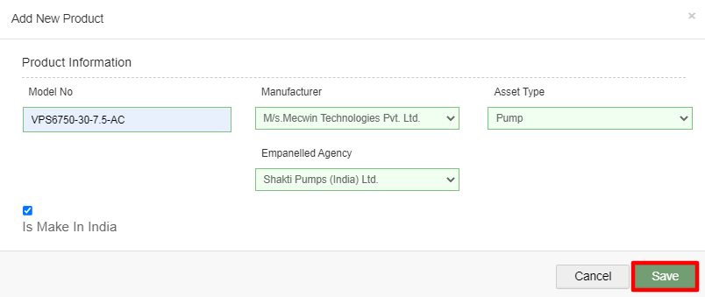

Figure 65 New Product Details

Table 28 PRODUCT REGISTRATION FIELDS DESCRIPTION
Field | Input | Drop Down & Check Box Options | Mandatory Field | Sample Values | Description
Model No. | Text | - |  | VPS6750-30-7.5-AC | -
Empanelled Agency | Drop Down | - Sai Babuji Project Pvt. Ltd.  - Sri Savitri Solar Pvt. Ltd  - Gautam Solar Pvt. Ltd.  - CRI Pumps Pvt. Ltd.  - Shakti Pumps Ltd.  - Solex Energy Ltd.  - Junna Solar System Pvt. Ltd. |  | Shakti Pumps (Idnia) Ltd. | Selection of relevant Empanelled Agency
Manufacturer | Drop Down | - Alectrona  - BHEIL  - Ethos Power Pvt. Ltd  - M/s. Sri Savitri Solar Pvt. Ltd |  | M/s Mecwin Technologies Pvt Ltd | Selection of the relevant manufacturer of the product
Asset | Drop Down | - Pump  - Solar Panel  - Pump Controller with RMS  - Structure |  | Pump | Selection of the asset type
Is Make In India | Check Box | - |  | - | Selecting this Check Box conveys that product is made in India

- After filling all the details, user has to click on the “Save” button (highlighted in red in above Figure 65) to register New Product.

11.6. REGISTRATION OF TENDER CHECKLIST

- Tender Checklist is a template consisting of tender checklist items which acts similar to “guaranteed technical particulars (GTP)” and filled by empanelled agencies as self-declaration of compliance to tender specifications during lot creation and verified by the State Implementing Agency after the lot creation. (click here to know more)
- SIA with Super Admin credentials can register new Tender Checklist by clicking on “Tender Checklist” tab as pointed in below Figure 66.
- Navigation Step :-
- Sign in on the State SEDM Portal
- Click on the Setting Module
- Click on Tender Checklist Tab

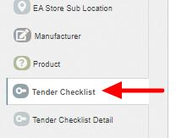

Figure 66 Tender Checklist Tab

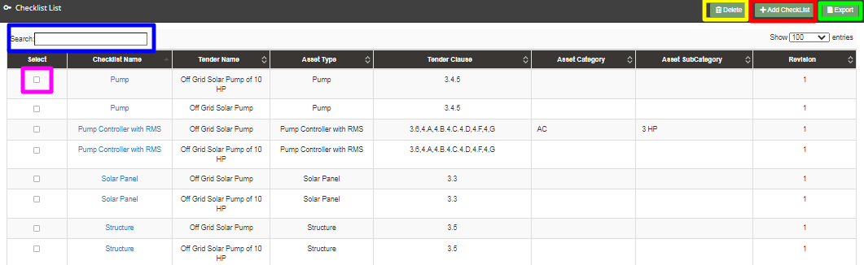

Figure 67 Tender Checklist Tab Dashboard

Table 29 TENDER CHECKLIST DASHBOARD EXPLANATION
Action | Functionality | Highlighted Colour | Type | Description
Search | Search Tender Checklist | Blue | Text Box | Enter input to explore Tender Checklist
Delete | Delete Tender Checklist | Yellow | Button | Select check box (highlighted in pink) and click on delete button to Delete Tender Checklist
Add Checklist | Register new Tender Checklist | Red | Button | Register new Tender Checklist by clicking on Add Checklist button.
Export | CSV file for Tender Checklist | Green | Button | Download CSV file of Tender Checklist

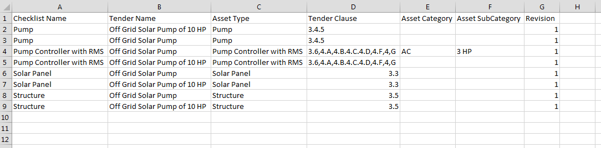
Figure 68 CSV of Tender Checklist

- User can register new Tender Checklist by clicking on “Add Checklist” button. (highlighted in red in Figure 67)

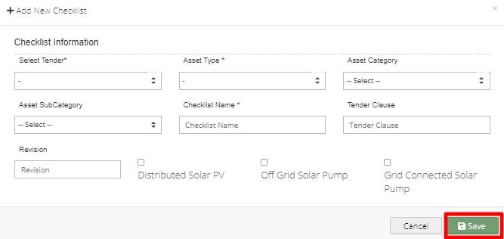

Figure 69 New Checklist Details

Table 30 TENDER CHECKLIST REGISTRATION FIELDS DESCRIPTION
Field | Input | Drop Down & Check Box Options | Mandatory Field | Sample Values | Description
Select Tender | Drop Down | - Off Grid Solar Pump  - Off Grid Solar Pump of 10 HP |  | Off Grid Solar Pump  . | Selection of relevant Tender
Asset Type | Drop Down | - Pump  - Solar Panel  - Pump Controller with RMS  - Structure  - USPC |  | Pump | Selection of the relevant asset type
Asset Category | Drop Down | - AC  - DC |  | AC | Selection of the relevant asset category
Asset Sub Category | Drop Down | - 1 HP  - 2 HP  - 3 HP  - 5 HP  - 7.5 HP  - 10 HP |  | 3 HP | Selection of the relevant asset sub category
Checklist Name | Text | - |  | Pump | Name for identification of checklist
Tender Clause | Text | - |  | - | Reference tender clause of corresponding tender
Revision | Text | - | - | - | Change in tender specifications can be tracked using revision
Component | Radio Button | - Distributed Solar PV (A)  - Off Grid Solar Pump (B)  - Grid Connected Solar Pump (C) |  | Off Grid Solar Pump (B) | Select PM-KUSUM Component

- After filling all the details, user has to click on the “Save” button (highlighted in red in above Figure 69) to register New Checklist.

11.7. REGISTRATION OF TENDER CHECKLIST DETAILS

- Tender Checklist Details is an individual checklist item which corresponds to tender specification/requirement. Empanelled agencies declare their compliance/deviation against ideal response. (click here to know more)
- Super Admin can register new Tender Checklist Template by clicking on “Tender Checklist Detail” tab as pointed in below Figure 70.

- Navigation Step :-
- Sign in on the State SEDM Portal
- Click on the Setting Module
- Click on Tender Checklist Detail Tab

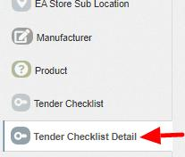

Figure 70 Tender Checklist Detail Tab

- By clicking on the Tender Checklist Detail tab, a drop down will occur on the screen as shown in below figure, to select the Tender Checklist Name which was added in the “Tender Checklist” tab.

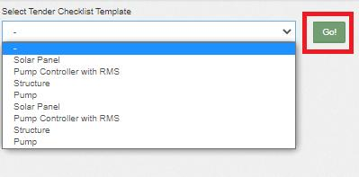
Figure 71 Select Tender Checklist Template
- After selecting the tender checklist template, user can see the Tender Checklist Template dashboard as shown below.

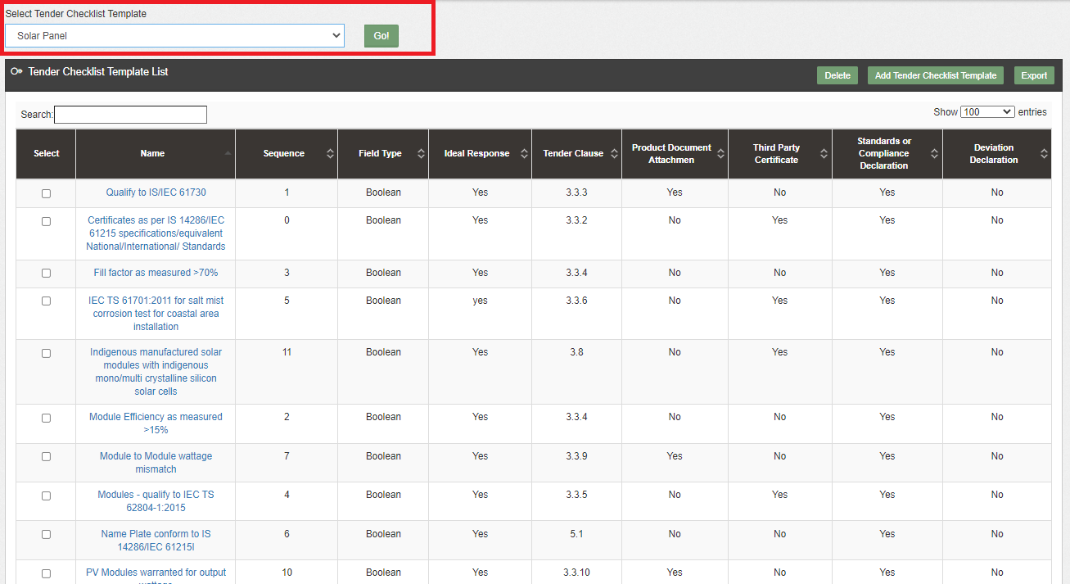
Figure 72 Tender Checklist Template Dashboard

Table 31 TENDER CHECKLIST Template DASHBOARD EXPLANATION
Action | Functionality | Highlighted Colour | Type | Description
Search | Search Tender Checklist Template | Blue | Text Box | Enter input to explore Tender Checklist Template
Delete | Delete Tender Checklist Template | Yellow | Button | Select check box (highlighted in pink) and click on delete button to Delete Tender Checklist Template
Add Tender Checklist Template | Register new Tender Checklist Template | Red | Button | Register new Tender Checklist Template by clicking on Add Tender Checklist Template button
Export | CSV file for Tender Checklist Template | Green | Button | Download CSV file of Tender Checklist Template

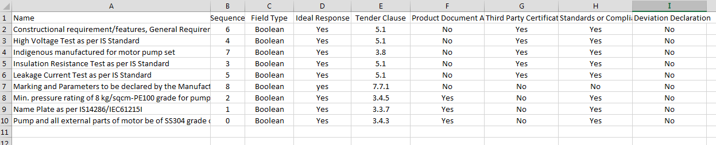

Figure 73 CSV of Tender Checklist Template

- User can register new Tender Checklist Template by clicking on “Add Tender Checklist Template” button. (highlighted in red in Figure 72)
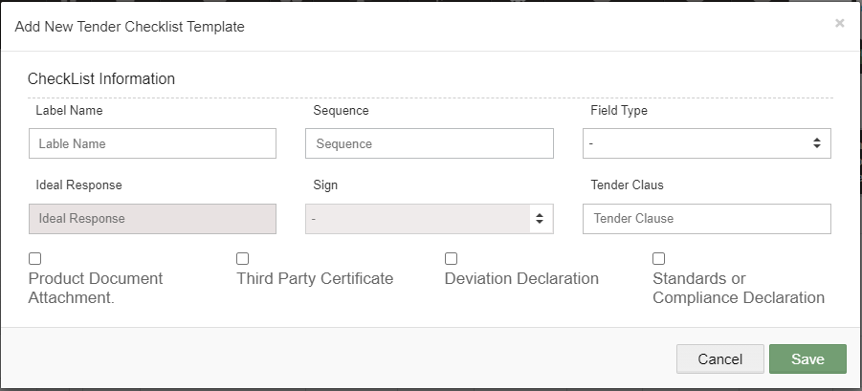
74 New Tender Checklist Details

Table 32 TENDER CHECKLIST TEMPLATE REGISTRATION FIELDS DESCRIPTION
Field | Input | Drop Down & Check Box Options | Mandatory Field | Sample Values | Description
Label Name | Text | - | - | Constructional requirement/features, General Requirements, Design features. | Identifier name to be given against checklist item
Sequence | Numerical | - |  | 6 | Input the sequence number where this checklist item is to be displayed. Display of the checklist item shall be ordered by sequence
Field Type | Drop Down | - Boolean  - String  - Drop Down  - Number | - | Boolean | Selection of the relevant field type of the tender checklist template
Ideal Response | Text | - | - | Yes | Input the ideal response value expected against this checklist item
Sign | Drop Down | - | - | - | Select the sign as per expectation of ideal response
Tender Clause | Numerical | - |  | 5.1 | Reference tender clause of corresponding tender
Additional required Input details against checklist item | Check Box | - Product Document Attachment  - Third Party Certificate  - Deviation Declaration  - Standard or Compliance Declaration | - | - Third Certificate  - Standard or Compliance Declaration | User need to submit corresponding documents/declaration as per selection

- After filling all the details, user has to click on the “Save” button (highlighted in red in above
- ) to register New Tender Checklist Template.

11.8. AUDIT TRAIL

- Audit Trail serves the purpose to store the details of the person that make last update on State SEDM Platform.
- SIA with Super Admin credentials can view the audit trail in “Setting” Menu.

- Navigation Step :-
- Sign in on the State SEDM Portal
- Click on the Setting Module
- Click on Audit Tab

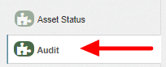
Figure 75 Audit Tab

- By clicking on the Audit tab, the screen along with three filters i.e. Select District, Select Space (modules) and date range will appear as shown in below Figure 76.

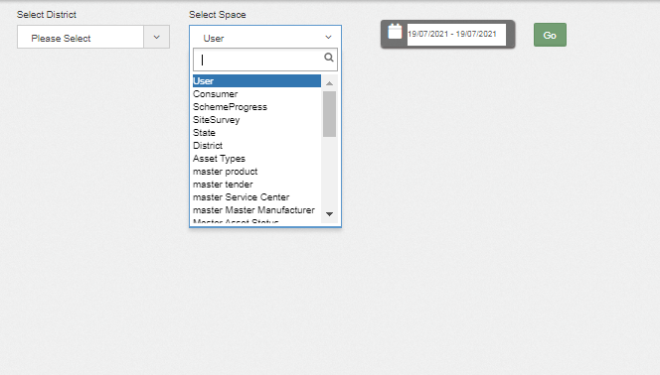

Figure 76 Audit Tab Filters

- By selecting any particular district and Space (modules) against the selected district and date range, Super Admin can get the details about last updates made in particular selected Space (module) as shown in below Figure 77.

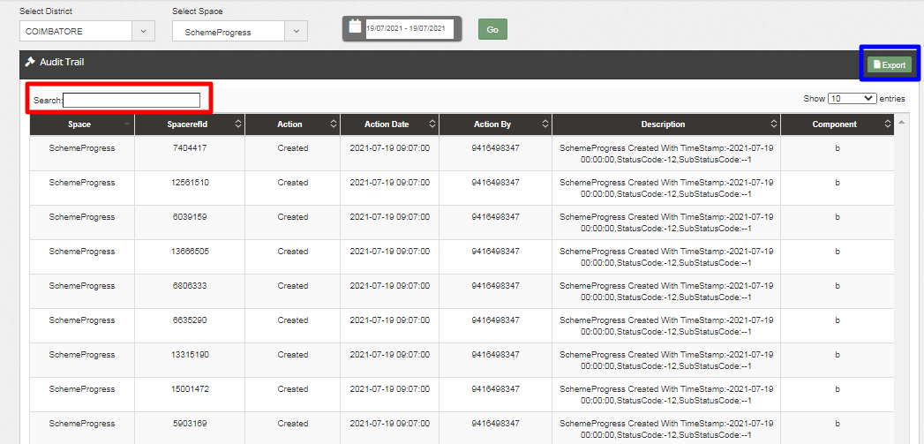

Figure 77 Audit Dashboard (Applied Filters)

- As shown in above Figure 77, filtered dashboard by selecting District : Coimbatore, Space : Scheme Progress and date range, one can find details like the person’s registered username (shown as phone numbers in above Figure 77) who had made updates in scheme progress, the date on which updates was made, the action he made while updating Scheme Progress, etc.
- User can search for specific detail by entering input in “Search” box. (highlighted in red in Figure 77)
- User can download a csv file (refer Figure 78) of filtered Audit details by clicking on export button. (highlighted in blue in Figure 77)

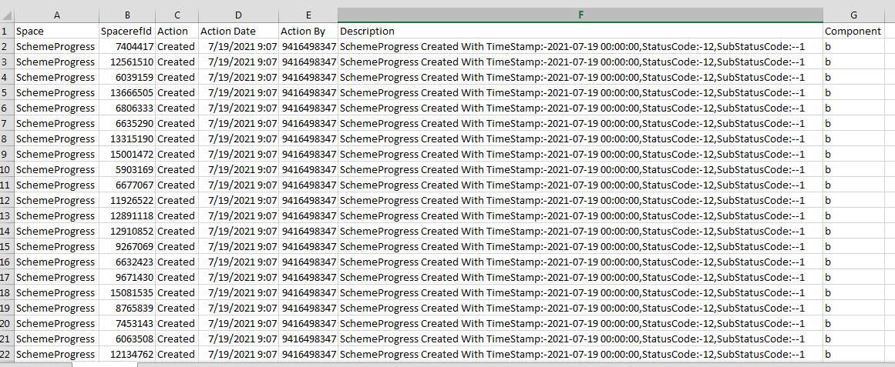

Figure 78 Audit Details – CSV File

APPLICATION WORKFLOW STAGES

- List of Responsible Users Of TN SEDM Portal who will be responsible for the below mentioned Workflow Stages :
  - Sub Division Officer (SDN)
  - Head Officer (HO)
  - Empanelled Agency (EA)

Table 33 FARMER APPLICATION WORKFLOW STAGES

Workflow Stages  (Clickable Links) | Description | Responsibility
Application Received | When consumer/farmer’s application is registered, Application Registration stage will be affected. | SDN/HO/EA
Site Survey Done | When the surveyor gather and upload the relevant data of consumer/farmer’s farm site location, Site Survey stage will be reflected. | EA
Feasible Application | When the authorized person approve the consumer/farmer’s application, Feasible Application stage will be affected. | SDN/HO
Applicant Contribution Received | When the authorized person receive the consumer/farmer’s share, Farmer Share Received stage will be affected. | SDN/HO
Order Placed to EA | When the authorized person allocate consumer/farmer’s application to the Empanelled Agency, Order Placed to EA stage will be reflected. | SDN/HO
Asset Test Report Creation by EA | In order to create Lot & Document, user has to create an Asset Test Report. | EA
Lot & Document Creation by EA | When the authorized person creates and submit Lot & Document, Lot & Document Creation by EA stage will be affected. | EA
Lot & Document Verified | When the authorized person verifies the submitted lot & document by EA, Lot & Document Verification Stage will be affected. | SDN/HO
Pre Dispatch Inspection | When the authorized person upload the Pre Dispatch Inspection (PDI) document, Pre Dispatch Inspection stage will be affected. | SDN/HO
Dispatched | When the authorized person dispatches the lot of assets, Dispatched stage will be affected. | EA
Installation & Commission (I & C) | When the authorized person map the asset serial no. with the consumers/farmers and upload all the 4 photos of RMS connected device, Installation & Commission (I & C) stage will be affected. | EA
I & C Verification | When the authorized person verifies the Site Inspection checklist, I & C verification stage will be affected. | SDN/HO

CONSUMER/FARMER APPLICATION REGISTRATION

- The Consumer/Farmer Management module of SEDM is focused towards Consumer/Farmer registration, setting up of Consumer/Farmer profile and to provide the application updates, all at one place
- Below are the authorized users for Application registration :
- State Implementing Agency (SIA)
  - Sub Division Officer (SDN)
  - Head Officer (HO)
- Empanelled Agency (EA).

- Navigation Steps for Consumer/Farmer application Registration :-
            - Sign in on the State SEDM Portal
            - Click on the “Details” on Consumer Module as shown in below Figure 79 Click on the “Add Farmer” button

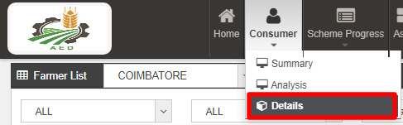
Figure 79 Details

- Select the district from where the new farmer belongs from and click on the “GO” button as shown in the below Figure 80 and Figure 81
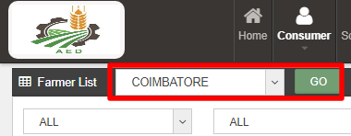
Figure 80 Select District
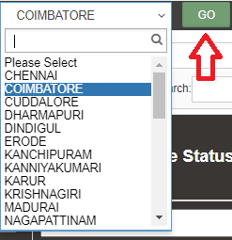
Figure 81 District List

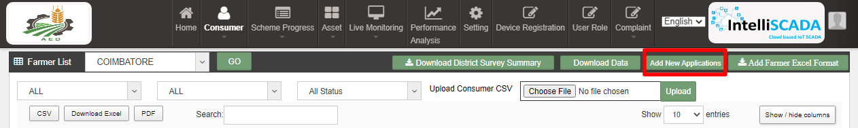
Figure 82 Add Farmer Button

- Click on the “Add New Application” button as highlighted in red in the above Figure 82.

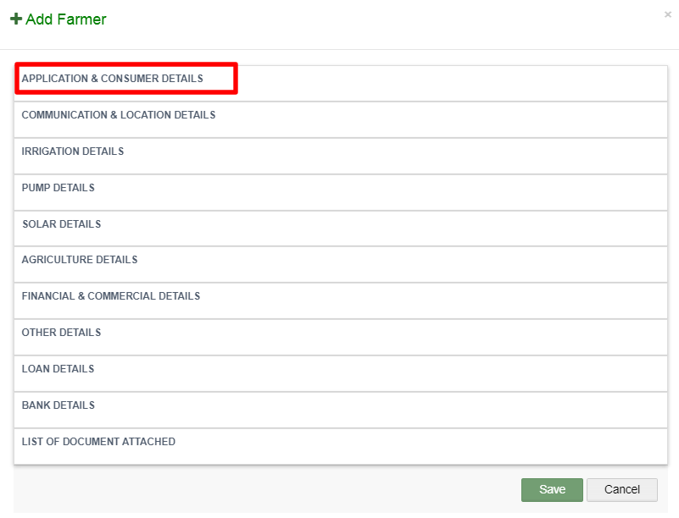
Figure 83 Add farmer Form

- After clicking on the “Add Farmer” button, a screen will appear as shown in above Figure 83.
- Multiple sections are there for filling out the farmer details.
- User has to click on the section name (highlighted in red in above Figure 83) to open the section of the form.

- Application & Consumer Details
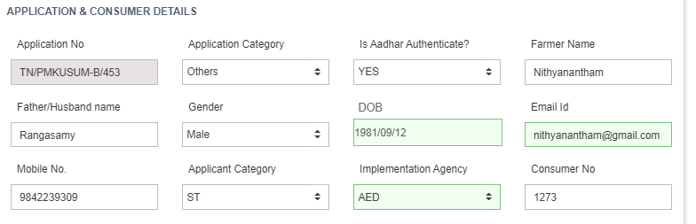

Figure 84 Application & Consumer Details

Table 34 APPLICATION AND CONSUMER DETAILS
Field | Input | Drop Down Options | Mandatory Field | Sample Values | Description
Application No. | Auto-Generated | - |  | TN/PM KUSUM/453 | Application no. will be unique and will be system generated
Application Category | Drop Down | - Farmer  - Gaushala  - Water User Association and Community  - Others  - Small Farmer  - Marginal Farmer |  | Others | This drop down conveys the category of the application
Is Aadhaar Authentication? | Drop Down | - Yes  - No |  | Yes | This drop down conveys that whether the manual Aadhar Authentication is done or not  From here Consumer/Farmer’s Application status “Aadhar Authentication” shall be updated.  SIA officer will manually verify the Aadhaar details and then confirm the authentication
Farmer Name | Text | - |  | Nithyanantham | -
Father/Husband name | Text | - | - | Rangasamy | -
Gender | Drop Down | - Male  - Female  - Transgender |  | Male | Selection of relevant gender of the applicant
DOB | Date | - |  | 1981/09/12 | Format should be YYYY/MM/DD
Email ID | Email | - | - | nithyanantham@gmail.com | -
Mobile No. (Unique) | Numerical | - |  | 9842239309 | -
Applicant Category | Drop Down | - General  - ST  - SC  - OBC  - Others |  | ST | Selection of relevant applicant caste
Implementing Agency | Autofill | - | - | AED | Specific Implementing Agency for the state
Consumer/Farmer No. | Numerical | - | - | 1273 | Any number which is enter by farmer.

- Communication & Location Details

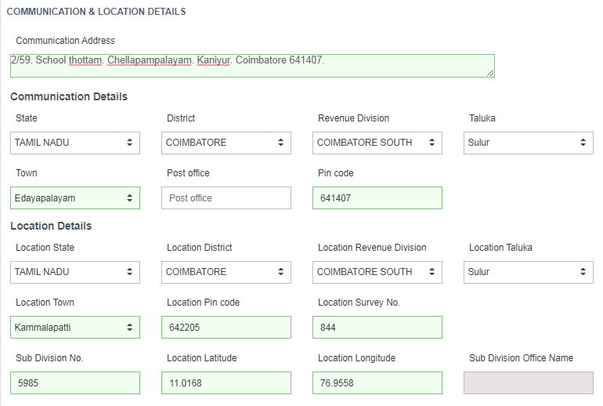
Figure 85 Communication & Location Details

Table 35 COMMUNICATION AND LOCATION DETAILS

Field | Input | Drop Down Options | Mandatory Field | Sample Values | Description
Communication Address | Text Area | - |  | 2/59. School thottam. Chellapampalayam. Kaniyur. Coimbatore 641407. | -
Communication (Residential) Details
State | Default | - |  | TAMIL NADU | -
District | Drop Down | - CHENNAI  - COIMBATORE  - CUDDALORE  - DHARMAPURI  - DINDIGUL  - ERODE  - KARUR  - MADURAI |  | COIMBATORE | This District selection is for the farmer’s residence district
Revenue Division | Drop Down | - COIMBATORE NORTH  - COIMBATORE SOUTH |  | Coimbatore SOUTH | This revenue division selection is for the farmer’s residence revenue division
Taluka | Drop Down | - Perur  - Coimbatore South  - Sulur | - | Sulur | This taluka selection is for the farmer’s residence taluka
Town | Drop Down | - Agraharasamakulam  - Akkaraisengapalli  - Ambodi  - Annur  - Edayapalayam  - Kunnathur  - Kuppanur | - | Edayapalayam | This town selection is for the farmer’s residence town
Post Office | Numerical | - | - | Coimbatore | -
Pin code | Numerical | - | - | 641407 | -
Location Details
Location State | Default | - |  | TAMIL NADU | -
Location District | Default | - |  | COIMBATORE | -
Location Revenue Division | Drop Down | - COIMBATORE NORTH  - COIMBATORE SOUTH |  | Coimbatore SOUTH | This Revenue District selection is of pump site location
Location Taluka | Drop Down | - Perur  - Coimbatore South  - Sulur | - | Sulur | This taluka selection is of pump site location
Location Town | Drop Down | - Agraharasamakulam  - Akkaraisengapalli  - Ambodi  - Annur  - Kammalapatti  - Kunnathur  - Kuppanur | - | Kammalapatti | This town selection is of pump site location
Location Pin code | Numerical | - | - | 642205 | Pin code of installation location.
Location Survey No | Numerical | - | - | 844 | Survey No of installation location.
Sub Division No | Numerical | - | - | 5985 | -
Location Latitude (Provisional) | Numerical | - |  | 11.0168 | Location Latitude of installation place.
Location Longitude (Provisional) | Numerical | - |  | 76.9558 | Location Longitude of installation place.
Sub Division Office Name | Autofill | - | - | Coimbatore | -

  - Communication Details : Consumer/Farmer’s Residential Details
  - Location Details : Farm site location where pump will be installed
  - Both details may vary.

- Irrigation Details

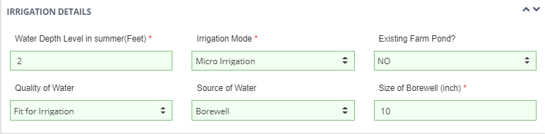

Figure 86 Irrigation Details

Table 36 IRRIGATION DETAILS

Field | Input | Drop Down Options | Mandatory Field | Sample Values | Description
Water Depth Level in summer(Feet) | Numerical | - |  | 2 | Depth of water level in feet
Irrigation Mode | Drop Down | - Micro irrigation  - Open Irrigation  - Underground Pipeline (UGPL) |  | Underground Pipeline (UGPL) | Selection of relevant Irrigation mode
Existing Farm Pond? | Drop Down | - Yes  - No  - Under Construction | - | No | This drop down means whether farmer have Pond or not
Quality of Water | Drop Down | - Fit for Irrigation  - Not Fit for Irrigation | - | Fir for irrigation | This drop down means whether farmer have water fit for irrigation or not
Source of Water | Drop Down | - Pond  - Bore Well  - Open Well  - Surface Tank  - Others |  | Borewell | Selection of relevant water source that farmer have
Size of Borewell (Inch) | Numerical | - |  |  | Size of Borewell in inches

- Pump Details

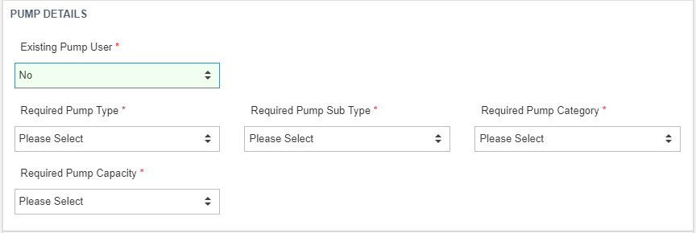
Figure 87 Pump Details

Table 37 PUMP INFORMATION
Field | Input | Drop Down Options | Mandatory Field | Sample Values | Description
Existing Pump User | Drop Down | - Yes  - No |  | No | This drop down means whether farmer is using Pump or not
Required Pump Type | Drop Down | - AC  - DC |  | AC | Selection of relevant Pump type
Required Pump Sub Type | Drop Down | - Submersible  - Surface  - BLDC |  | Submersible | Selection of relevant Pump sub type
Required Pump Category | Drop Down | - Waterfilled  - Oilfilled |  | Waterfilled | Selection of relevant Pump category
Required Pump Capacity | Drop Down | - 1HP  - 2HP  - 3HP  - 5HP  - 7.5HP  - 10HP |  | 5 hp | Selection of relevant Pump capacity

- If Farmer is already using pump , then user will have to fill Existing pump Type, Existing PumpsubType, Existing Pump Capacity, Power Source of Existing Pump and whether current pump is energy efficient or not.
- Solar Details

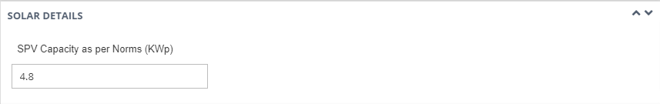
Figure 88 Solar Details

Table 38 SOLAR DETAILS
Field | Input | Mandatory Field | Sample Values
SPV Capacity as per Norms (KWp) | Autofill based on Required Pump Capacity selection | - | 4.8

- Agriculture Details

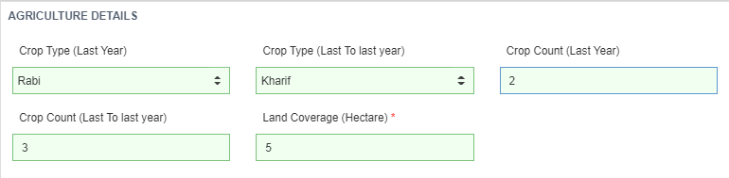

Figure 89 Agriculture Details

Table 39 AGRICULTURE INFORMATION
Field | Input | Drop Down Option | Mandatory Field | Sample Values | Description
Crop Type (Last Year) | Drop Down | - Rabi  - Kharif  - Zaid | - | Rabi | Selection of relevant Crop type of last year
Crop Type (Last to last year) | Drop Down | - Rabi  - Kharif  - Zaid | - | Kharif | Selection of relevant Crop type of last to last year
Crop Count (Last Year) | Numerical | - | - | 2 | -
Crop Count (Last to last year) | Numerical | - | - | 3 | -
Land Coverage (Hectare) | Numerical | - | - | 5 | -

- Financial & Commercial Details

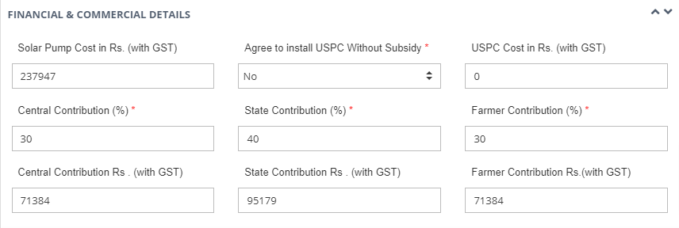
Figure 90 Financial & Commercial Details

Table 40 FINANCIAL AND COMMERCIAL DETAILS
Field | Input | Drop Down Options | Mandatory Field | Sample Values | Description
Solar Pump Cost in Rs (with GST) | Autofill | - | - | 237947 | -
Agree to install USPC Without Subsidy | Drop Down | - Yes  - No |  | No | This field means whether farmer is agreed to install USPC without Subsidy or not.
USPC Cost in Rs (with GST) | Numerical | - | - | 0 | -
Central Contribution (%) | Autofill | - |  | 30 | -
State Contribution (%) | Autofill | - |  | 40 | -
Farmer Contribution (%) | Autofill | - |  | 30 | -
Central Contribution Rs (with GST) | Autofill | - | - | 71384 | -
State Contribution Rs (with GST) | Autofill | - | - | 95179 | -
Farmer Contribution Rs (with GST) | Autofill | - | - | 71384 | -

- When the user will fill all the required pump details, above details will be filled automatically according to the details added in the EA Rate Card.

- Other Details

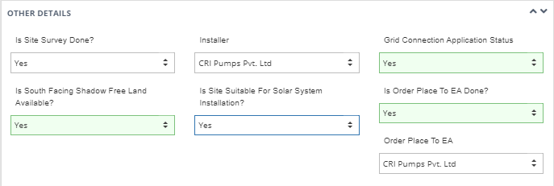

Figure 91 Other Details

Table 41 OTHER DETAILS
Field | Input | Drop Down Options | Mandatory Field | Sample Values | Description
Is Site Survey Done? | Drop Down | - Yes  - No | - | Yes | This drop down conveys that whether Site Survey is done or not
Installer | Drop Down | - Sai Babuji Project Pvt. Ltd.  - Gautam Solar Pvt. Ltd.  - CRI Pumps Pvt. Ltd.  - Shakti Pumps Ltd.  - Solex Energy Ltd.  - Junna Solar System Pvt. Ltd. | - | Solex Energy Ltd. | If Site Survey is done then selection should be done of that Installer who had done Site Survey
Grid Connection Application Status | Drop Down | - Yes  - Not Applied  - In Process | - | Yes | This drop down conveys that whether farmer had applied for the Grid Connection or not
Is South Facing Shadow Free Land Available? | Drop Down | - Yes  - No | - | Yes | This drop down conveys that whether the Site has South facing shadow free land available or not
Is Site Suitable for Solar System Installation? | Drop Down | - Yes  - No | - | Yes | This drop down conveys that whether the Site is suitable for the installation of Solar Pump or not
Is Order Place to EA Done? | Drop Down | - Yes  - No | - | Yes | This drop down conveys that whether the order is assigned to any Empanelled Agency or not
Order Place to EA | Drop Down | - Sai Babuji Project Pvt. Ltd.  - Gautam Solar Pvt. Ltd.  - CRI Pumps Pvt. Ltd.  - Shakti Pumps Ltd.  - Solex Energy Ltd.  - Junna Solar System Pvt. Ltd. | - | Solex Energy Ltd. | If order is assigned to any Empanelled Agency then selection should be done of that Empanelled Agency to whom order has been placed.

- Loan Details

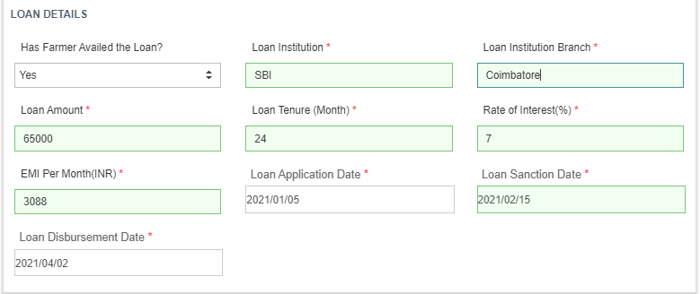

Figure 92 Loan Details

Table 42 LOAN DETAILS
Field | Input | Drop Down Options | Mandatory Field | Sample Values | Description
Has Farmer Availed the Loan? | Drop Down | - Yes  - No |  | Yes | This drop down conveys that whether the farmer had loan available or not
Loan Institution | Text | - |  | SBI Bank | Name of the Institution from where loan has been availed
Loan Institution Branch | Text | - |  | Chennai | Branch name of the Institution
Loan Amount | Numerical | - |  | 40,000 | Loan Amount availed
Loan Tenure | Text | - |  | 20 months | Loan Duration in Months
Rate of Interest (%) | Numerical | - |  | 9 | Rate of interest at which loan is availed
EMI per month (INR) | Numerical | - |  | 5000 | Equated Monthly Instalments to be paid for loan closure
Loan Application Date | Date | - |  | 2021/09/13 | Date on which loan application has been made (YYYY/MM/DD)
Loan Sanction Date | Date | - |  | 2021/09/17 | Date on which loan application has been sanctioned (YYYY/MM/DD)
Loan Disbursement Date | Date | - |  | 2021/09/27 | Date on which loan has been disbursed (YYYY/MM/DD)

- Bank Details

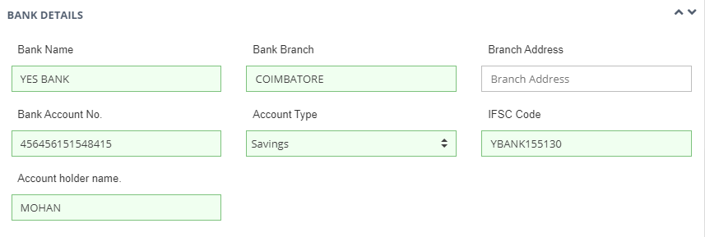

Figure 93 Bank Details

Table 43 BANK DETAILS
Field | Input | Drop Down Options | Mandatory Field | Sample Values | Description
Bank Name | Text | - | - | Yes Bank | Name of given Bank
Bank Branch | Text | - | - | COIMBATORE | Name of given Bank Branch
Branch Address | Text | - | - | Coimbatore | Bank Branch address
Bank Account No | Numerical | - | - | 458856478953 | Account no of Bank
Account Type | Drop Down | - Savings  - Current | - | Savings | Selection of relevant bank account type of Farmer
IFSC Code | Text | - | - | YBANK155130 | -
Account holder name | Text | - | - | Mohan | -

- List of Document Attached

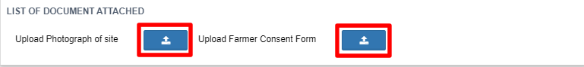

Figure 94 List of Document Attached

- List of document consist of “Photograph of Site” & “Farmer Consent Form”.
- By clicking on the red coloured icons in above Figure 94, user can upload these two forms from farmer registration form.

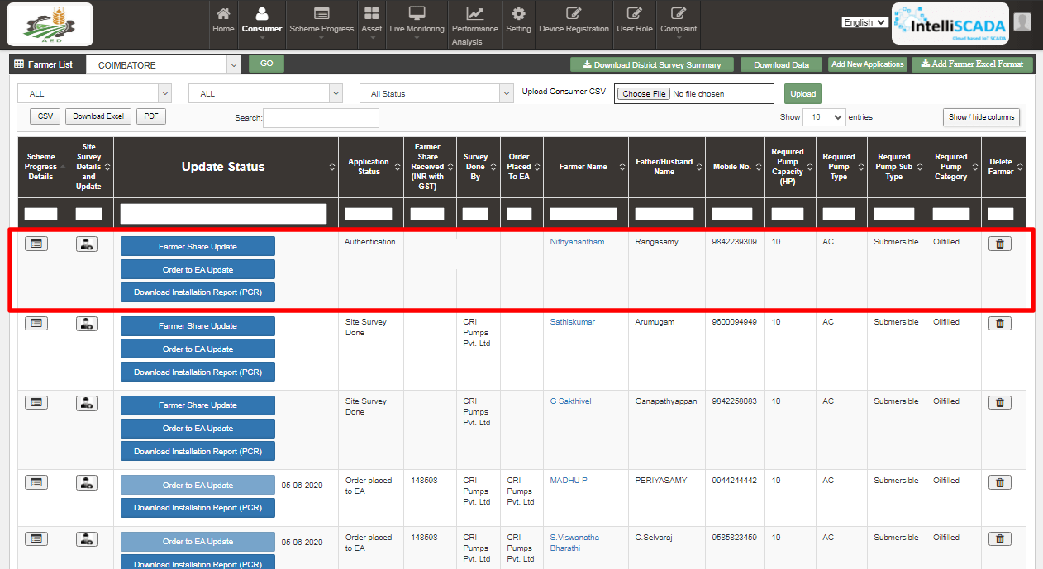
Figure 95 Detail Dashboard

- After application registration, new application will be entered in the consumer/farmer details dashboard as fresh entry (as highlighted in red above Figure 95) whose application scheme progress is yet to commence.
- Details dashboard consists following data columns :

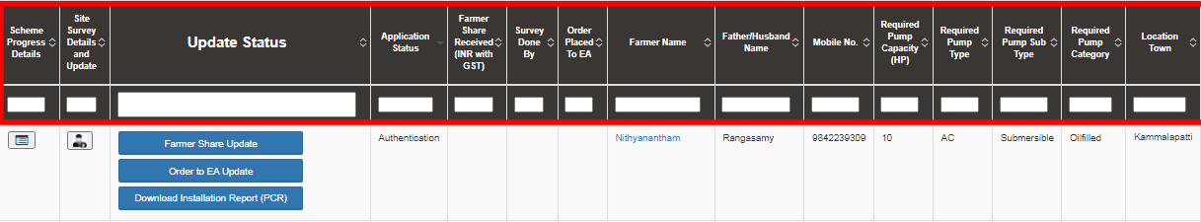
Figure 96 Consumer Detail Data Columns (i)

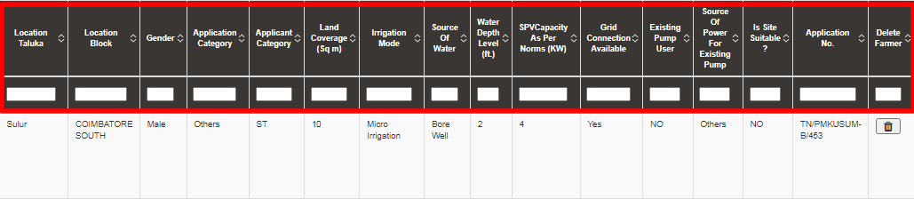
Figure 97 Consumer Detail Data Columns (iI)

Table 44 DATA COLUMN DESCRIPTION
Column Name | Data | Description
Scheme Progress Details | - | Scheme Progress Report
Site Survey Details & Update | - | Site Survey Details Report
Update Status | - | Status Buttons
Application Status | Authentication | Current Application Status
Farmer Share Received (INR with GST) | <Farmer Contribution in RS.> | Farmer share in terms of INR including GST
Survey Done By | <Empanelled Agency Name> | Surveyed Empanelled Agency Name
Order Place to EA | <Empanelled Agency Name> | Assigned Empanelled Agency Name
Farmer Name | Nithyanantham | Name of the Consumer/farmer
Father/Husband Name | Rangasamy | Name of Consumer/farmer’s husband or father
Mobile No. | 9842239309 | Consumer/Farmer’s mobile number
Pump Capacity (HP) | 10 | Solar Pump capacity in terms of horse power (HP)
Pump Type | AC | Type of the solar pump
Pump Sub Type | Submersible | Sub type of the solar pump
Pump Category | Oilfilled | Category of the solar pump
Location Town | Kammalapatti | Town of the farm site
Location Taluka | Sulur | Taluka of the farm site
Location Revenue Division | COIMBATORE SOUTH | Revenue Division of the farm site
Gender | Male | Gender of the consumer/farmer
Application Category | Others | Application category of the consumer/farmer
Applicant Category | ST | Applicant Category of the consumer/farmer
Land Coverage (Sq. Meter) | 10 | Coverage of land in terms of Hector
Irrigation Mode | Micro Irrigation | Mode of the irrigation
Source of Water | Bore Well | Water source at farm site
Water Depth Level (ft.) | 2 | Water depth level at farm site
SPV Capacity as per norms (KW) | 4 | SPV Capacity of solar pump as per norms
Grid Connection Available | Yes | Availability of grid connection at farm site
Existing Pump User | NO | Whether consumer/farmer is existing pump user or not
Source of Power for Existing Pump | Others | If consumer/farmer is existing pump user then the power source of existing solar pump
Is Site Suitable? | NO | Is farm site suitable to install solar pump
Application No. | TN/PMKUSUM-B/453 | Application no. of the farmer
Delete Farmer | <delete icon> | By clicking on the delete icon, all updated status of farmer will be deleted and the farmer application will be taken back to the very first application status “Application Received”

NOTE: FOR UPDATING THE STATUS “SITE SURVEY DONE”,
SITE SURVEY Click here TO KNOW ABOUT IT.

- Consumer Details Dashboard Explanation
.
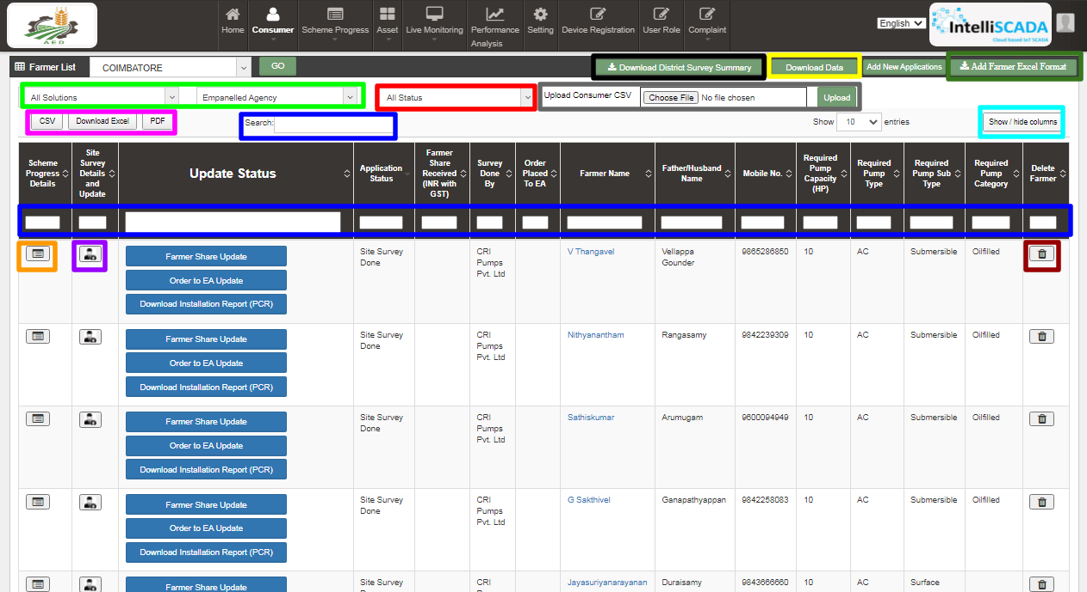
Figure 98 Consumer/Farmer Detail Dashboard

- The blue buttons in third column of Consumer Details dashboard will be used further to update the application status “Farmer Share Received” (click here to know more) & “Order Place To EA” (click here to know more) and after updating all 14 application stages, user can download the Project Completion Report (PCR) of the consumer/farmer.
- There are two types of boxes for searching any particular type of consumer/farmer which is highlighted in two blue boxes in above Figure 98. User can search for a specific query to check for the consumer/farmer information on the Consumer Details dashboard by inputting their search parameter in ‘Search’ dialogue box.
- By clicking upon the delete icon (highlighted in brown in above Figure 98) below screen will appear (), will delete all the updated status of the consumer/farmer application and take back the application to the very first application stage i.e. “Application Received”.

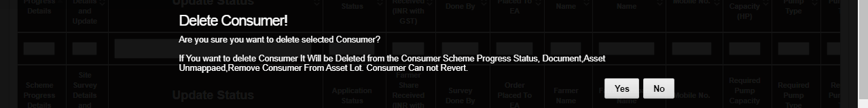
Figure 99 Confirmation Screen to Delete All Updated Consumer/Farmer Application Status

- Consumer/Farmer Details dashboard entries can be filtered out in two ways i.e. 1. Solution & Empanelled Agency wise (highlighted in green in above Figure 98) and 2. Application Status wise. (highlighted in red in above Figure 98)
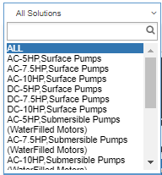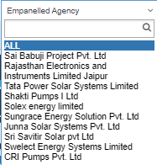
Figure 100 Filter 1 Solution & Empanelled Agency

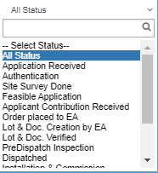
Figure 101 Filter 2 Empanelled Agency

- User can download consumer survey summary details CSV file (refer Figure 102) by clicking “Download District Survey Summary” button. (highlighted in black in Figure 98)
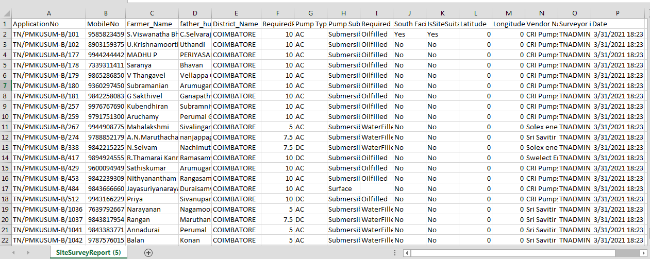

Figure 102 District Survey Summary Details CSV

- The users can also access the data and information provided under Consumer/Farmer Management offline by downloading the data in Excel format by clicking on the ‘Download Data’ option on top right corner of the .dashboard (highlighted in yellow in Figure 98)
- Upon clicking the ‘Download Data’ option, a screen appears where user must enter the filter parameters of District, Pump Capacity, Application Status and the dates for which they want to view the data as shown in the below Figure 103.
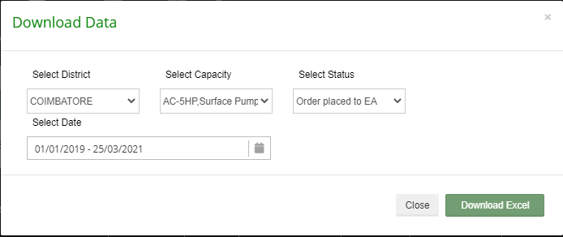

Figure 103 Download data Filters Screen

- User also can download Consumer/Farmer Details in either of three formats i.e. CSV/EXCEL/PDF by clicking either of three buttons i.e. “CSV”, “Download Excel” & “PDF”. (buttons highlighted in pink in Figure 98)

- CSV file output - as shown in Figure 104 & Figure 105

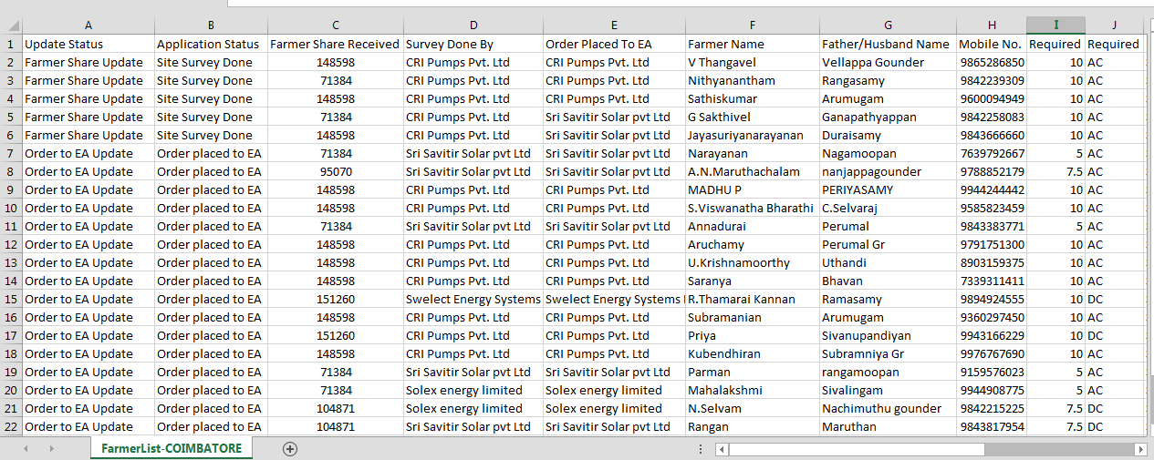
Figure 104 Details dashboard csv file (i)
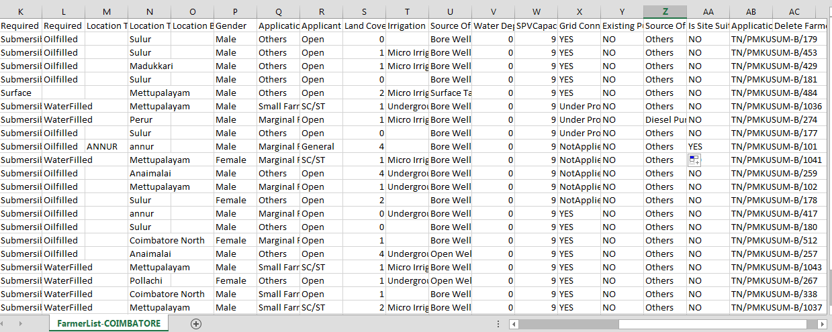
Figure 105 Details dashboard csv file (ii)

- Excel file output - as shown in Figure 106, Figure 107 & Figure 108
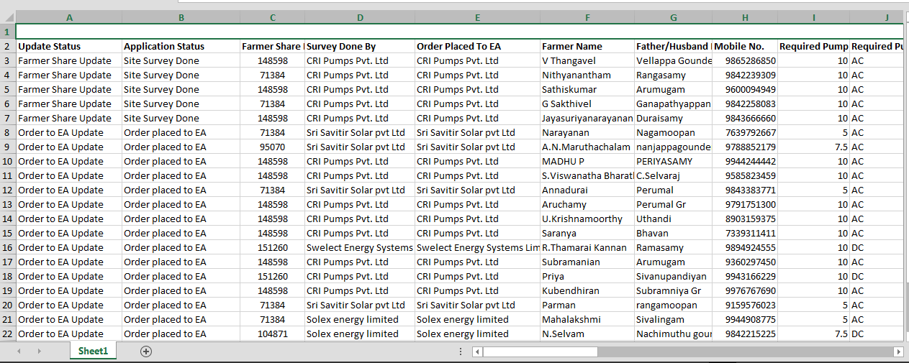
Figure 106 Details dashboard Excel file (i)

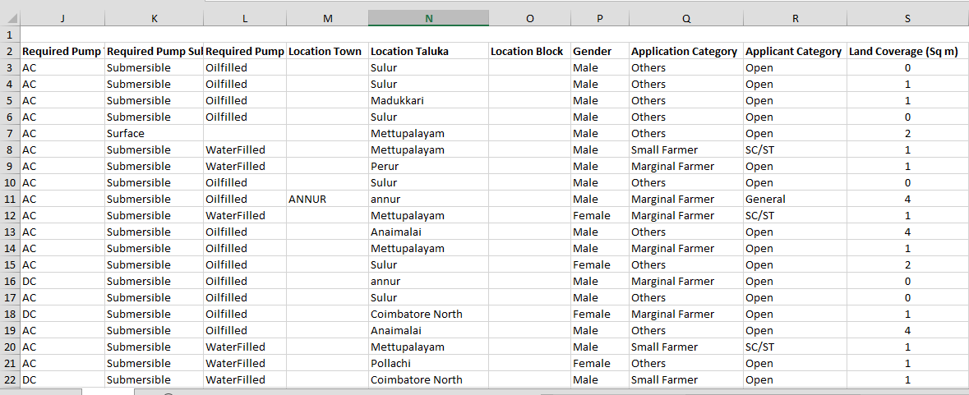
Figure 107 Details dashboard Excel file (ii)

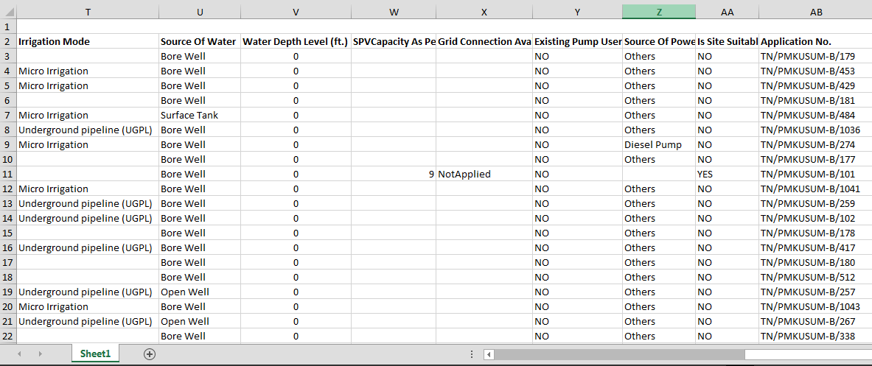
Figure 108 Details dashboard Excel file (iii)

- PDF file output - as shown in Figure 109
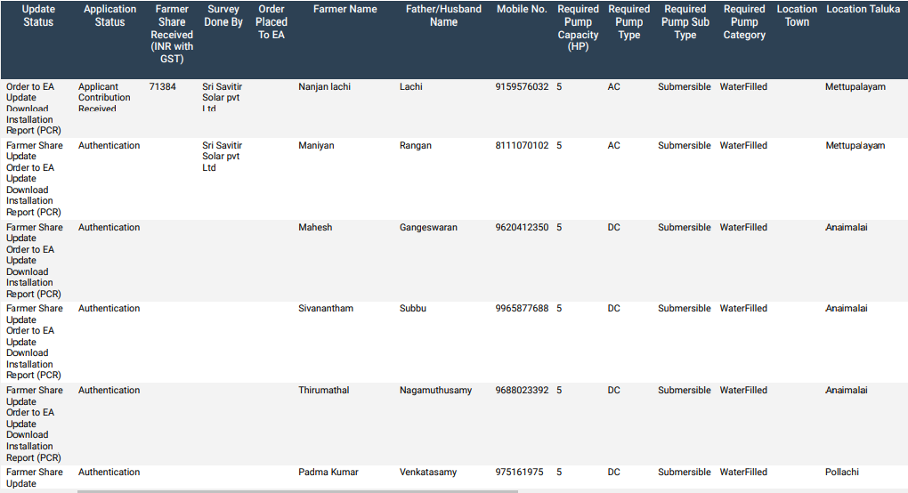
Figure 109 Details dashboard PDF

- The users can choose to see only the relevant information as required by them by selecting the necessary columns under the ‘Show/Hide’ columns. (highlighted in sky blue in Figure 98)
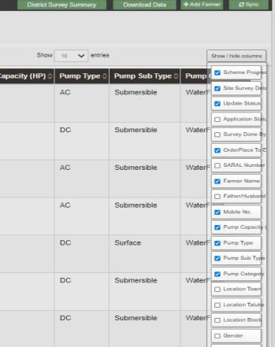
Figure 110 Show / Hide columns filter

- In Figure 98, by clicking onto the orange highlighted icon first column of Consumer Details dashboard, the user can view the chronological data for scheme progress details of any individual farmer. (as shown in below Figure 111)
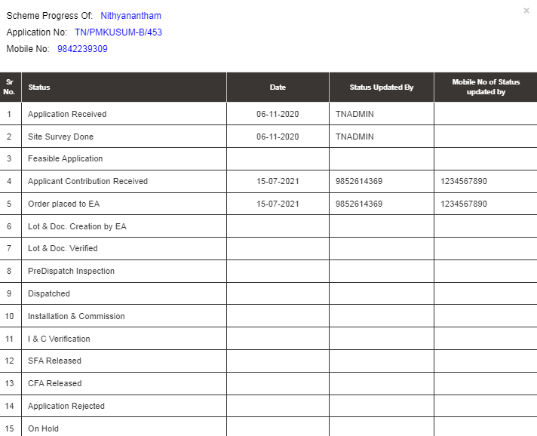
Figure 111 Scheme Progress report for Consumer/Farmer

- Similarly, by clicking on the icon (highlighted in purple in Figure 98) in the second column, the user can view the site survey details of the consumer/farmer as well as take action against individual farmer’s application and also can upload Site Photographs and Farmer Consent Form.
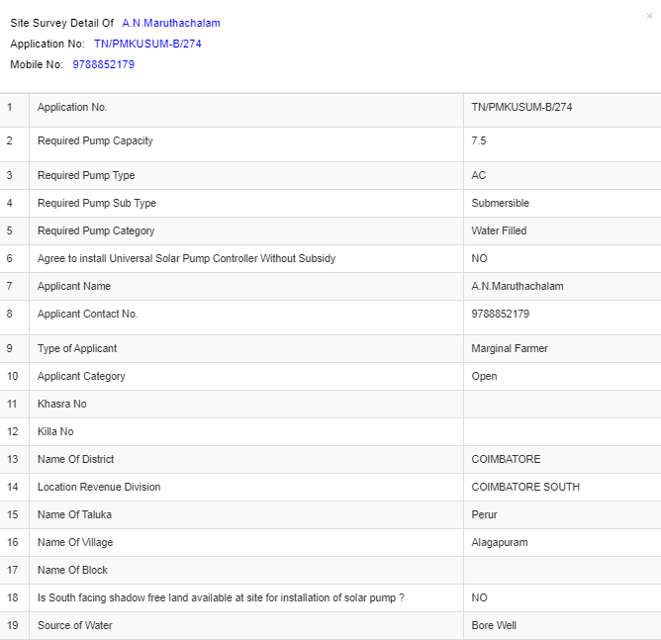
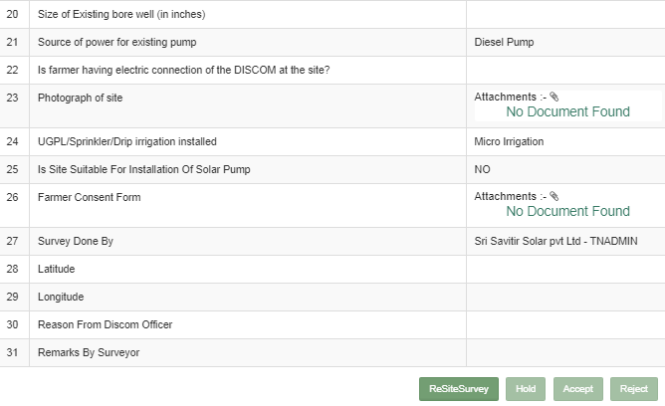
Figure 112 Site Survey Detail of Consumer/Farmer

  - At the end of the report form, user can see 4 button options (in above Figure 112) – ReSiteSurvey, Hold, Accept, and Reject. These buttons are solely under the authorisation of District Officer or District Office.
The SIA user can give the application to the corresponding Empanelled Agency for ResiteSurvey or Accept the farmer application or Reject the farmer application or put the application on hold after reviewing all the documents and photos submitted by the farmer and EA. (click here to know more)

FEASIBLE APPLICATION

- Below are the authorized users for Feasible Application :
- State Implementing Agency (SIA)
- Sub Division Officer (SDN)
- Head Officer (HO)

- Navigation Steps to change application status “Feasible Application” :-
- Sign in on the State SEDM Portal
- Click on the “Details” on Consumer Module as shown in below Figure 113
Figure 113 Details
- After Aadhaar Authentication, to update the scheme progress, authorized user can change the status “Feasible Application”.
- In Details dashboard as shown in below figure, Consumer/Farmer details are displayed along with the blue buttons of Status in third column. (highlighted in red in below Figure 114)
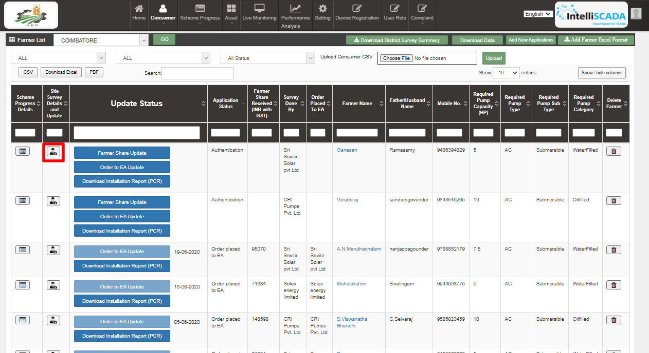
Figure 114 Details Dashboard
- User has to click on the user icon (highlighted in red in above Figure 114).
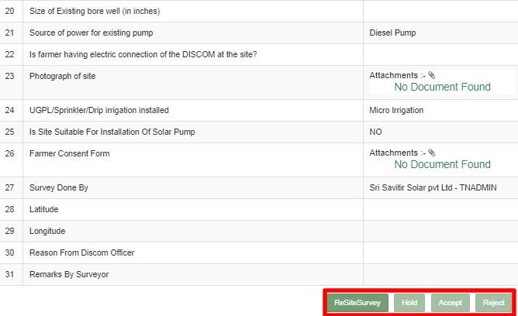
Figure 115 Site Survey Details
- The above report form is generated under the Site Survey details tab of the Consumer/Farmer details.
- The authorized user will Site Resurvey / Accept / Reject / Hold the application according to the site survey details.
- To change the application status to “Feasible Application”, user has to click on the “Accept” button. (pointed in the below Figure 116)
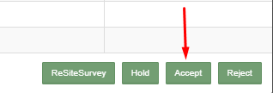

Figure 116 Application Accept button

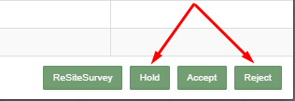
Figure 117 Application Hold-Reject Button
- To put application on hold or to reject the application, user has to click on the “Hold” or “Reject” button (pointed in red in above Figure 117) and have to give the reason for the same.
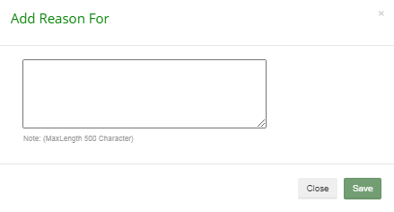
Figure 118 Reason for Application Hold/Reject

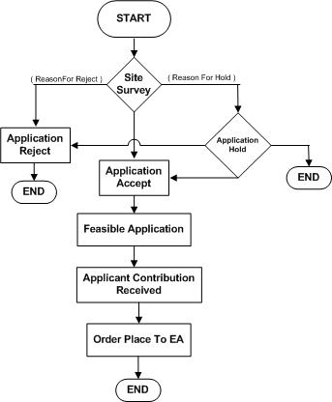

Figure 119 Farmer Application Flow Chart

FARMER SHARE RECEIVED

- Below are the authorized users for Farmer Share Received :
- State Implementing Agency (SIA)
  - Sub Division Officer (SDN)
  - Head Officer (HO)
- Navigation Steps to change application status Farmer Share Received :-
- Sign in on the State SEDM Portal
- Click on the “Details” on Consumer Module as shown in below figure

Figure 120 Details

- After the application is accepted/feasible, SIA users has to change the status “Farmer Share Received”.
- In Details dashboard as shown in below figure, Consumer/Farmer details are displayed along with the blue buttons of Status in third column. (highlighted in red in below Figure 121)
- 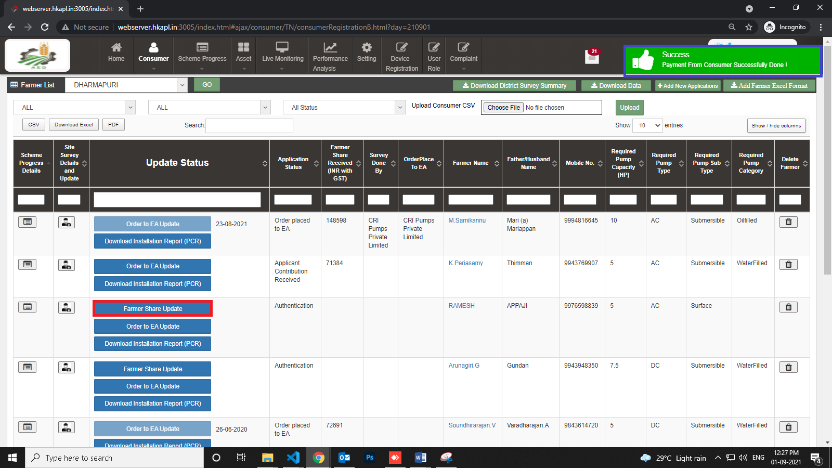

Figure 121 Updated Farmer Share Received

- User has to click on “Farmer Share Update” button (highlighted in red in Figure 121) to change the Consumer/Farmer application status to “Farmer Share Received”.
- When the button “Farmer Share Update” is clicked, a success message will arrive i.e. “Payment from Consumer Successfully Done!” (highlighted in blue in Figure 121)

NOTE: To update status “Farmer Share Received” in bulk i.e. of multiple consumers/farmers at once, click here to know more.

ORDER PLACED TO EMPANELLED AGENCY (EA)

- Below are the authorized users for Order Placed to EA :
- State Implementing Agency (SIA)
  - Sub Division Officer (SDN)
  - Head Officer (HO)
- Navigation Steps to change application status Order Placed to EA :-
- Sign in on the State SEDM Portal
- Click on the “Details” on Consumer Module as shown in below Figure 122 Details
Figure 122 Details
- After Farmer Share Received, authorized users has to change the status “Order Placed to EA”.
- In Details dashboard as shown in below figure, Consumer/Farmer details are displayed along with the blue buttons of Status in third column. (highlighted in red in below figure 100)
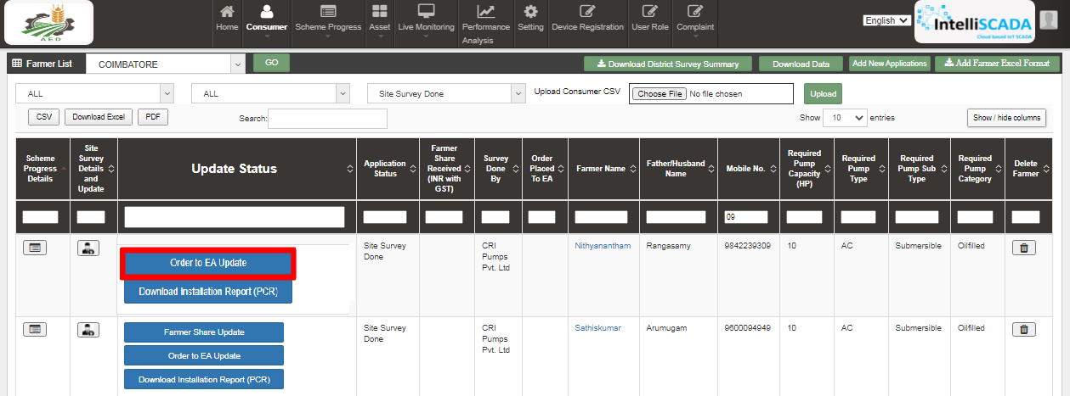
Figure 123 Details Dashboard
- User has to click on “Order to EA Update” button (highlighted in red in above Figure 123) to change the Consumer/Farmer application status to “Order Placed to EA”.
- When the user will click on the “Order Placed to EA” button, a small window will open for assigning Empanelled Agency (EA) to the particular Consumer/Farmer. (as shown in below Figure 124)
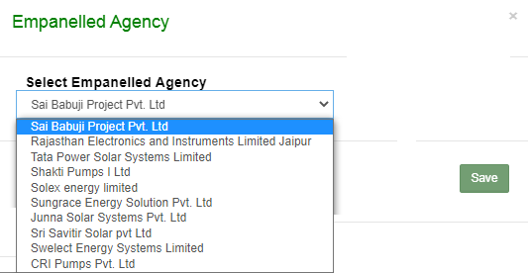
Figure 124 Assign EA to the Consumer/Farmer.
- Selected Empanelled Agency can see those consumers/farmers which are assigned only to them only and not the one that are assigned to other Empanelled Agencies.
- Selected Empanelled Agency can change the further status of the consumers/farmers that are assigned only to them.
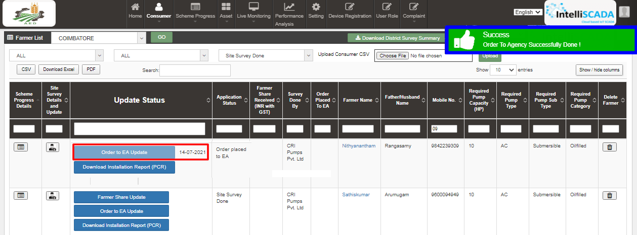
Figure 125 Updated Order Place to EA

- When the button “Order to EA Update” is clicked, a success message will arrive i.e. “Order To Agency Successfully Done !” (highlighted in blue in Figure 125 and a date (on which the button “Order to EA Update” is clicked and Empanelled Agency is assigned) will appear just beside the “Order to EA Update” button (highlighted in red in above Figure 125) which means that status “Order Place to EA” is updated.

NOTE: To update status “Order Placed to EA” in bulk i.e. of multiple consumers/farmers at once, click here to know more.

ASSET TEST REPORT CREATION BY EA

- Empanelled Agency (EA) is the authorized user for creation of Asset Test Report.
- Before Asset Test Report creation, Organization admin of Empanelled Agency has to add the “Asset Model Numbers”, its “Manufacturer” details and “SubLocation of Under Inspection Store” in master settings.(click on the blue highlighted underlined link to know how to add these details)
- These details will be added in Asset Test Reports which further will be added while Lot Creation. (click here to know more)
- Creation of Asset Test Reports serves the purpose that Empanelled Agency can supply assets i.e. Solar Pump, Solar Panel, Pump Controller and Structure, against these Test Reports only.

- Navigation Steps: -
1. Sign in on the State SEDM Portal
2. Click on the ‘Asset’ option on the Title Bar of the SEDM Portal Dashboard
3. Click on the ‘Test Report’ option from the drop-down menu
- Sign In >> Asset Management >> Test Report

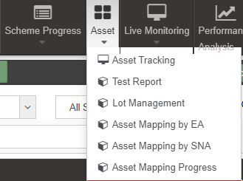
Figure 126 Test Report

- In this feature of Asset Management, a complete Test Report is generated for the users comprising Test Report Number, Empanelled Agency, Test Report Agency, Report Issue Date, Description and Test Report Documents.

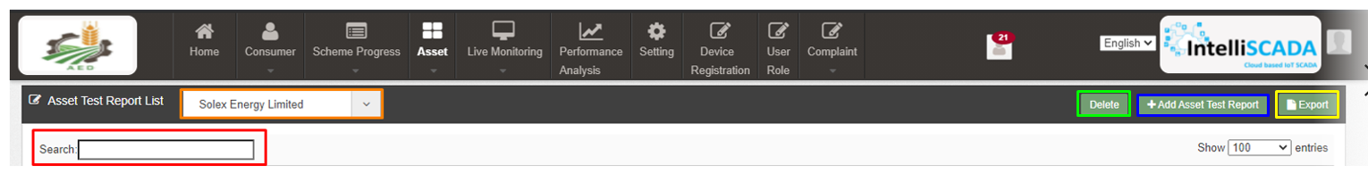

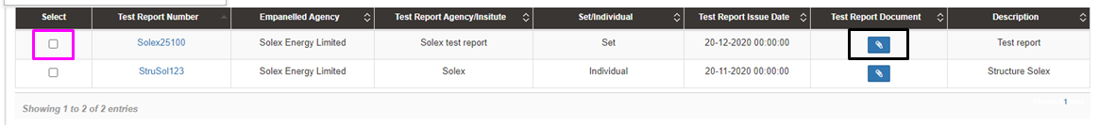
Figure 127 Asset Test Report

Table 45 ASSET TEST REPORT DASHBOARD DESCRIPTION
Action | Functionality | Highlighted Colour | Type | Description
Empaneled Agency | Empanelled Agency Selection | Orange | Drop Down | By selecting an Empanelled Agency, user can Test Reports of selected Empanelled Agency only
Search | Search Asset Test Report | Red | Text Box | Enter input to explore Asset Test Report details
Delete | Delete Asset Test Report | Green | Button | Select check box (highlighted in pink) and click on delete button to delete Asset test report details
Add Asset Test Report | Add new Asset Test Report | Blue | Button | Add new asset test report by clicking on Add Asset Test Report button
Export | Excel file of all uploaded Asset Test Report details | Yellow | Button | Download Excel file of all uploaded Asset Test Report details
Test Report Document | Download uploaded document of asset test report | Black | Icon Button | Download uploaded asset test report document by clicking on the blue pin icon.

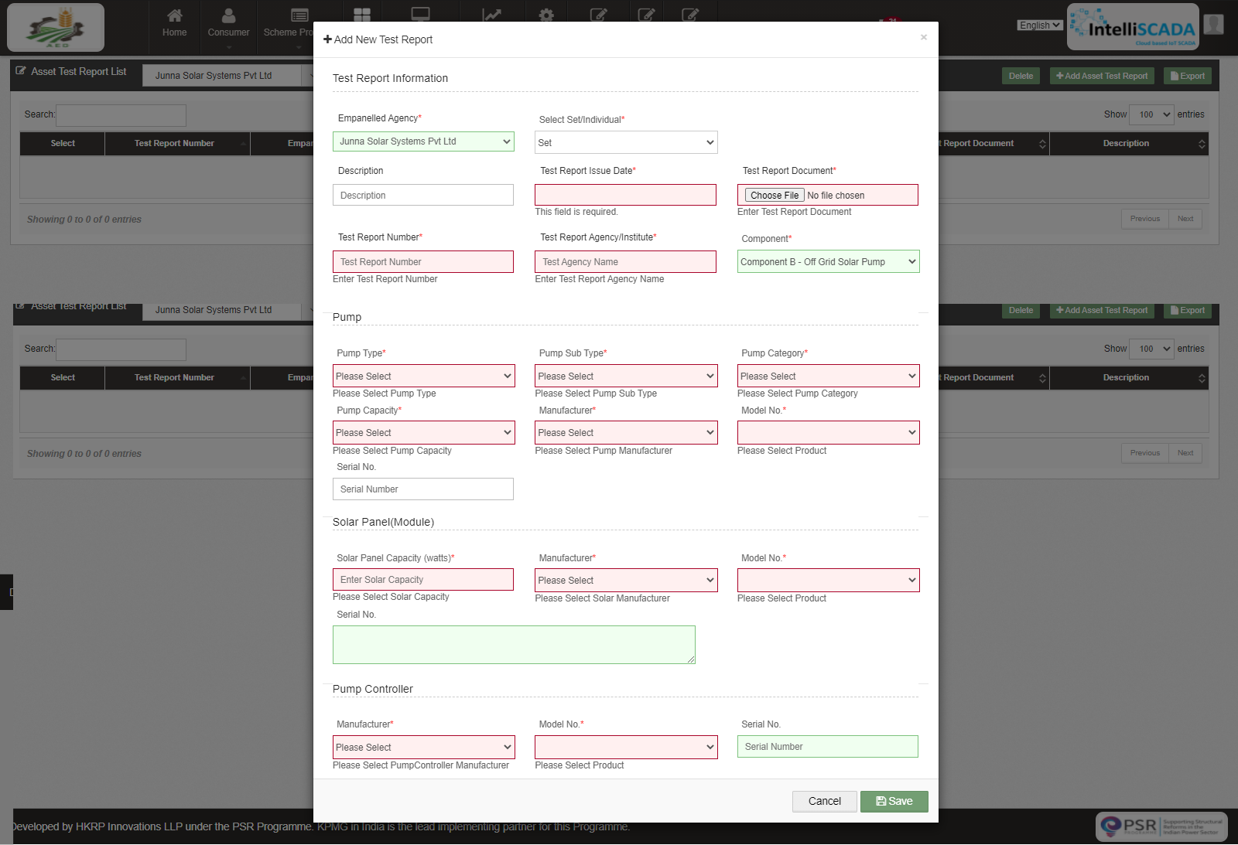
Figure 128 Add Asset Test Report

Table 46 ASSET TEST REPORT FIELD DESCRIPTION
Field | Input | Drop Down & Check Box Options | Mandatory Field | Sample Value | Description
Empanelled Agency | Drop Down | - Sai Babuji Project Pvt. Ltd.  - Sri Savitir Solar Pvt. Ltd.CRI Pumps Pvt. Ltd.  - Shakti Pumps Ltd. |  | Sri Savitir Solar Pvt. Ltd. | Selection of relevant Empanelled Agency
Test Report Number | Text | - |  | MRTCTP09320200111 | Selection of no of Test Report
Test Report Agency | Text | - |  | MAXOP RESEARCH & TESTING INSTITUTE PVT LTD. | Agency name of test report
Description | Text | - | - | PV WATER PUMPING SYSTEM | -
Test Report Issue Date | Date | - |  | 02/12/2020 | -
Test Report Document  (max size 5 MB) | File Upload | - |  | Report.pdf  (size 4.50 MB) | -
Select Set/Individual | Drop Down | - Set  - Individual |  | Set | Selection of either Set report (includes all 3 assets i.e. Pump, Solar Pump & Pump Controller) or Individual (Selection of only 1 asset either Pump or Solar Pump or Pump Controller or Structure)
Select Asset Type | Drop Down | - Pump  - Solar Panel  - Pump Controller with RMS  - Structure |  | Pump | If Individual is selected instead of Set from above Drop Down, Selection of any one asset to create an individual Asset Test Report
Component | Drop Down | - Distributed Solar PV  - Off Grid Solar Pump  - Grid Connected Solar Pump |  | Off Grid Solar Pump | Selection of relevant Component from all three components
Pump
Pump Type | Drop Down | - AC  - DC |  | AC | Selection of relevant Pump Type
Pump Sub Type | Drop Down | - Submersible  - Surface |  | Submersible | Selection of relevant Pump Sub Type
Pump Category | Drop Down | - Water Filled  - Oil Filled |  | Water Filled | Selection of relevant Pump Category
Pump Capacity | Drop Down | - 1 hp  - 2 hp  - 3 hp  - 5 hp  - 7.5 hp  - 10 hp |  | 5 hp | Selection of relevant Pump Category
Manufacturer | Drop Down | - M/s. Suguna Industries  - M/s. Mecwin Technologies Pvt. Ltd. |  | M/s Sugna Industries | Selection of relevant Pump Manufacturer
Model no. | Drop Down | - SSAC SRF 5/24  - SSAC SRF 7.5  - SSDC SRF 7.5/13 |  | SSAC SRF 5/24 | Selection of relevant Pump Model No.
Serial no. | Text | - | - | - | -
Solar Panel
Solar Panel Capacity (watts) | Numerical | - |  | 320 | -
Manufacturer | Drop Down | - M/s. Sri Savitri Solar Pvt. Ltd.  - M/s Suguna Industries  - Oswal Pumps  - Premier Solar Pump |  | M/s Sri Savitr Solar Pvt | Selection of relevant Solar Panel Manufacturer
Model no. | Drop Down | - SSSPL-302  - SSSPL-310 |  | SSSPL-302 | Selection of relevant Solar Panel Model No.
Serial no. | Text | - | - | - | -
Pump Controller
Manufacturer | Drop Down | - M/s. Sri Savitri Solar Pvt. Ltd.  - M/s Suguna Industries  - Oswal Pumps  - Premier Solar Pump |  | M/s Suguna Industries | Selection of relevant Pump Controller Manufacturer
Model no. | Drop Down | - SSAC 05  - SSAC 7.5  - SSDC 7.5 |  | SSAC 05 | Selection of relevant Pump Controller Model No.
Serial no. | Text | - | - | - | -

- Report can be created in two ways i.e. either a set report (includes all three assets details i.e. Solar Pump, Solar Panel and Pump Controller) or an individual asset report (includes either of 4 assets details i.e. either Solar Pump report or Solar Panel report or Pump Controller report or Structure report)

- Creation of a Set Report
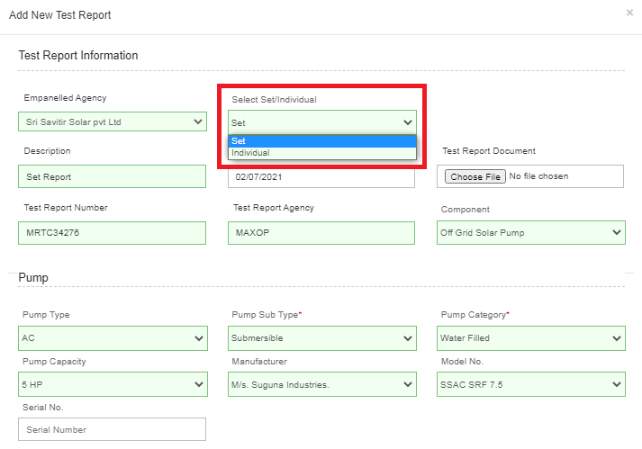
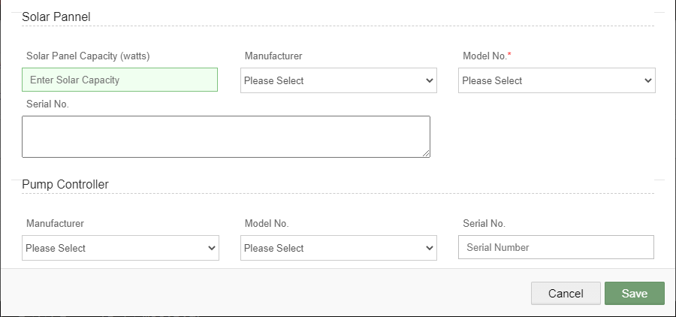
Figure 129 Set Report
- By selecting “Set” in Select Set/Individual dropdown (highlighted in red in above Figure 129), user can create a set report that includes all three assets details i.e. Solar Pump, Solar Panel and Pump Controller.

- Creation of an Individual Report

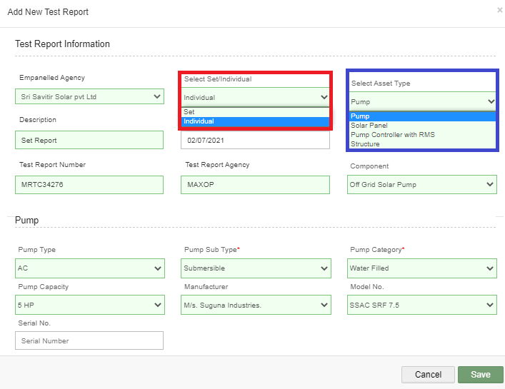
Figure 130 Individual Report

- By selecting “Individual” option in Select Set/Individual dropdown (highlighted in red in above Figure 130), user can create an individual report of either of four assets i.e. report of either Solar Pump or Solar Panel or Pump Controller or Structure. (selection of asset type shown in above Figure 130, highlighted in blue)

NOTE: The report of ‘Structure’ will not be a part of set so it can be created only by selecting “Individual” option in Select Set/Individual dropdown.

LOT CREATION & UPDATING PDI STATUS

- Empanelled Agency (EA) is the authorized user for creation of Lot & Document.
- Lot creation serves the purpose of adding asset details like Manufacturer details, Asset Model nos. and Asset Serial nos. which further will be utilized for Asset Serial no. Mapping with the consumers/farmers.

- Navigation Steps: -
1. Sign in on the State SEDM Portal
2. Click on the ‘Asset’ option on the Title Bar of the SEDM Portal Dashboard

- Sign In >> Asset >> Lot Management
Figure 131 Lot Management Option
- Below are the brief points covered under this module:
- Template Generation: Register a tender and generate specification Checklist template against individual items
- Asset Registration: Empanelled Agencies can register bulk assets against a lot prepared for PDI (Pre-Dispatch Inspections)
- Multiple Asset Type Configurations: A virtual inventory management of multiple asset type such as Solar Assets, Pump Assets, Metering Assets, Remote Monitoring and Data Acquisition System
- Asset Lot Management: To create consignment lot of multiple assets with serial numbers for Pre-Dispatch Inspection and Check List submission
- Asset Check List: Empanelled Agencies can fill up check list against template requirements with required documents to speed up PDI such as Ratings, Specifications, Type Tests, Certificates
- Consumer/Farmer Asset Registration Mapping: Mapping of asset details provided to each customer with the standard inventory, which can be later utilized to address service.
- Make, Model No, Serial No, Manufacturing Date
- The Lot Management feature of Asset Management module offers users a useful functionality of bulk mapping the asset tracking reports, view the Consumer/Farmer details, check the quantitative statistics, and manage documents for multiple Consumers/farmers all at once.

LOT CREATION

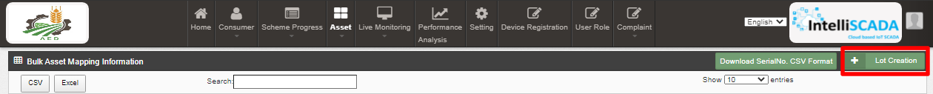
Figure 132 Lot Creation Button

- On the Lot Management Dashboard, the users can create new Lot by clicking onto the ‘Lot Creation’ button present on the top right corner (highlighted in red in above Figure 132). After clicking onto the button, a window screen appears (shown in Figure 133) in which user must enter all the details and attach the required documents for necessary verification process.

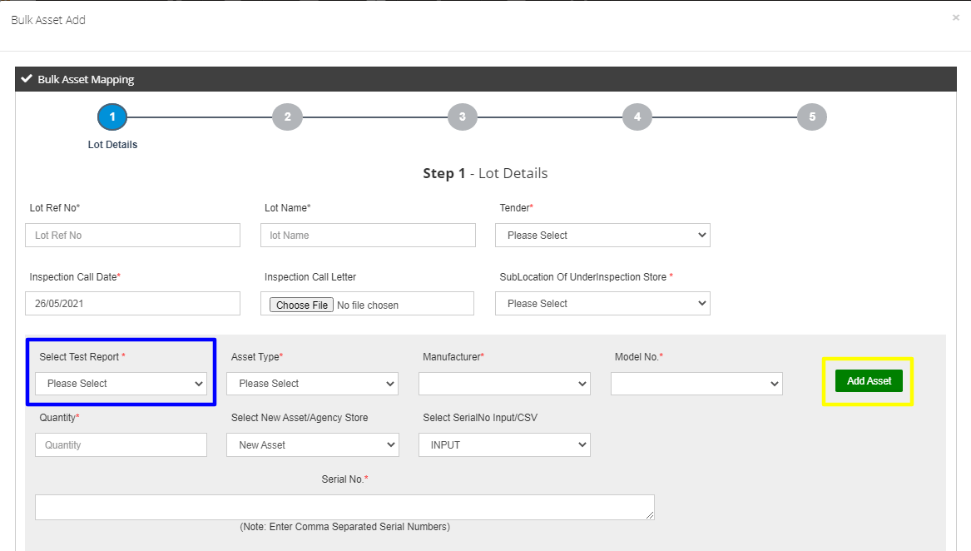
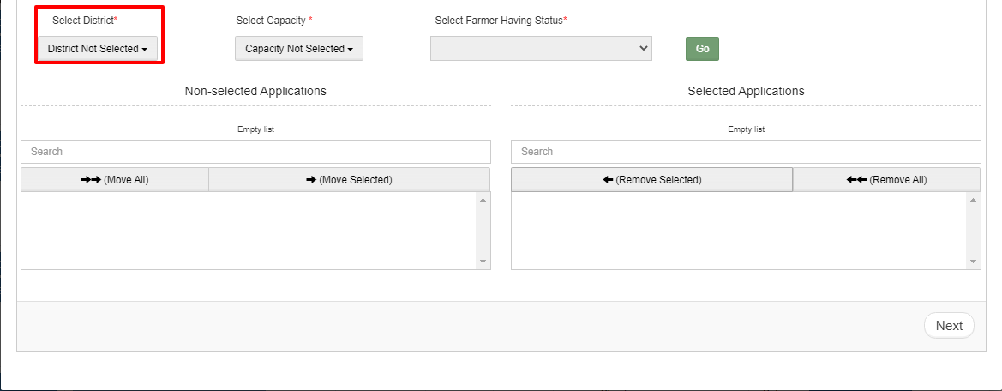
Figure 133 Lot Form

Table 47 LOT FIELD DESCRIPTION
Field | Input | Drop Down & Check Box Options | Mandatory Field | Sample Values | Description
Lot Ref No. | Text | - |  | 1 | -
Lot Name | Text | - |  | LOT 1 | -
Tender | Drop Down | - Off Grid Solar Pump  - Off Grid Solar Pump of 10 HP |  | Off Grid Solar Pump | Selection of relevant Tender
Inspection Call Date | Date | - |  | 26/05/2021 | -
Inspection Call Letter | File Upload Control | - | - | PDI1.pdf | -
Sub Location of Under Inspection Store | Drop Down | - Chennai, Tamil Nadu  - Erode, Tamil nadu  - Coimbatore, Tamil Nadu  - Dindigul, Tamil Nadu |  | Chennai, Tamil Nadu | Selection of Under Inspection Store where assets are inspected.  To register Sub Location of Under Inspection Store, click EA Store Under Inspection
Select Test Report | Drop Down | - MRTCTP09320200111  - MRTCTP09320200111-Structure  - MRTCTP09320200111-INDV Controller  - MRTCTP09320200111 Individual  - MRTCTP09320200111-Controller  - MRTCTP09320200111-Solar Panel  - MRTCTP09320200111-Struct |  | MRTCTP09320200111 | Selection of relevant Asset Test Report
Asset Type | Autofill | - |  | Pump | Auto-filled based on Test Report Selection
Manufacturer | Autofill | - |  | Alectrona | Auto-filled based on Test Report Selection
Model No. | Autofill | - |  | DC1HP | Auto-filled based on Test Report Selection
Quantity | Numerical | - |  | 2 | No of Assets offered for lot creation
Select New Asset/Agency Store | Drop Down | - New Asset  - Agency Store | - | New Asset | If asset is new then “New Asset” should be selected, if asset is need to be replaced from the Agency Store then “Agency Store” should be selected.
Select Serial No Input/CSV | Drop Down | - INPUT  - CSV |  | Input | If uploading Serial no. will be done manually in the Serial No. field then “Input” option should be selected.  If uploading Asset Serial No. via CSV file then “CSV” should be selected against selected Asset Type
Upload Serial No. CSV | File Upload | - |  | Asset Serial No..csv | -
Serial No. | Numerical | - |  | SRNO1, SRNO2 | Ensure Unique Serial nos are provided against each Asset Type, Model & Manufacturer
Add Asset | Button | - |  | - | Click here to add new Asset Type to be included in Lot
Select District | Drop Down | - ARIYALUR  - UDAYARPALAYAM  - TAMBARAM  - CENTRAL CHENNAI  - SOUTH CHENNAI  - NORTH CHENNAI  - CHENNAI  - COIMBATORE  - CUDDALORE  - ERODE  - DINDIGUL |  | CHENNAI | Selection of relevant District from where the Consumers/farmers belong to for filtering purpose
Select Capacity | Drop Down | - AC-5HP,Surface Pumps  - AC-7.5HP,Surface Pumps  - AC-10HP,Surface Pumps  - DC-5HP,Surface Pumps |  | AC-5, Surface Pumps | Selection of the relevant capacity for filtering purpose
Select Farmer Having Status | Autofill | - |  | Order Placed to EA | Only list of farmers whose order has been placed and has not be included previously in any lot creation and farmers whose order has been placed to logged in EA will be available for selection, No of farmers to be selected cannot be greater than no of Pump Assets.

Serial Nos. can be entered in two ways: Manually or by Uploading a CSV File.

- Entering Serial Nos. Manually

- For entering asset serial nos. manually, EA user has to select “Input” in “Select Serial No. Input/CSV” dropdown as shown in below Figure 134 :

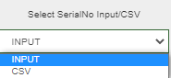
Figure 134 Select Input/CSV Dropdown

- After selecting “Input” EA user has to enter comma separated Serial nos.in “Serial No.” field as shown in below Figure 135:
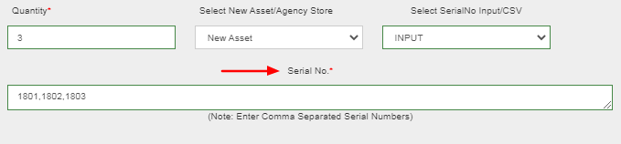
Figure 135 Entering Comma Separated Asset Serial Nos.

Uniqueness of Serial numbers is verified and validated considering Asset Type, Manufacturer and Model No
- Entering Serial Nos. via Uploading CSV.

- Before Creation of Lot, EA user has to create CSV files of Asset serial numbers and Application numbers of Consumers/Farmers.
- When the quantity of an asset is huge then EA user can upload the CSV file that carries Asset Serial Nos. instead of entering Asset Serial nos. manually.
- EA user can download Asset Serial No. CSV format by clicking on “Serial No. CSV format” button (highlighted in red in below Figure 136) in Lot Management dashboard.

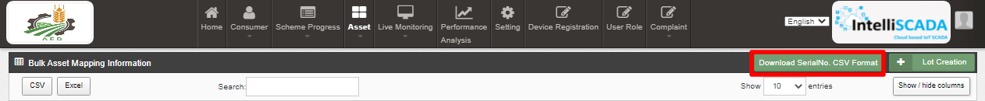
Figure 136 Serial No. CSV Format Button

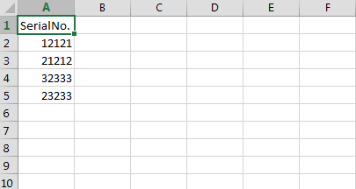
Figure 137 Serial No CSV File
- Above shown Figure 137 is a CSV file format for uploading Asset Serial numbers in huge quantity where the heading in the 1st Row of the CSV file should remain as it is then EA user has to delete the demo serial nos shown in the above Figure 137 from the 2nd Row and has to enter their own asset serial number.

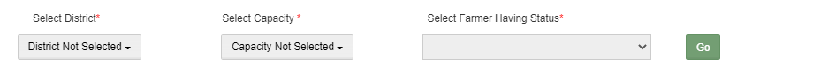

Figure 138 Filters to Fetch Out Consumer/Farmer’s Application Numbers

- In the above Figure 138, represented three filter options:
  - Select District dropdown where users can select multiple district entries corresponding to a Farmer.
  - Select Capacity, by using this filter users can filter the results for desired asset capacity. By clicking on the ‘Go’ button, all the farmers get categorised under 2 groups – Selected & Non-selected Applications.
  - Select Farmer Having Status, this filter is by default selected to Order Placed to EA in order to bring out the list of consumers/farmers whose status is Order Placed to EA.

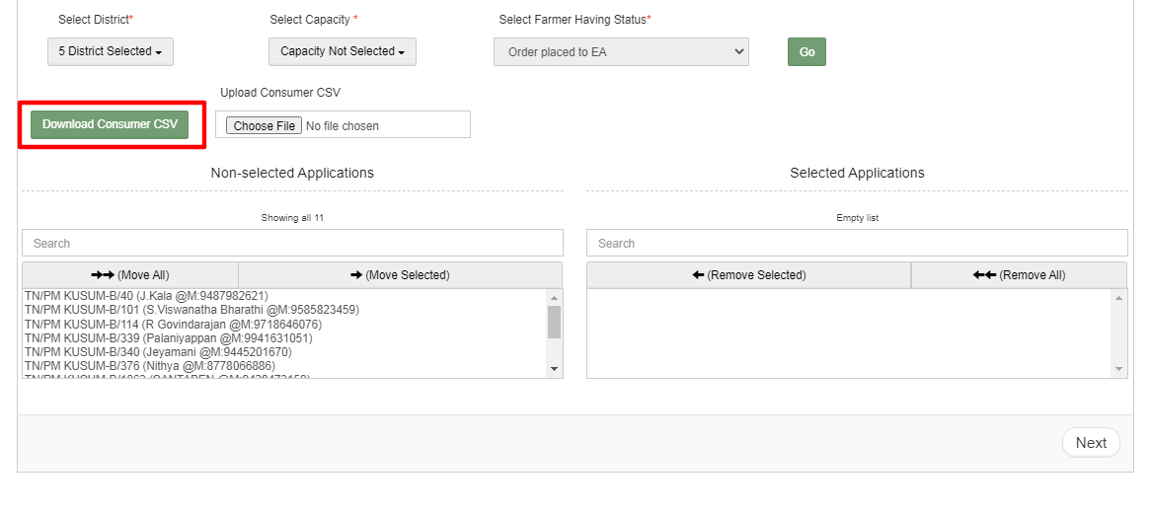
Figure 139 Add Asset box

- After the filtered results are displayed, the users can click on the ‘Download Consumer/Farmer CSV’ button to download the CSV file in which they can know the format of how to enter the farmer’s Application numbers.
- The Authorised User can move farmers from Non-selected application to Selected applications, by either manually selecting each individual entry or by uploading the Consumer/Farmer CSV file, by entering the Application numbers of required farmers in CSV file, which then after being successfully uploaded will automatically move those farmers (whose application numbers are presented in CSV file) from Non-selected Applications column to Selected Applications column.
- All the entered application numbers of farmers in CSV file will be validated if their order has been placed to signed in EA.

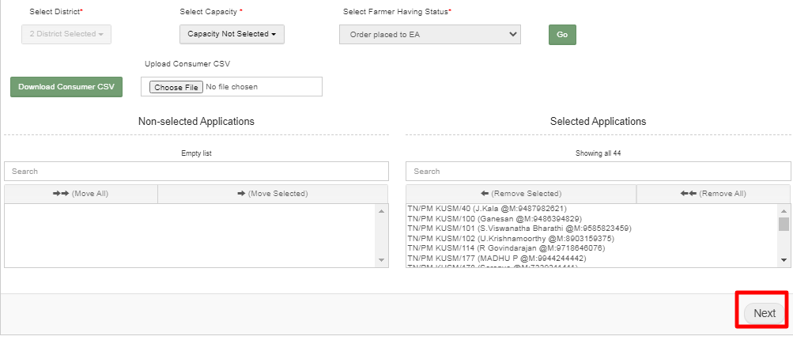
Figure 140 Next Button
- After moving the necessary consumers/farmers to Selected Applications, user has to click on the next button in the bottom right corner in the lot form as shown in the above Figure 140.
- When the user will click on the “Next” button, window of assets checklist will occur as shown in below Figure 141.
- These checklists are configured by SIA from setting tab.

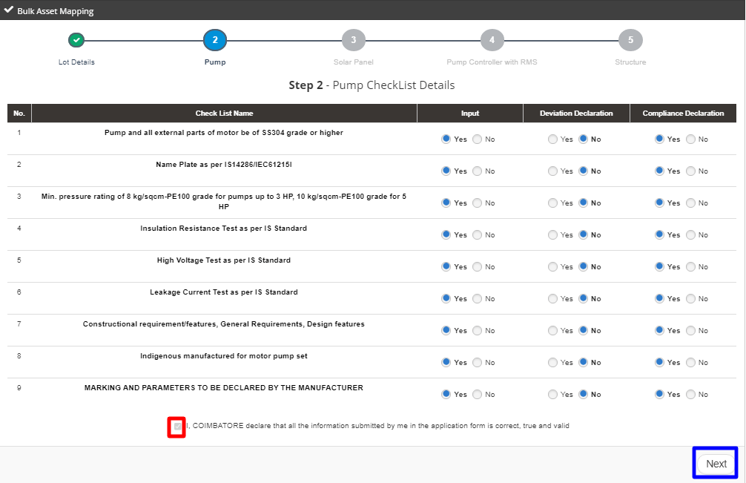
Figure 141 Pump Checklist

- In the Pump Checklist window, user has to verify the checklists and click on the Check Box (highlighted in red in above Figure 141) and click on the “Next” button. (highlighted in blue in above Figure 141)
- After clicking on the “Next” button, next asset checklist window will appear as shown in below Figure 142, Figure 143 and Figure 144 .

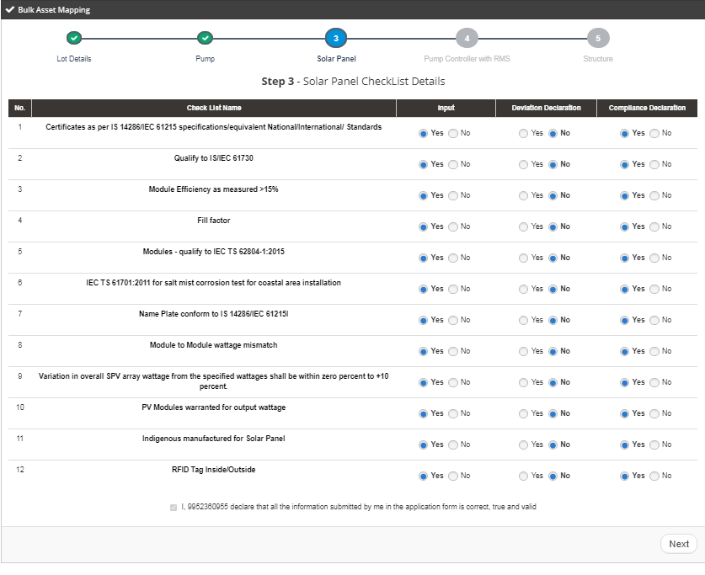
Figure 142 Solar Panel Checklist
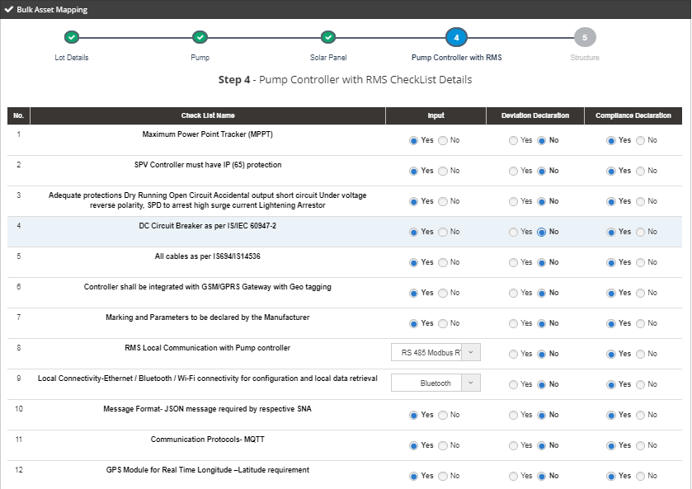
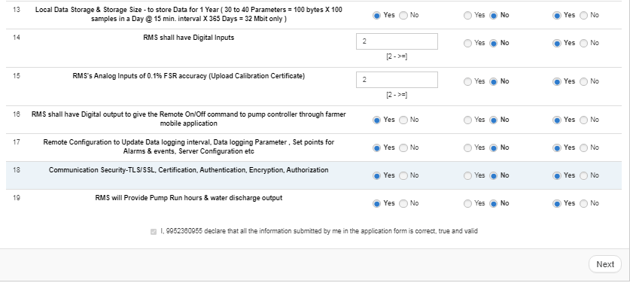
Figure 143 Pump Controller Checklist
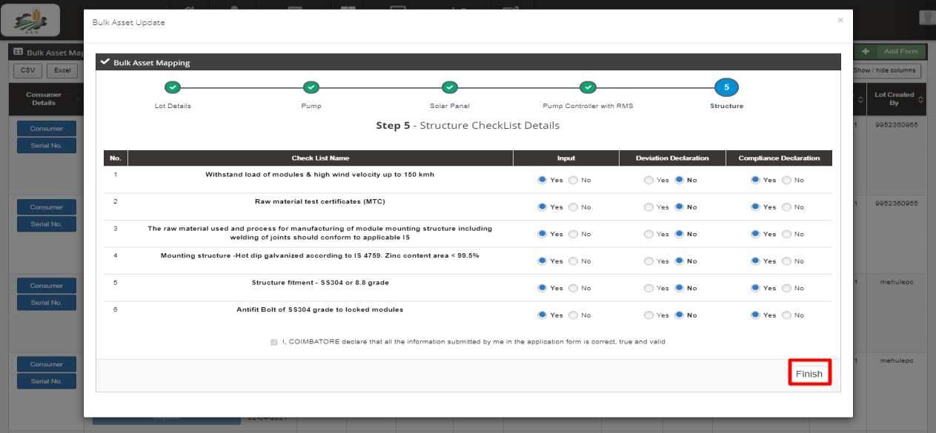
Figure 144 Structure Checklist
- After verifying checklist of all assets, EA user has to click on the “Finish” button (highlighted in red in above Figure 144) and lot will be created after finishing the checklist verification.

UPDATING PDI STATUS

- After creating the lot, EA user has to click the first button “Checklist & Doc. Submitted by EA” (as pointed in below Figure 145) to change the PDI status of all selected consumers/farmers.

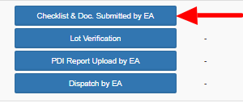
Figure 145 Checklist & Document Submit Button

Add reference scheme progress in consumer details,
- When the EA user will click on “Checklist & Doc. Submitted by EA” button, four different status i.e.1. Checklist & Document Submit, 2. Lot Verification, 3. Pre Dispatch Inspection and 4. Dispatch, will updated all together at once and a current date will appear just beside all four buttons (highlighted in red in Figure 146), that means “Checklist & Doc. Submitted by EA” button is clicked and all four status are updated of all the consumers/farmers presented in that lot.

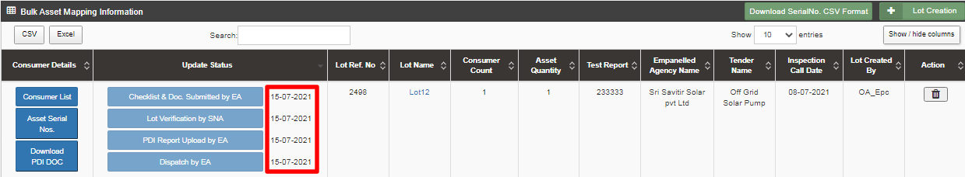
Figure 146 Status Updated

INSTALLATION AND COMMISSION (I&C) DONE

- Empanelled Agency (EA) is the authorized user for changing status “Installation & Commission (I&C)”.
- After updating the Lot status, EA user has to change the status “Installation & Commission” of individual Consumers/Farmers whose current status is “Dispatch”.
- Updating status “Installation & Commission done” signifies Installation & Commission data. In here, the date on which the foundation was laid on the site, structure was installed, required tools and components were set up and the final commission along with working of installed components was done is updated for the SIA to review.
- To change the status of Consumers/Farmers to “Installation & Commission”, EA user has to complete the following 3 stages:
- Asset Serial No. Mapping : Serial nos of assets deployed in field are mapped against farmer
- IMEI No. Mapping
- Update the stages of “Foundation”, “Structure”, “PV System & Controller/Inverter” and “Installation & Commission Done (RMS Connected)”. While updating these stages site photograph is also captured.
- The above stages are explained in upcoming sections.

19.1 ASSET SERIAL NO. AND IMEI NUMBER MAPPING

- Empanelled Agency is an authorized user to perform the mapping functionalities.
- The asset serial nos. that previously added in Lot can only be mapped to the consumer/farmer.

- Navigation Steps: -
1. Sign in on the State SEDM Portal
2. Click on the ‘Asset’ option on the Title Bar of the SEDM Portal Dashboard
3. Click on the ‘Asset Mapping by EA’ option from the drop-down menu
- Sign In >> Asset >> Asset Mapping by EA
Figure 147 Asset Mapping By EA Option

- EA user can map asset serial nos. with the farmers in bulk by just uploading a CSV file in “Asset Mapping by EA”.

Figure 148 Asset Mapping in Bulk

- EA user can download “.xlxs” file format by clicking on “Bulk Asset and IMEI Mapping Format” button (highlighted in yellow in above Figure 148) for creating csv file to map assets with farmers in bulk.
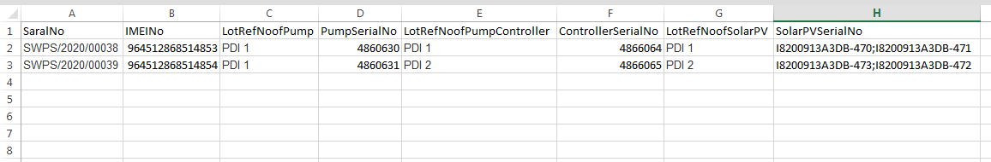
Figure 149 Asset Mapping Format
- The above Figure 149 is an Excel file of Asset Mapping in Bulk format in which user has to delete the two dummy entries of asset mapping and has to enter their own data from the “2nd Row”.
NOTE : 1st Row of above excel file should not be edited or deleted as it is the actual format of the file otherwise bulk asset mapping csv file would not get uploaded. Serial nos. of solar panel should be separated by semi colon “ ; ”. IMEI nos. should be 15 digits, no more or less.
NOTE : To know more about Bulk Asset & IMEI mapping, refer Troubleshooting Guide of Asset & IMEI mapping in bulk.

- After filling the data into the file, user has to save the file as “.csv ” as shown in below Figure 150.
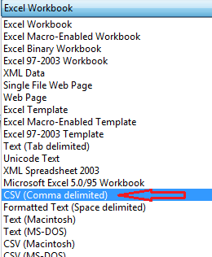
Figure 150 Save as CSV (Comma Delimited)
- After saving file as “.csv”, user has to upload that file in the choose file option. (highlighted in red in Figure 148)
- EA user can map asset serial nos. with the farmers individually also in “Asset Mapping by EA”.
- To search consumer/farmer for individual asset serial no or IMEI no mapping, user can search consumer/farmer by two ways i.e. either entering IMEI number (if mapped) or Application number (highlighted in yellow in below Figure 151), the corresponding details of the consumer/farmer gets displayed on the Asset Mapping by EA Dashboard or the another way is, by applying four filters i.e. District selection, Empanelled Agency selection, Capacity selection and Application Status selection (highlighted in pink in below Figure 151) to get the particular consumer/farmer details.
- Empanelled Agency can view only those consumers/farmers details whose Order is placed to them.

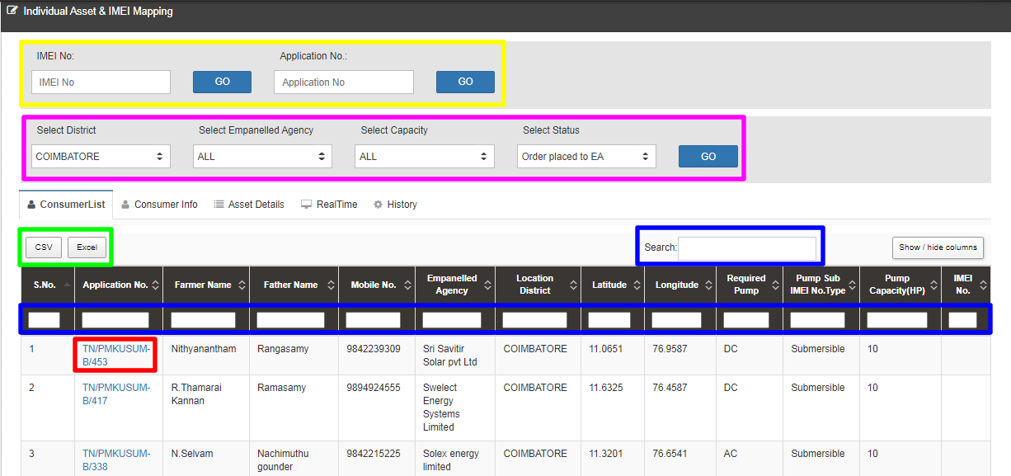

Figure 151 Asset Mapping by EA Dashboard

- User can download CSV or Excel file (highlighted in green in Figure 151) of the filtered farmer details for analysis.
- User also can search the particular farmer details by entering input in the search boxes. (highlighted in blue in Figure 151)
- By clicking on to the farmer’s Application no. (Highlighted in red in above Figure 151) user will be redirected to the Consumer Info tab as highlighted in red in below Figure 152.

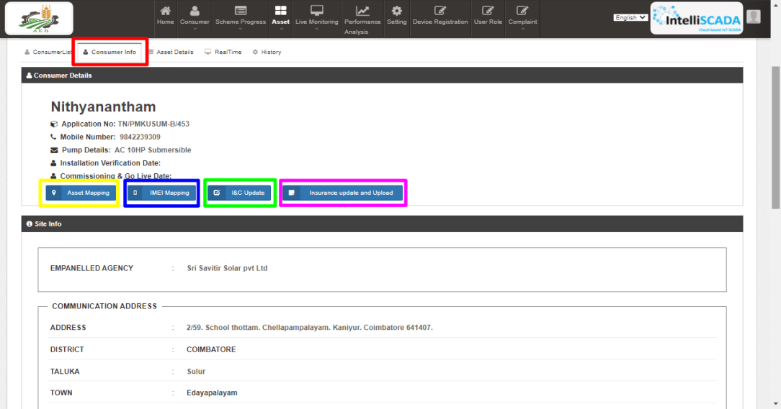
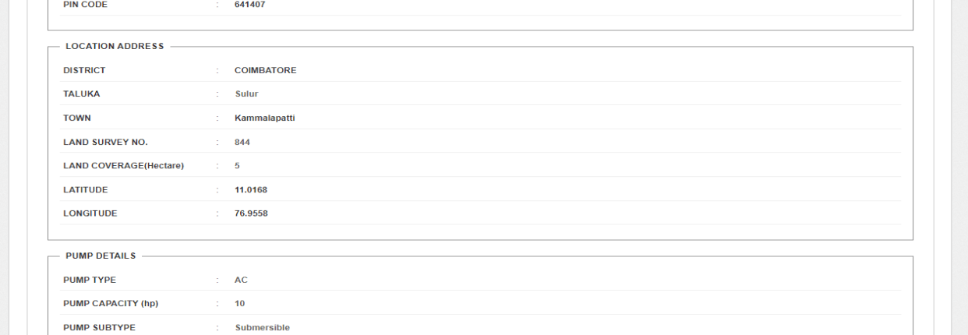
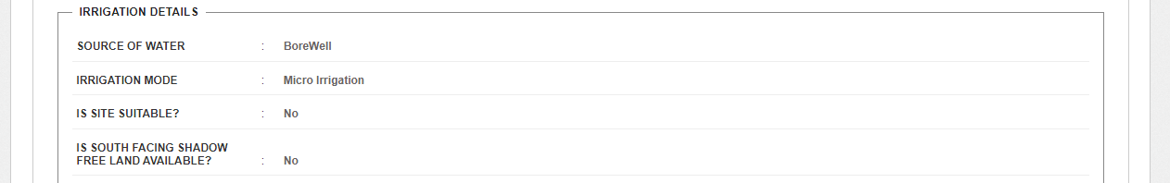
Figure 152 Consumer Info Tab
- In above Figure 152, the four sub features will function for the Asset Mapping, IMEI mapping, uploading I&C photos and uploading Insurance policy details.

- The first sub feature is “Individual Asset Mapping”. By clicking “Asset Mapping” button (highlighted in yellow in above Figure 152), user can map asset serial nos. individually with the farmer as shown in below Figure 153. Only Assets with relevant capacity and which has been dispatched against lot can only be mapped against farmer.
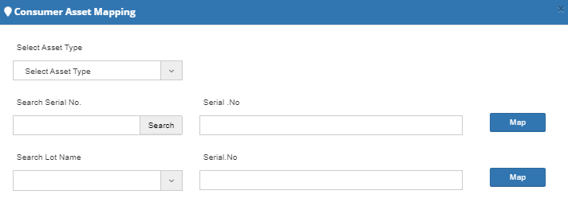
Figure 153 Individual Asset Mapping
- The second sub feature is “IMEI Number Mapping”. By clicking “IMEI Mapping” button (highlighted in blue in Figure 152), user can map new IMEI no. (as shown in below Figure 154), IMEI nos of own empanelled agency shall be available for mapping.
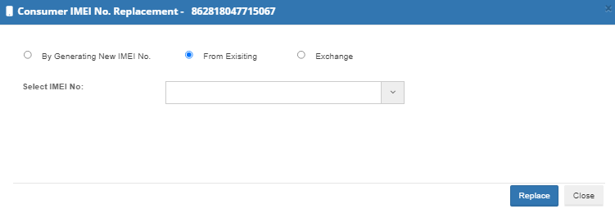
Figure 154 IMEI Replacement

NOTE: To register IMEI nos., click here to know about it.

19.2 INSTALLATION & COMMISSION DONE (I&C)

- The third sub-feature is ‘I&C done.
- By clicking “I&C Update” button (highlighted in green in Figure 152), a screen will appear (as shown in Figure 155) in which user has to upload below mentioned four photographs:
  - Foundation
  - Structure
  - PV System & Controller/Inverter
  - Installation & Commission Done (RMS Connected)
- I&C Photo’s specifications :
  - Supported Photo extension : “jpeg”, “png” & “pdf”
  - Photo Size restriction : Less than 5 MB
- It is preferred that all the uploaded I&C photos are imprinted with Latitude-Longitude.
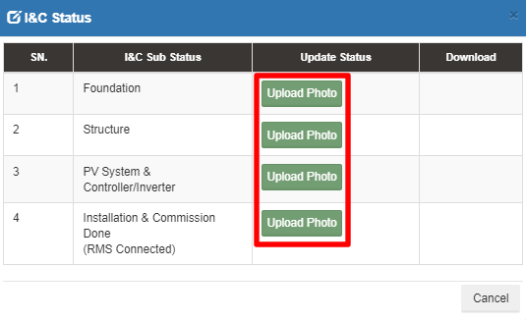
Figure 155 I & C Photos

- User has to click on the “Upload Photo” (green button highlighted in red in above Figure 155) to upload the photos.
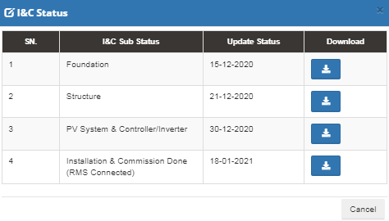
Figure 156 I&C Status box
- When the photo gets uploaded, the current date will appear just beside the I&C Sub Status name (as shown in third column in above Figure 156) and user can also download the uploaded photo by clicking on the blue coloured download icon. (as shown in fourth column in above Figure 156)

UPLAODING INSURANCE POLICY DETAILS

- The fourth sub-feature is related to the ‘Insurance Policy’ of the farmer.
- By clicking the “Insurance Update & Upload” button (highlighted in pink in Figure 152), a screen will appear (as shown in below Figure 157) to the user to enter Insurance Number and upload Insurance Policy Document of the consumer/farmer.
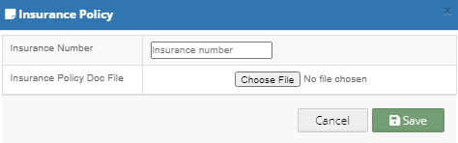
Figure 157 Insurance Policy

- The second tab of the Asset Mapping by EA Dashboard displays the Consumer Asset Details by listing out the allocated Empanelled Agency, Asset Type, Serial No., Commissioning date, Installation date, etc. (as shown below in Figure 158)
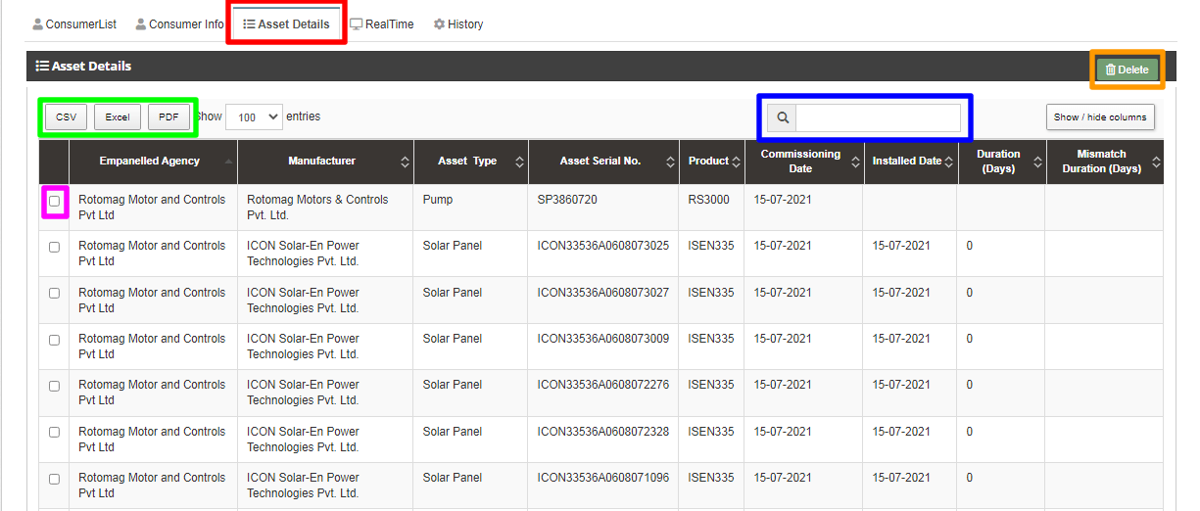
Figure 158 Asset Details

Table 48 ASSET DETAILS DASHBOARD DESCRIPTION
Action | Functionality | Highlighted Colour | Type | Description
CSV/Excel/PDF | Download CSV/Excel/PDF of Asset Serial Nos. | Green | Button | The authorised user can download the Asset Details Report for any Consumer/Farmer in format of CSV/Excel/PDF by selecting the relevant button option
Search | Search Mapped Asset Serial no. | Blue | Text | The users can search for a particular asset information by entering its serial number in the ‘search’ dialogue box.
Delete | Unmap the Asset Serial Number | Orange | Button | User can select any asset serial no. by clicking on the check box (highlighted in pink in Figure 158) and click on the delete button to unmap any faulty asset serial no. against the farmer.

- The third panel tab of the Consumer Monitoring Dashboard gives us a Real Time view of the functioning of different components and their output, like the data that is shown on the consumer mobile application.
- This data is received from the RMS module, which is installed along with the Pump Controller.
- The Real Time dashboard lists down the site location, IMEI number, Device ID, Geographic coordinates, RSSI, energy generated per day and the live performance of the Pump

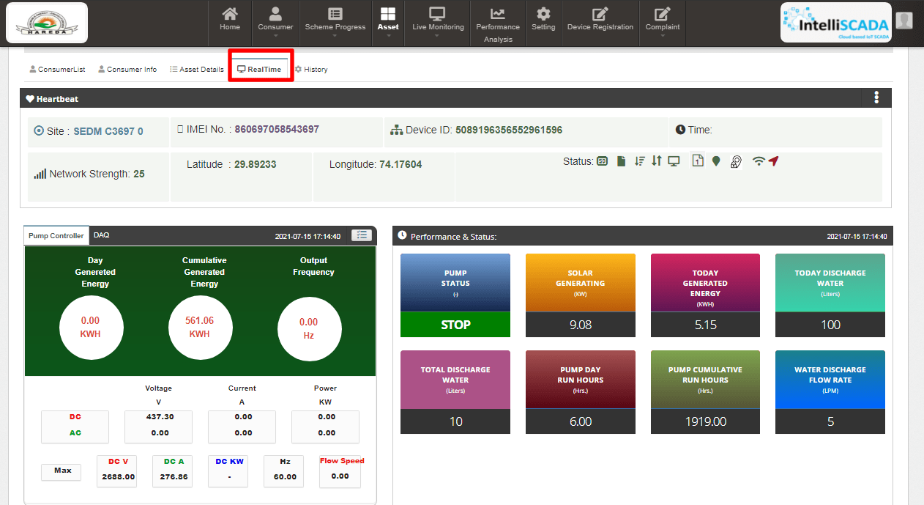
Figure 159 Real-time Dashboard

- The fourth option tab of Asset Mapping by EA Dashboard gives the users a mode to retrieve and view the History of data and activities of a farmer by entering the time period for which they want to search the results. (highlighted in red in below Figure 160)

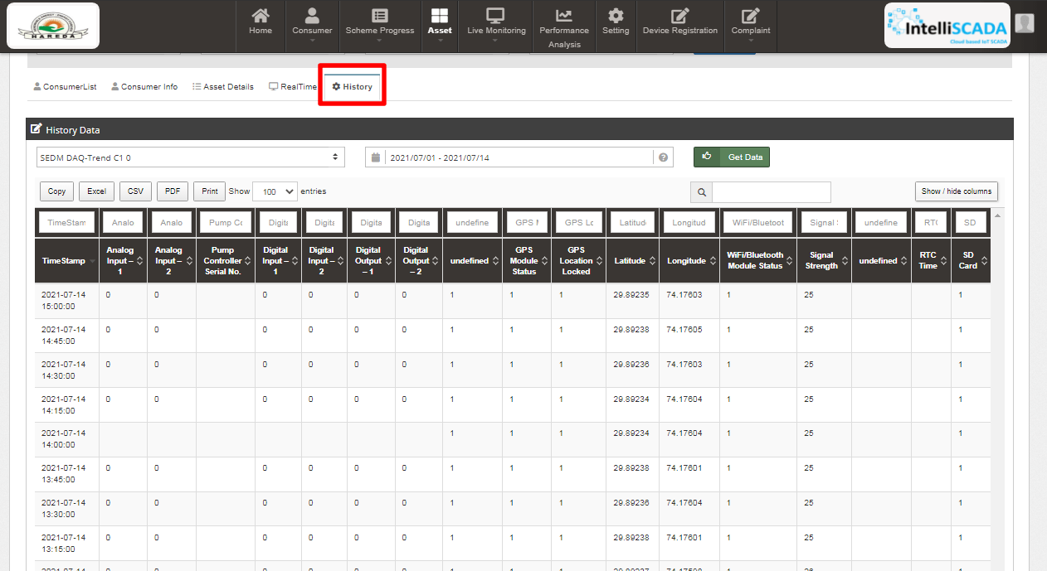
Figure 160 View History

INSTALLATION & COMMISSION (I&C) VERIFICATION

- Below are the authorized users for I&C Verification :
- State Implementing Agency (SIA)
  - Sub Division Officer (SDN)
  - Head Officer (HO)
- After updating “Installation & Commission” status of the consumer/farmer, SIA user has to change the status “I&C Verification”.

- Navigation Steps: -
1. Sign in on the State SEDM Portal
2. Click on the ‘Asset” option on the Title Bar of the SEDM Portal Dashboard
3. Click on the “Asset Mapping by SNA” option from the drop-down menu
- Sign In >> Asset >> Asset Mapping by SNA
Figure 161 Asset Mapping By SNA Option

- To search consumer/farmer for individual asset serial no or IMEI no mapping, user can search consumer/farmer by two ways i.e. either entering IMEI number (if mapped) or Application number (highlighted in yellow in below Figure 162), the corresponding details of the consumer/farmer gets displayed on the Asset Mapping by SNA Dashboard or the another way is, by applying four filters i.e. District selection, Empanelled Agency selection, Capacity selection and Application Status selection (highlighted in pink in below Figure 162) to get the particular consumer/farmer details.
- After entering IMEI number or Application number, the corresponding details of the Consumer/Farmer gets displayed on the Asset Mapping by SNA Dashboard.
- SIA user can view only those consumer/farmer details who belongs from their corresponding district.

Figure 162 Asset Mapping by SNA Dashboard
- User can download CSV or Excel file (highlighted in green in Figure 162) of the filtered farmer details for additional information.
- User also can search the particular farmer details by entering input in the search boxes. (highlighted in blue in Figure 162)
- By clicking on to the farmer’s Application no. (Highlighted in red in above Figure 162) user will be redirected to the Consumer Info tab as highlighted in red in below Figure 163.

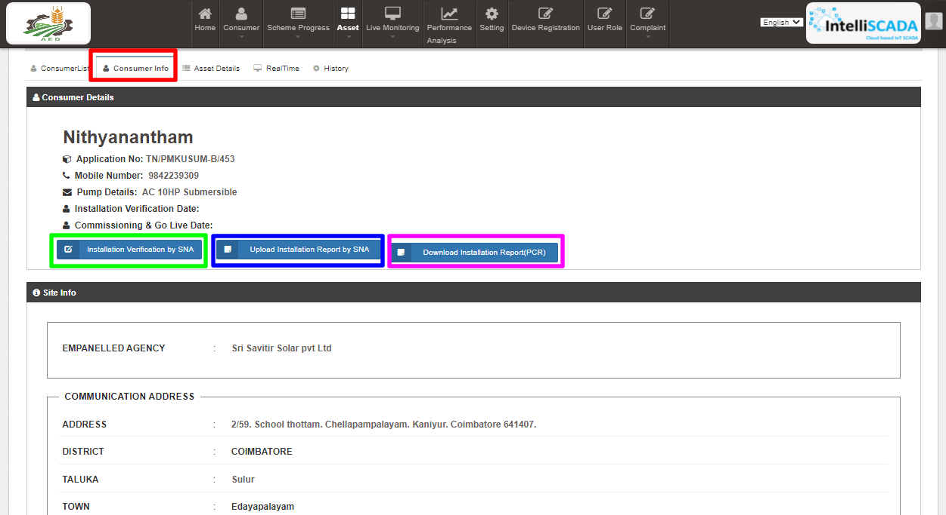
Figure 163 Consumer info Tab
- To update application status “I & C Verification”, user has to click on the “Installation Verification by SNA” button as highlighted in green in above Figure 163.
- After clicking the Installation Verification by SNA button, a window screen will appear as shown in the below Figure 164.

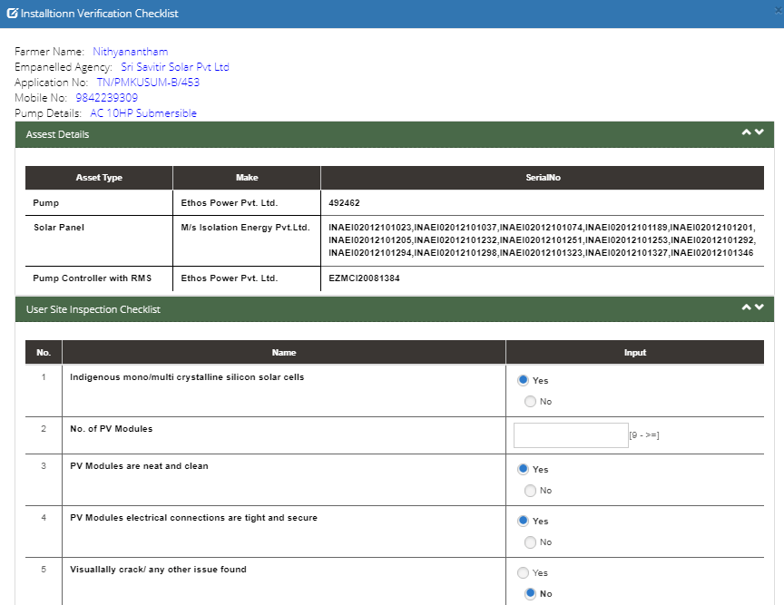
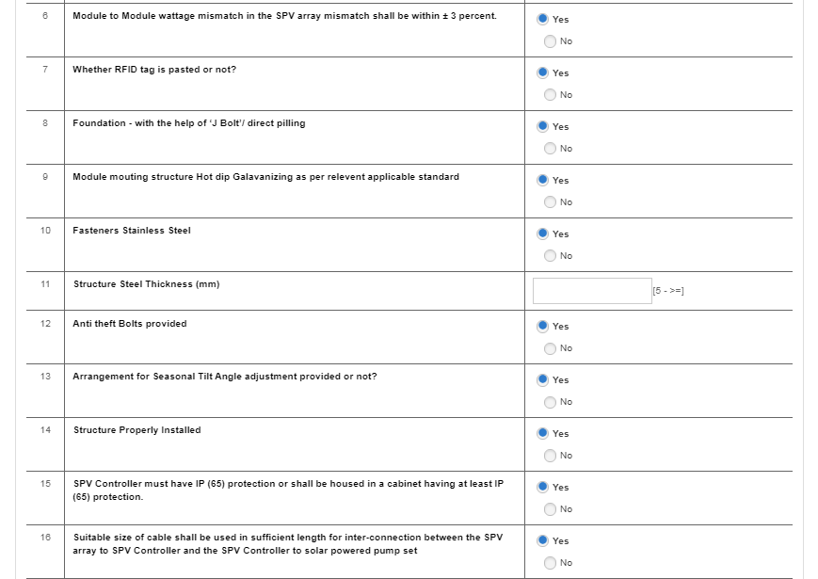
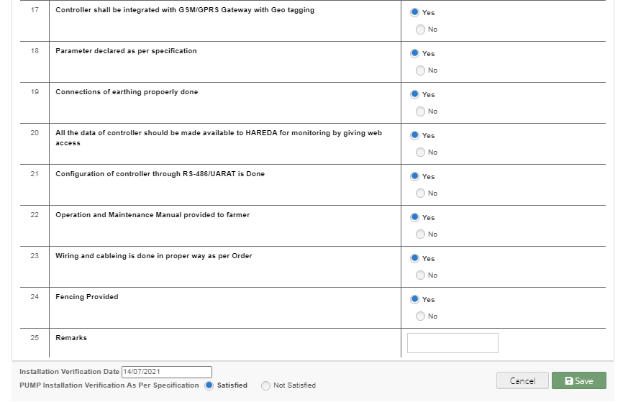
Figure 164 Site Inspection Checklist
- In the above screen, SIA user has to fill all the details and has to click on the save button to update the status “I&C Verification” of consumer/farmer.
- SIA user has to upload the Installation Verification (Site Inspection) report which conveys that all the assets i.e. Solar Pump, Solar Panel, Pump Controller with RMS and Structure are installed successfully on the consumer/farmer’s site location.
- SIA user can upload Installation verification report by clicking on “Upload Installation Report by SNA” button (highlighted in blue in Figure 163) in Consumer Info tab.
- Below screen (Figure 165) will appear for uploading Installation Report.
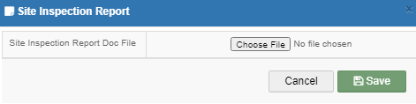
Figure 165 Installation Report Upload Screen

PCR (PROJECT COMPLETION REPORT)

- SIA User can download the PCR (Project Completion Report) by clicking on “Download Installation Report (PCR)” (highlighted in pink in Figure 163) in which following details of consumer/farmer will be available. (refer Figure 166)

  - Consumer/Farmer Details
  - Installed Pump Details
  - Project Progress
  - Site Survey Details
  - Financial Information
  - Asset Details
  - RMS Connectivity Details
  - PDI - Pump Check List
  - PDI - Solar Panel Check List
  - PDI - Pump Controller and RMS Check List
  - Site Inspection Check List
  - Four I & C uploaded photos

- Also the PCR can be downloaded by clicking on “PDF” button. (highlighted in in below Figure 166)

NOTE: PCR can be downloaded only after all application status are updated from “Application Received” to “I & C Verification”.

- PCR Report

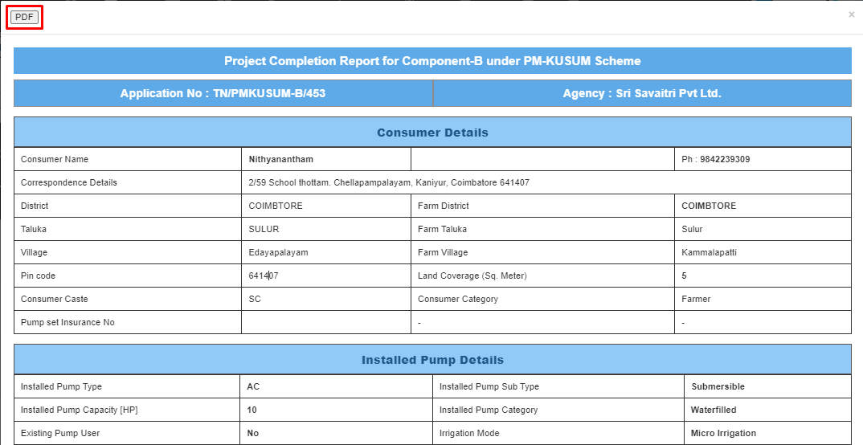
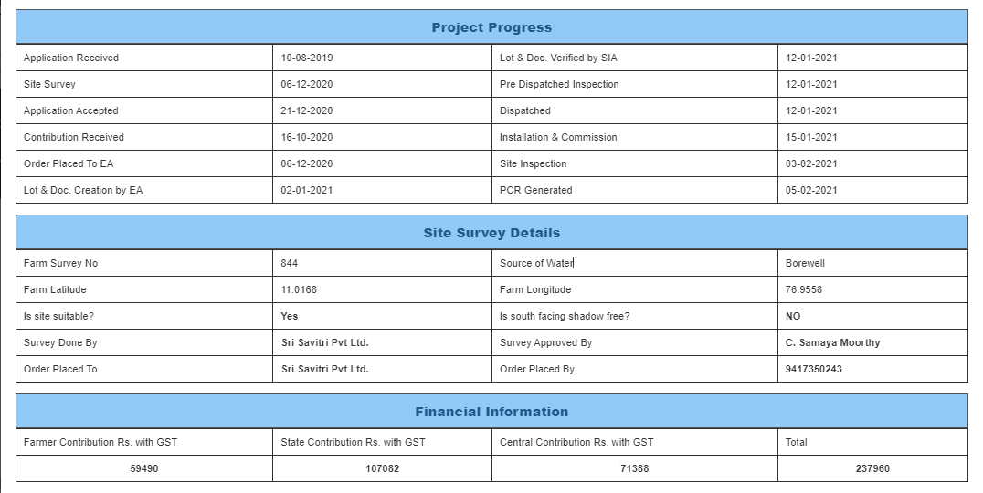
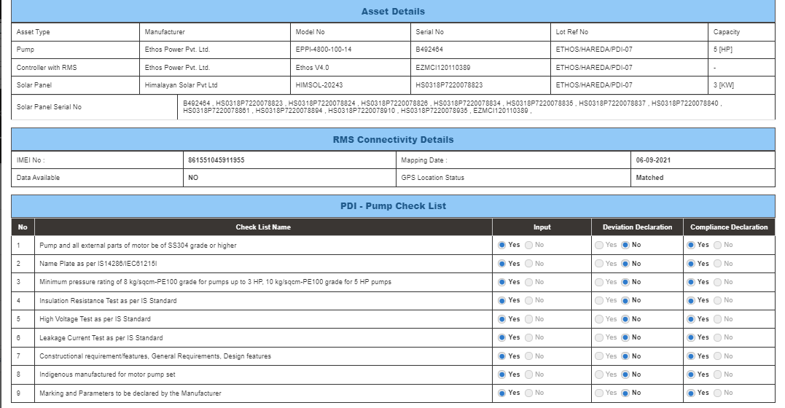
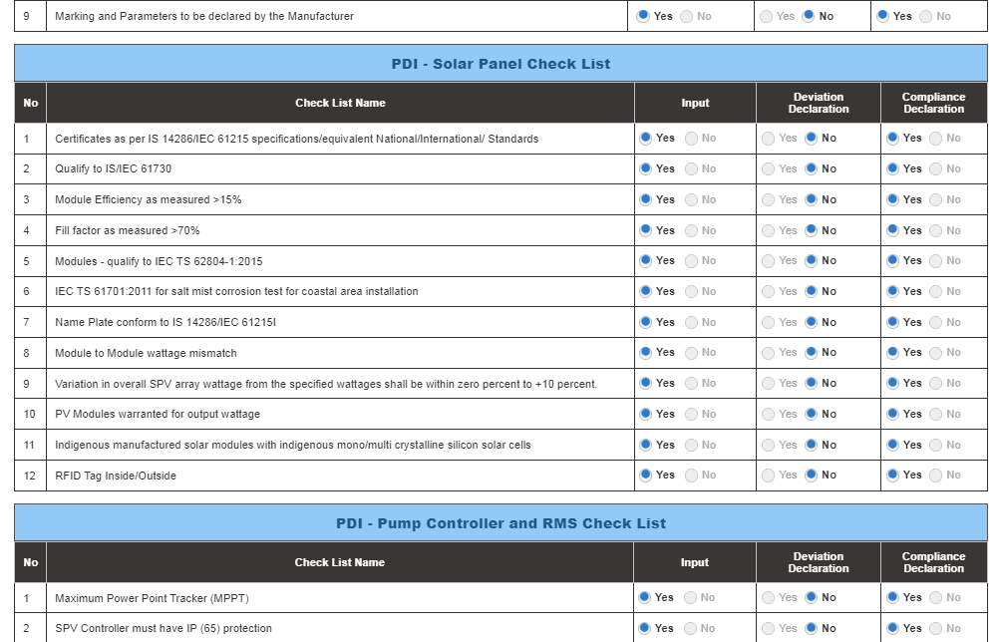
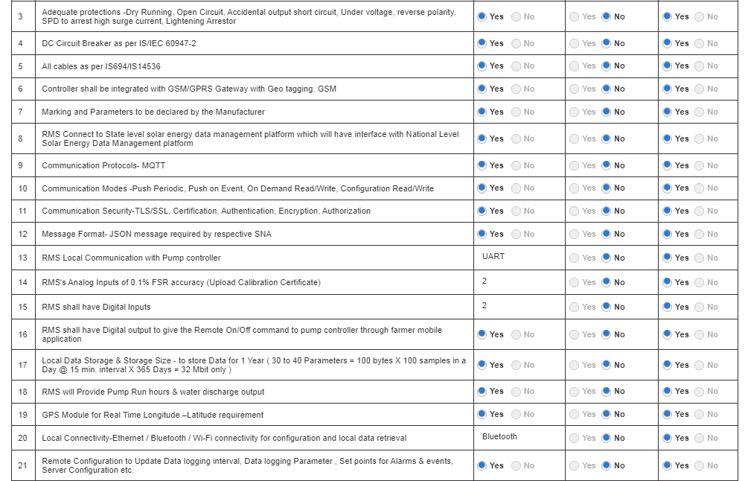
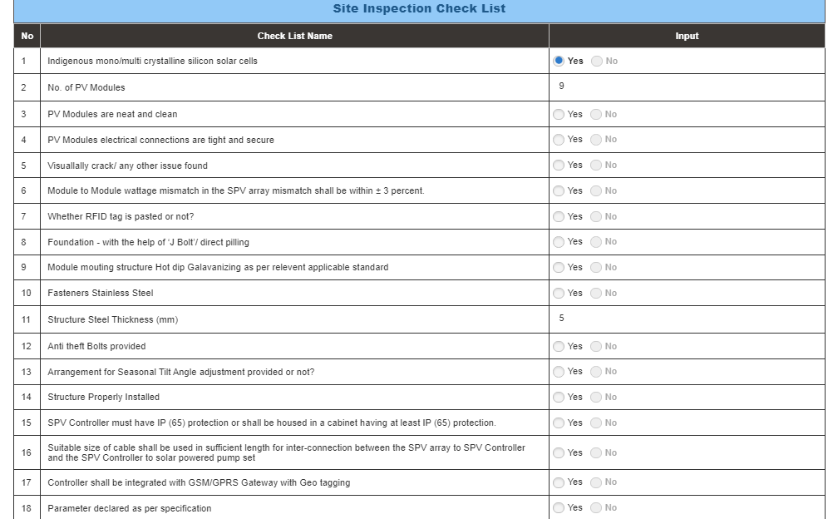
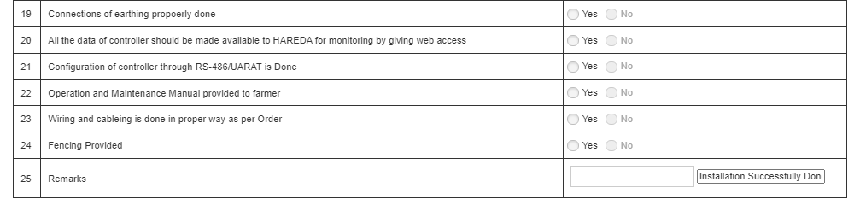
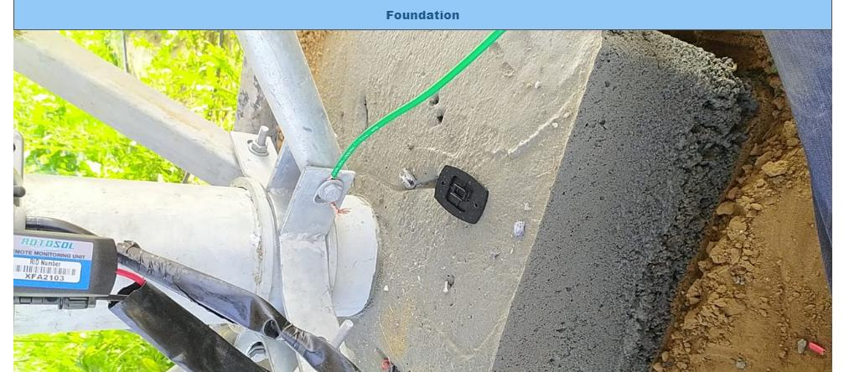
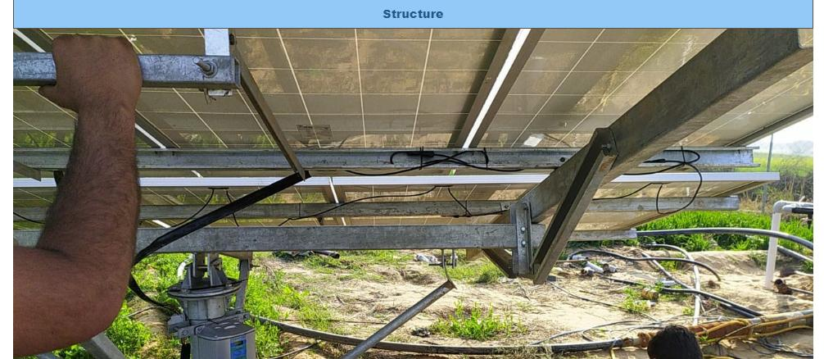
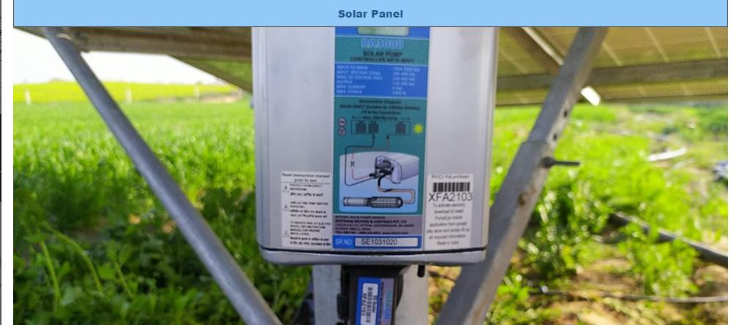
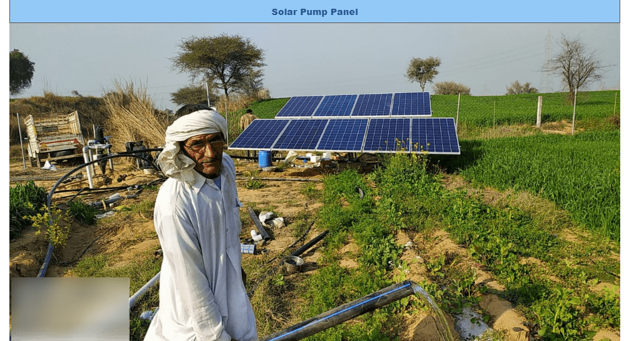
Figure 166 Project Completion Report

LIVE MONITORING

- The Live Monitoring Module on SEDM Platform gives the users a dynamic functionality to monitor and assess the scheme statistics as well as the functioning of the solar plant/pump efficiently, all of this from a single window.

- Navigation Steps: -
- Sign in on the State SEDM Portal
- Click on the ‘Live Monitoring’ option on the Title Bar of the SEDM Portal Dashboard
- Navigate “Dashboard” (as shown in Figure 167)

- Sign In >> Live Monitoring >> Dashboard

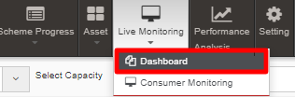
Figure 167 Live Monitoring Dashboard Option

- Live Monitoring Dashboard Screen

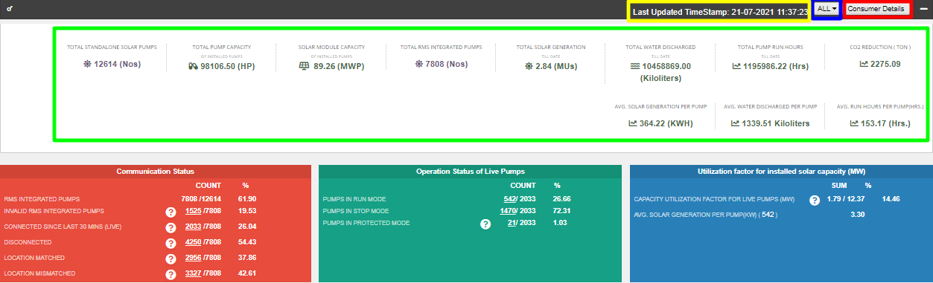
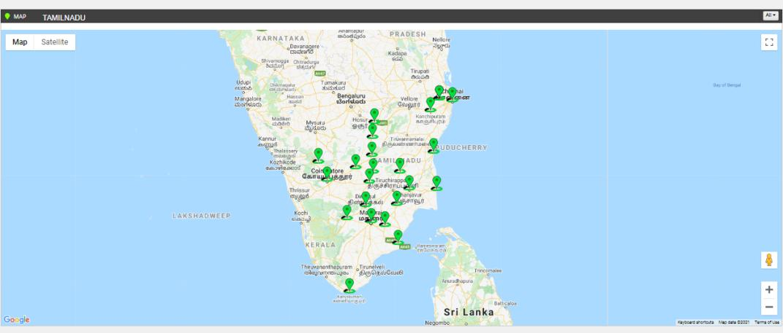
Figure 168 Live Monitoring Dashboard
- Last Updated Time Stamp (highlighted in yellow in above Figure 168)
It is the start date when the system became operational.
- This time stamp updates every 15 minutes in Live Monitoring Dashboard on State SEDM Platform and consequently, data of live monitoring dashboard gets updated every 15 minutes.
- Empanelled Agency Filter (highlighted in blue in above Figure 168)
    - User can view live monitoring dashboard data of all empanelled agencies or else, can view data empanelled agency wise also by filtering out empanelled agency.
- Consumer Details (highlighted in red in above Figure 168)
    - By clicking on the “Consumer Details” button, user can view a screen where the consumer details as well as their corresponding RMS details (last updated) will be displayed and can also edit consumer’s RMS latitude-longitude in this screen only just for once.

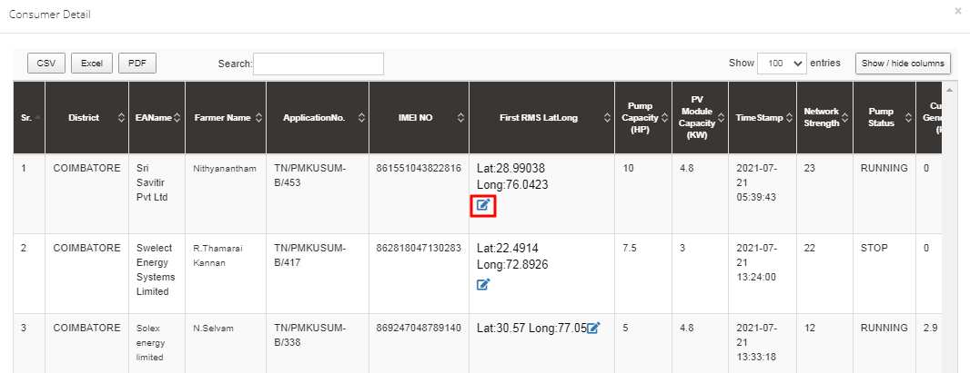
Figure 169 Consumer Details (i)
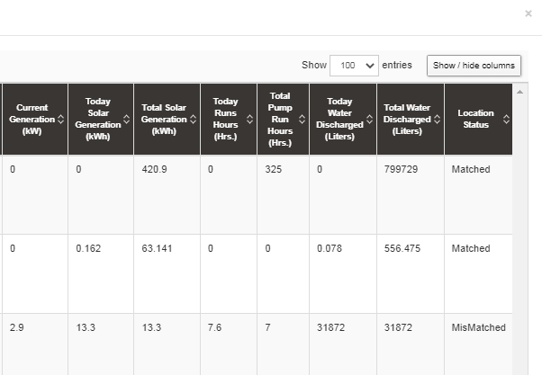
Figure 170 Consumer Details (ii)
- User can change RMS latitude and longitude by clicking on edit icon (highlighted in red in above Figure 169) and in below Figure 171 is shown how to change the RMS latitude and longitude.

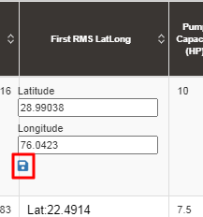
Figure 171 Update RMS Latitude - Longitude

- After entering new RMS latitude and longitude, user has to click on the save icon (highlighted in red in Figure 168) to update the RMS latitude-longitude.

NOTE: RMS Latitude-Longitude can be updated only once and not more than that.

- Below are the parameters covered in Live monitoring dashboard (highlighted in green in above Figure 168) :

  - Total Standalone Pumps
    - It reflects the total numbers of applications whose application status is updated to “Installation & Verification done”.
  - Total Pump Capacity
    - It reflects the total sum of capacity (HP) of total standalone pumps.
  - Total Module Capacity
    - It reflects the total sum of SPV capacity of total standalone pumps. (SPV Capacity as per EA rate card, click here to know more)
  - Total RMS Integrated Pumps
    - It reflects the total number of pumps who had sent RMS data on the portal for the first time.
  - Total Solar Generation
    - It reflects the total cumulative Solar Generation of RMS Integrated pumps till today. (in terms of MUs i.e. Million Units)
  - Total Water Discharge
    - It reflects the total cumulative kilolitres of Water discharged from RMS Integrated pumps till today.
  - Total Pump Run Hours
    - It reflects the total cumulative hours that RMS Integrated pumps ran till today.
  - CO2 Reduction (TON)
    - CO2
  - Avg. Solar Generation per Pump
    - Formula : Total Solar Generation / Total RMS Integrated pumps
  - Avg. Water Discharge per Pump
    - Formula : Total Water Discharge / Total RMS Integrated pumps
  - Avg. Run Hours
    - Formula : Total Pump Run Hours / Total RMS Integrated pumps

- Live Monitoring has three different coloured boxes (Red, Green and Blue as shown in Figure 168) are explained in below Table 49.

Table 49 Live Monitoring – Explanation of three boxes
Box Name (Colour) | Sub Status | Description | Refer Figure 168 for below figures as an example
Communication Status (Red Box) | RMS Integrated Pumps | Displays Total RMS Integrated Pumps out of Total Pumps whose current status is Installation & Commission Done | 7808 (Total RMS Integrated pumps) / 12614 (Total Pumps having current status Installation & Commission )
 | Invalid RMS Integrated Pumps | This sub status considers standard time of Total Pump running hours as 12 hours. If any pump from total RMS Integrated pumps runs for more than standard hours than it falls in Invalid category | 1525 (Pumps ran more than standard hours) / 7808 (Total RMS Integrated pumps)
 | Connected Since Last 30 Mins (LIVE) | Displays Total no. of Pumps that are connected from last 30 mins out of Total RMS Integrated pumps | 2033 (Total Pumps connected since last 30 minutes) / 7808 (Total RMS Integrated pumps)
 | Disconnected | Displays Total no. of Pumps that are disconnected out of Total RMS Integrated pumps | 4250 (Total disconnected Pumps) / 7808 (Total RMS Integrated pumps)
 | Location Matched | Displays Total no. of pumps whose latitude-longitude (captured while Site Survey) matched with the latitude-longitude that RMS had sent along with the data for the first time on the portal out of Total RMS Integrated pumps | 2956 (matched Latitude-Longitude) / 7808 (Total RMS Integrated pumps)
 | Location Mismatched | Displays Total no. of pumps whose latitude-longitude (captured while Site Survey) mismatched with the latitude-longitude that RMS had sent along with the data for the first time on the portal out of Total RMS Integrated pumps | 3327 (mismatched Latitude-Longitude) / 7808 (Total RMS Integrated pumps)
Operation Status of Live Pumps (Green Box) | Pumps in Run Mode | Displays Total no. of pumps that are currently running out of total no. of pumps that are connected since 30 minutes (sub status given in red box) | 542 (Pumps currently running) / 2033 (Pumps connected since last 30 minutes)
 | Pumps in Stop Mode | Displays Total no. of pumps that are currently not running i.e. stopped out of total no. of pumps that are connected since 30 minutes (sub status given in red box) | 1470 (Pumps currently stopped) / 2033 (Pumps connected since last 30 minutes)
 | Pumps in Protected Mode | Displays total no. of pumps that falls in below shown four categories (highlighted in red in below Figure 172) out of total no. of pumps that are connected since 30 minutes (sub status given in red box) | 21 (Invalid Pumps) / 2033 (Pumps connected since last 30 minutes)
Utilization Factor for installed solar capacity (MV) (Blue Box) | Capacity Utilization Factor For Live Pumps (MV) | Displays total SPV capacity (MW) produced of total no. of pumps (currently in run mode - sub status given in green box) out of total SPV capacity as mentioned in the EA rate card (click here to know about SPV capacity as per EA rate card) | 1.79 (total SPV capacity (MW) produced of total no. of running pumps) / 12.37 (total SPV capacity as mentioned in the EA rate card)  1.79 / 12.37 * 100 = 14.46 % (percentage shown in blue box of live monitoring dashboard in Figure 168)
 | Avg. Solar Generation per Pump (KW) 542 (Pumps currently in run mode) | 1.79 (total SPV capacity (MW) produced of total no. of running pumps) / 542 (Pumps currently in run mode) * 1000 (to convert value from MW into KW) = 3.30 KW

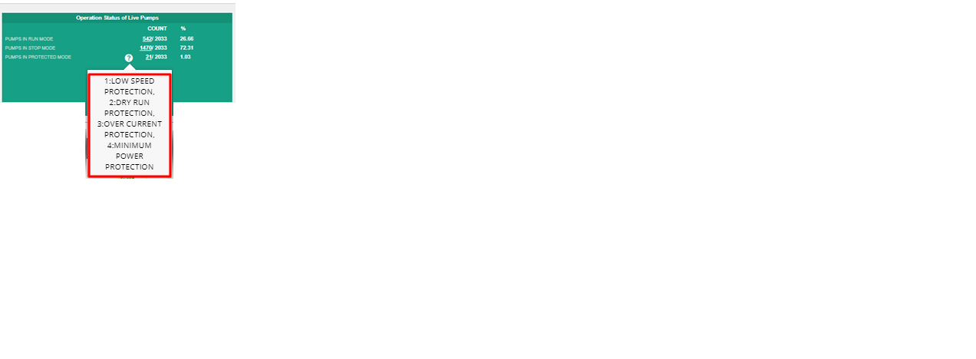
Figure 172 Invalid Parameters of Green Box of Live Monitoring Dashboard

- Below are the brief points covered under map of Live Monitoring dashboard:
- Monitoring of Live Parameters on Dashboard with Map View
- Navigation:
- It is possible to navigate from state to district to individual Consumer/Farmer on a single page in the map view.
- At state and district level, summary of parameters are displayed in a pop-up window.
- By clicking upon the green location icon on map (shown in Figure 168), a screen (refer ) will open that covers the following list of Important Parameters of particular district:
- Standalone Solar Pumps
  - Total no. of Standalone Solar Pumps
  - Total Pump Capacity (HP)
  - Total Solar Module Capacity (Actual) (KW)
- RMS Integrated Pumps
  - Total no. of RMS Integrated Pumps
  - Pumps in Run Mode
  - Pumps in Stop Mode
  - Pumps in Protection Mode
  - Current Solar Capacity Utilization of Pump in Run Mode (KW)
- Indicators
  - Pump Run Hours
  - Solar Generation (kWh)
  - Water Discharged (Kiloliter)

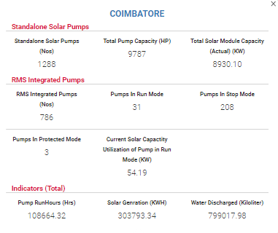
Figure 173 Coimbatore District Solar Pump Statistics

- By clicking upon district name, user will get a broad view of selected district in which consumers/farmers of that district (in terms of green and red location icons, as shown in below Figure 174) will be displayed.
  - Green Icon (Live) - Consumer/Farmer’s Solar Pump that is connected since 30 minutes.
  - Red Icon (Not Live) - Consumer/Farmer’s Solar Pump that is disconnected.
- User can filter out the view by selecting any of the three status of Solar Pump. (highlighted in yellow in below Figure 174)
- Also user can navigate back to the state view by clicking on state name. (highlighted in red in below Figure 174)

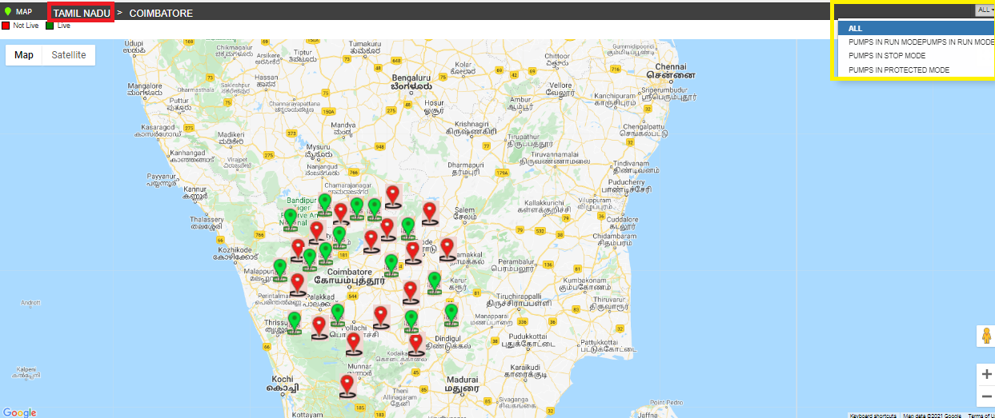
Figure 174 Broad View of Consumer/Farmer of Selected District

- By clicking on any of two coloured icon, user can view particular consumer/farmer’s Solar Pump statistics as shown below in Figure 175.

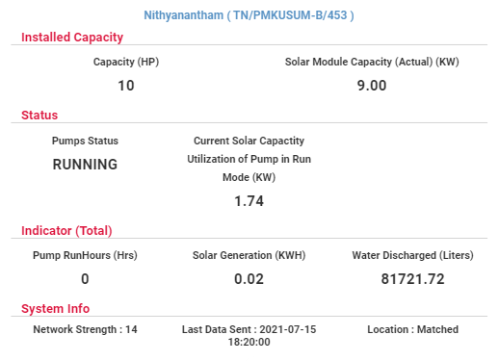
Figure 175 Consumer/Farmer Solar Pump Statistics

- By clicking on consumer/farmer’s name and application no. (Blue text in above Figure 175), user will be redirected to the Real Time tab under Asset Mapping by EA under Asset module.

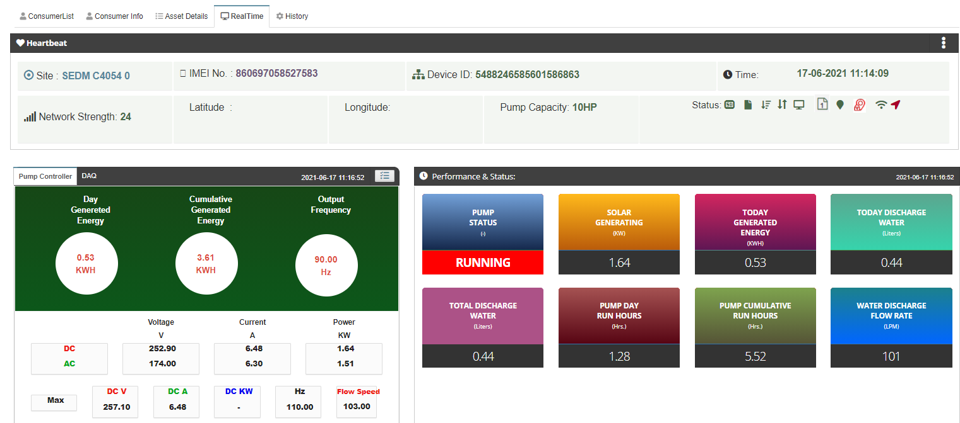

Figure 176 Real Time View of the Consumer/Farmer

PERFORMANCE ANALYSIS

- The Performance Analysis Module of the SEDM Portal gives a detailed analytical report comprising System Performance Numbers and Energy Transaction Statistics, for both state-level and district-level analysis, based on the date range or district selection provided by the user.

- Navigation Steps: -
1. Sign in on the State SEDM Portal
2. Click on the ‘Performance Analysis’ option on the Title Bar of the SEDM Portal Dashboard
- Sign In >> Performance Analysis

- Below are the brief points covered under this module:
- Duration Selection Filter
- Last Week
- Last Month
- Current Week
- Current Month
- Between User Configurable Dates

- System Performance Analysis
- Solar Performance Analysis – Generation, %CUF, %PR
- RMS Performance Analysis - % Data Availability, % Device Connectivity

- On the State Level Performance Analysis Dashboard, in the centre, a map of State is displayed with locations marked where the Solar Pump Project is set up.
- The columns on either side of the dashboard show various Diagnostic Statistics and Asset Performance and Parameters.
- Users can view the performance report for any desired date range, Empanelled Agency and District by selecting the relevant option from the filters. (highlighted in red in below Figure 177)

NOTE: Date Custom range is allowed upto 60 days only.

- State Level Performance Analysis

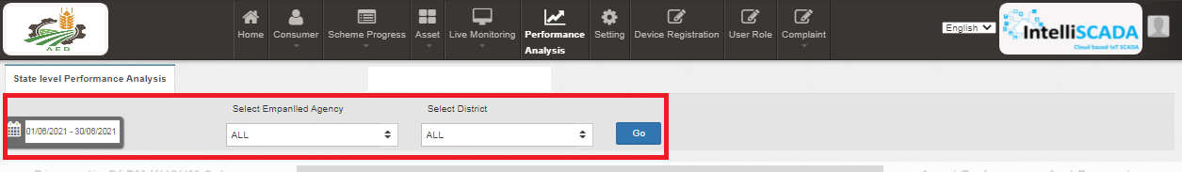
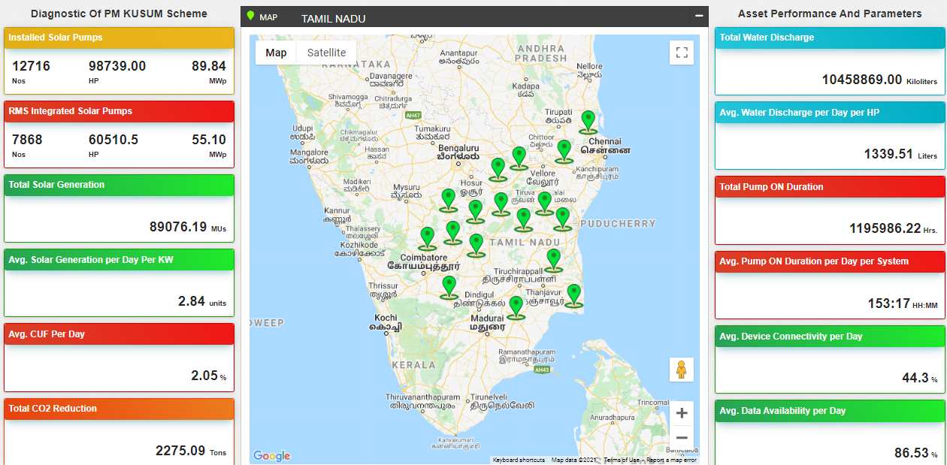

Figure 177 State level performance analysis

Table 50 Performance Analysis Statics Calculations and Description

Performance Analysis Statistics | Calculation | Description
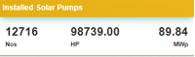 | - Nos. :- Total no. of I&C Pumps  - HP :- Sum of Capacity (HP) of Total no. of I&C Pumps  - MWp :- Sum of KWp / 1000 (to convert in MWp) = (value in MWp) | Displays the details of total no. of Solar Pumps of the consumer/farmer application whose current status is “Installation & Commission Done”
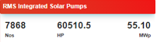 | - Nos. :- Total no. of RMS Integrated Pumps  - HP :- Sum of Capacity (HP) of Total no. of RMS Integrated Pumps  - MWp :- Sum of KWp / 1000 (to convert in MWp) = (value in MWp) | Displays the details of total no. of RMS integrated pumps. (the pumps that had sent data on the State SEDM Platform since the first time)
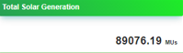 | - Cumulative Sum of total solar generation (KWh) according the selected days in date range / 1000000 (to convert in MUs) | It is calculated as per :  1MWp = 1000 KWp  1KWp = 1000 watts  (1kwh/1000000)=MUs
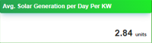 | - Total Solar Generation / ( selected no. of days in date range * Total capacity of RMS Integrated Pumps (HP) ) | It is calculated considering Total Solar generation, Sum of total Capacity of RMS Integrated Pumps and Date range (no. of days)
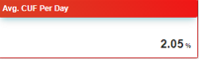 | - Total Solar Generation / (Total capacity of RMS Integrated Pumps (HP) * selected no. of days in date range) * 100 = (value in %) | It is calculated consider the no. of units generated per day, solar generation (kWp) and 24 hours (to calculate avg per day)
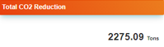 | - Total Solar Generation / 1000000 (MUs) * 800 = (value in Tons) | This calculation consider Total Solar Generation and convert it into Tons by dividing the value by 10,00,000
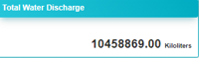 | - Cumulative Sum of total water discharged according to the capacity of total RMS Integrated Pumps | This calculations will be Cumulative considering total units generated per HP and sum of total capacity (HP)
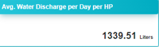 | - Total water discharge / 30 (days selected in date range) / total rms integrated pumps capacity (HP) | This calculations will be Cumulative considering total water discharge, selected days in date range and total capacity (HP) of RMS Integrated Pumps
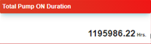 | - Sum of total running hours of RMS Integrated Pumps according to the selected no. of days in date range | This calculations will be Cumulative considering total running hours of RMS Integrated Pumps and selected days in date range
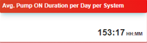 | - Total Pump ON Duration / 30 (selected no. of days in date range) / Total no of RMS Integrated Pumps = (value in HH:MM) | This calculation will be Cumulative considering Total running hours of RMS Integrated Pumps, no. of days selected in date range and total no. of RMS Integrated Pumps
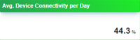 | - Total no. of hours of RMS device connectivity / Total no. of RMS Integrated Pumps / selected no. days in date range * 100 = (value in %) | This calculation considers the total no. hours that RMS device has been connected on the State SEDM Platform, total no. of RMS integrated pumps to calculate average of each device and no. of days selected in date range to calculate average device connectivity per day
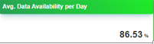 | - Total no. of samples (RMS data) received from the RMS device / Total no. of hours of RMS device connectivity / selected no. days in date range * 100 = (value in %) | This calculation considers total no. of samples (RMS data) that is received from the RMS device from the total hours of RMS device connectivity with the State SEDM Platform and no. of days selected in date range to calculate average device connectivity per day

- By clicking upon the green location icon (shown in Figure 178), user can view Performance Analysis statistics of particular district as shown in below Figure 178.

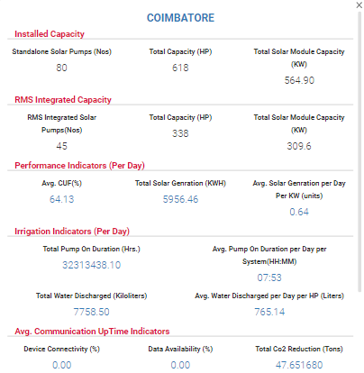
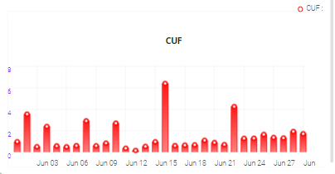
Figure 178 District Statistics

- By clicking upon district name, user will get a broad view of selected district in which consumers/farmers of that district (in terms of green and red location icons, as shown in below Figure 179) will be displayed.
  - Green Icon (Live) - Consumer/Farmer’s Solar Pump that is connected since 30 minutes.
  - Red Icon (Not Live) - Consumer/Farmer’s Solar Pump that is disconnected.

- Also user can navigate back to the state view by clicking on state name. (highlighted in red in below Figure 179)

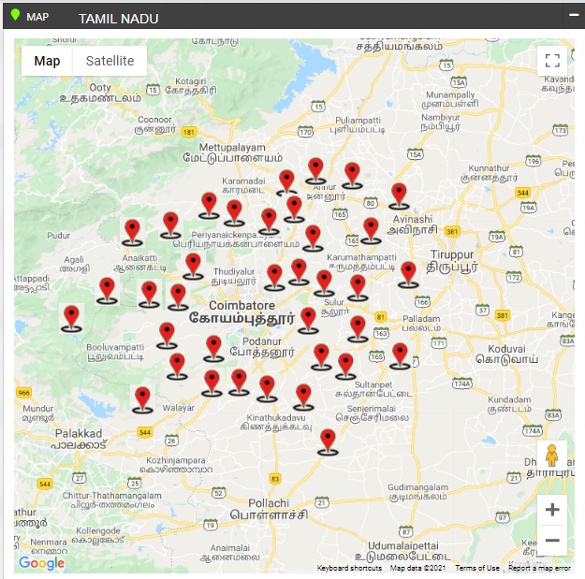
Figure 179 Broad View of Consumer/Farmer of Selected District

- By clicking on red location icon, user can view particular consumer/farmer’s Solar Pump statistics as shown below in Figure 180.

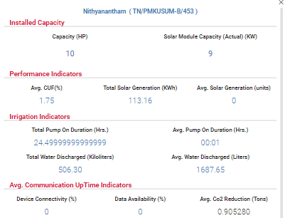
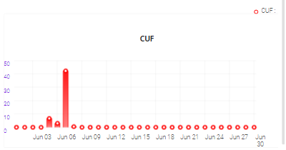
Figure 180 Consumer/Farmer Solar Pump Statistics

- By clicking on consumer/farmer’s name and application no. (Blue text in above Figure 180), user will be redirected to the Real Time tab under Asset Mapping by EA under Asset module. (as shown in below Figure 181)

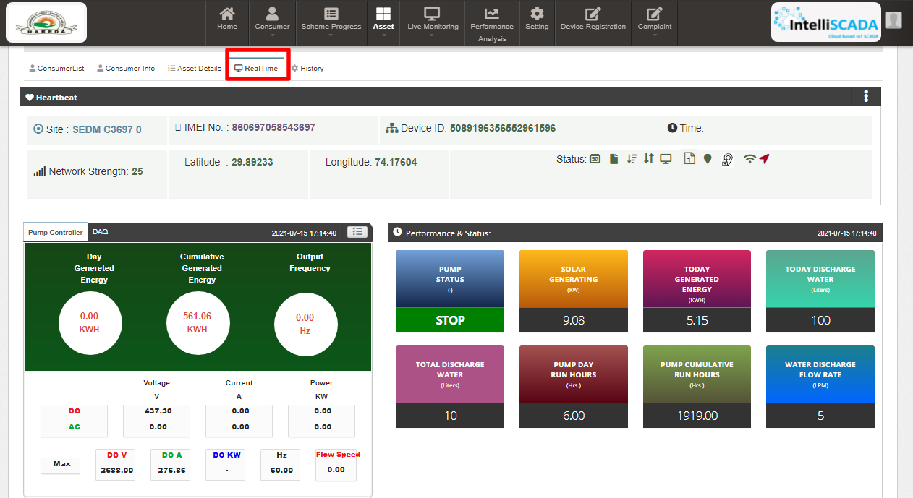
Figure 181 Real Time View of the Consumer/Farmer

SUMMARY

- Under the ‘Consumer/Farmer’ tab title bar, there are three options in the drop-down menu. These options provide different views of application tracking and analysis.
- The first option is ‘Summary’ provides an overall Consumer/Farmer Management Summary.
This dashboard displays an organised flowchart which helps user to understand different stages of application processing and to view details about any specific EA if needed.
- Navigation Steps: -
1. Sign in on the State SEDM Portal
2. Click on the ‘Consumer/Farmer’ option on the Title Bar of the SEDM Portal Dashboard
3. Click on the ‘Summary’ option from the drop-down menu
- Sign In >> Consumer/Farmer >> Summary
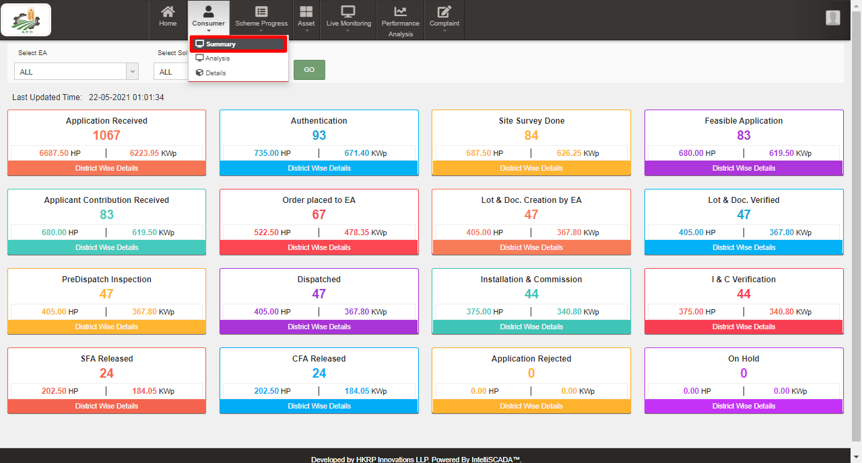

Figure 182 Consumer/Farmer Management Summary option selected on Consumer/Farmer Dashboard

- Description of each and every coloured boxes of application status as shown in the above image

- Count of all application status will be incremented according to the status gets changed of the consumers/farmers by the authorized person.

Status | Image | Description | Want to know how to change status?  (Click Ctrl + Click)
Application Received | 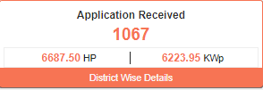 | This box indicates the total number of consumer/farmer applications received. | Click here
Aadhar Authentication | 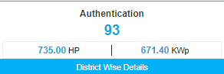 | This box indicates the total number of Aadhar authenticated consumers/farmers. | Refer Table 34
Site Survey Done | 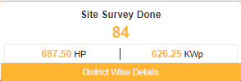 | This box indicates the total number of consumers/farmers whose status “Site Survey Done” is updated. | Click here
Feasible Application | 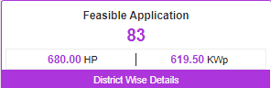 | This box indicates the total number of consumers/farmers whose application is accepted by the authorized user. | Click here
Farmer Share Received | 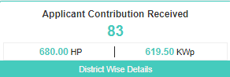 | This box indicates the total number of consumers/farmers whose contribution is received. | Click here
Order Placed to EA | 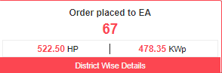 | This box indicates the total number of consumers/farmers whose application is assigned to the Empanelled Agency. | Click here
Lot & Doc. Creation by EA | 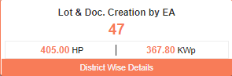 | This box indicates the total number of consumers/farmers whose status is changed to “Lot & Doc. Creation by EA”. | Click here
Lot & Doc. Verified | 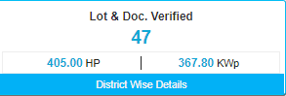 | This box indicates the total number of consumers/farmers whose status is changed to “Lot & Doc. Verified”. | Click here
Pre Dispatch Inspection (PDI) | 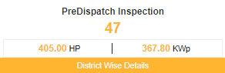 | This box indicates the total number of consumers/farmers whose status is changed to “Pre Dispatch Inspection”. | Click here
Dispatched | 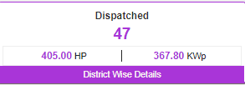 | This box indicates the total number of consumers/farmers whose status is changed to “Dispatched”. | Click here
Installation & Commission (I&C) | 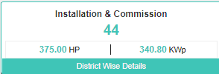 | This box indicated the total number of consumers/farmers whose status is changed to “Installation & Commission”. | Click here
I & C Verification | 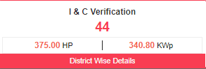 | This box indicates the total number of consumers/farmers, when authorized person changes the status “I & C Verification” of consumers/farmers. | Click here
SFA (State Financial Assistance) released | 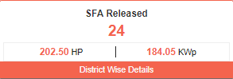 | This box indicates the total number of consumers/farmers whose State fund is released by the authorized user. | Click here
CFA (Central Financial Assistance) released | 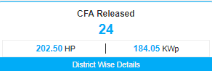 | This box indicates the total number of consumers/farmers whose Central fund is released by the authorized user. | Click here
Application on Hold | 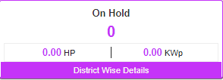 | This box indicates the total number of consumers/farmers whose application is on Hold by the authorized user. | Click here
Application Rejected | 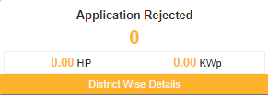 | The above box indicates the total number of consumers/farmers whose application is Rejected by the authorized user. | Click here

- There are several Empanelled Agencies that a user can choose from (pointed out in below Figure 183), depending on their analytical requirement or data studying.

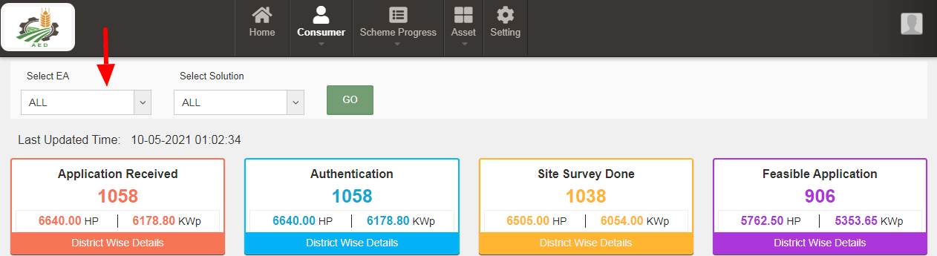
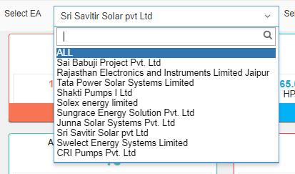
Figure 183 EA selection option in ‘Select EA’ filter
- Users also get the option to filter the results by selecting the Pump capacity (pointed out in below Figure 184), under the ‘Select Solution’ drop-down text field.

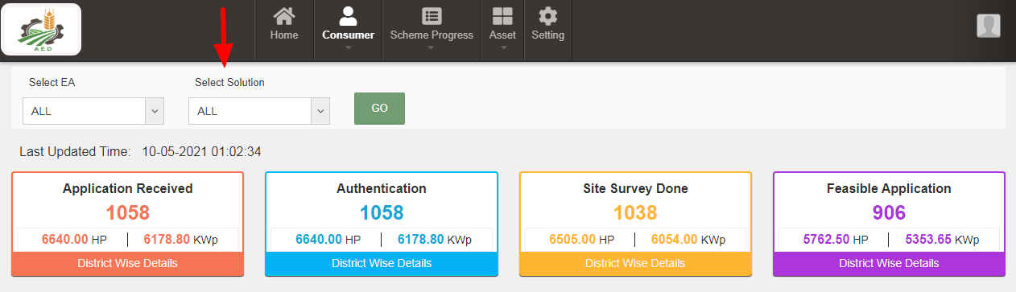
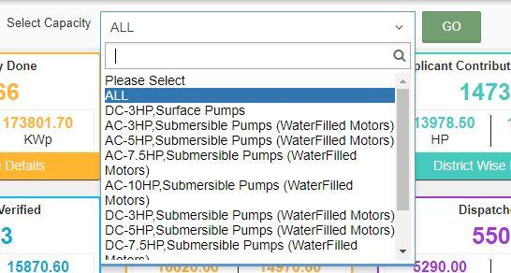
Figure 184 Capacity options in ‘Select Capacity’ filter

- Consumer/Farmer Management Dashboard Output after applying filters. (shown in below Figure 185)
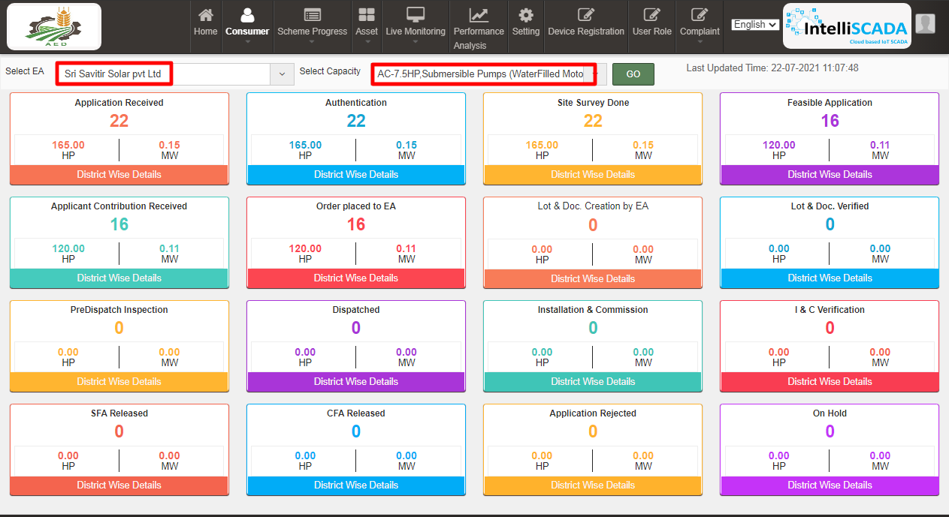
Figure 185 Applied filter: Sri Savitir Solar Pvt Ltd (EA), AC-7.5HP, Submersible Pumps (Waterfilled Motors)
- Each box label has a suitable name given to it which signifies the step at which the application of a user has reached at. It also provides the statistical numbers for this information, along with total solar installation capacity in kilowatts peak (kWp) generated in Horsepower (HP), for allocated users.
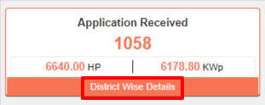
Figure 186 Individual application stage

- To get more details for every sub-division, users can click on the ‘District Wise Details’ button in the label box. It will display the screen shown below in Figure 187 :
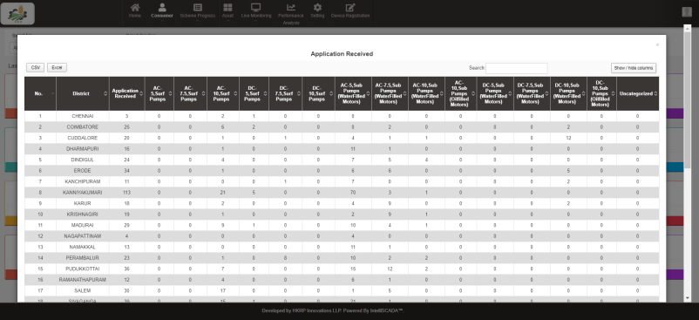
Figure 187 District-wise summary of Applications Received for various pump models report
- In this table, users can choose to show or hide columns as per their preference by selecting ‘Show / hide columns’ button on top right corner.
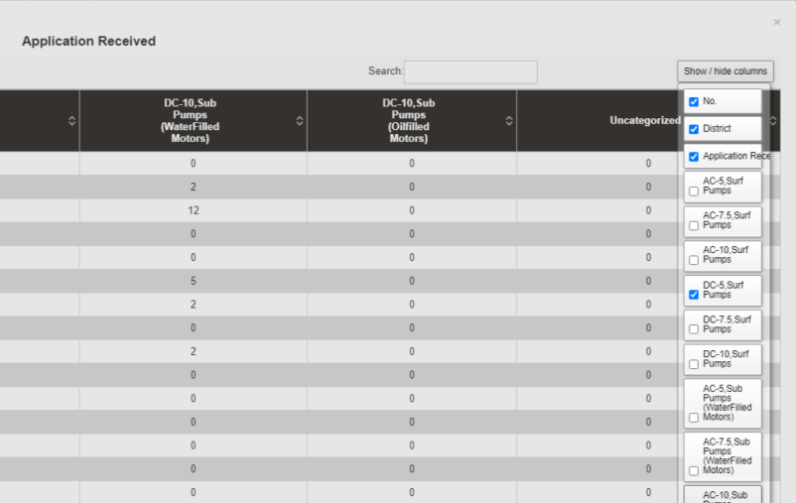

Figure 188 Show / Hide columns filter

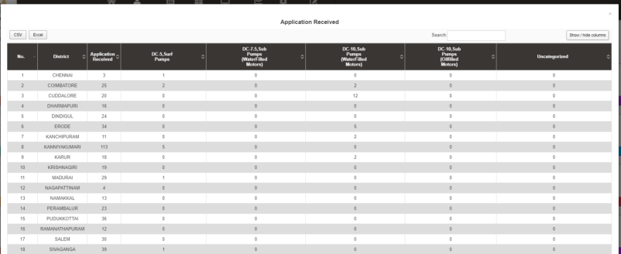
Figure 189 Using the filter “Show / hide columns” to display only selected columns

- Additionally, users can search for their specific division or sub-division by inputting the relevant search query in the ‘Search’ dialogue box. (highlighted in red in below Figure 190)
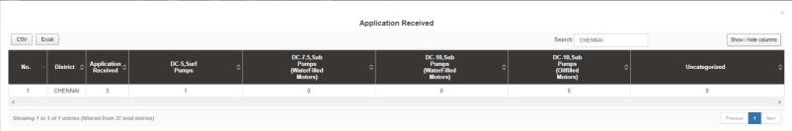
Figure 190 Using “Search” filter to list down all entries for District = Chennai

- The users can directly download the whole data in tabular formats by clicking onto the required file source buttons, i.e. CSV or Excel, present on the top left corner. (highlighted in blue in above Figure 190)
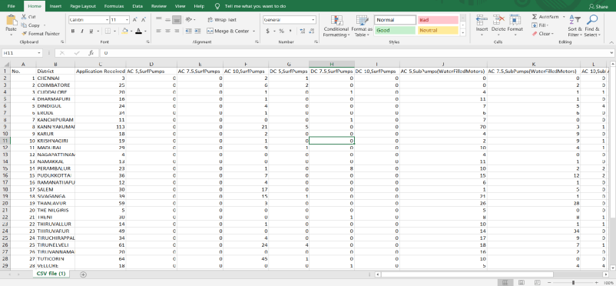
Figure 191 The view of downloaded CSV/Excel file

CONSUMER/FARMER MANAGEMENT ANALYSIS

- Consumer/Farmer Management module provides users a feature to conduct data analysis on SEDM Portal. The ‘Analysis’ option under Consumer/Farmer drop-down menu provides the data representation in different graphical format, such as, map, stacked column chart, bar chart, funnel chart and pie chart.
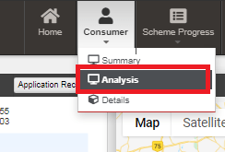
Figure 192 Consumer/Farmer Management Analysis option selected on Consumer/Farmer Dashboard
- Navigation Steps: -
1. Sign in on the State SEDM Portal
2. Click on the ‘Consumer/Farmer’ option on the Title Bar of the SEDM Portal Dashboard
3. Click on the ‘Analysis’ option from the drop-down menu
- Sign In >> Consumer/Farmer >> Analysis
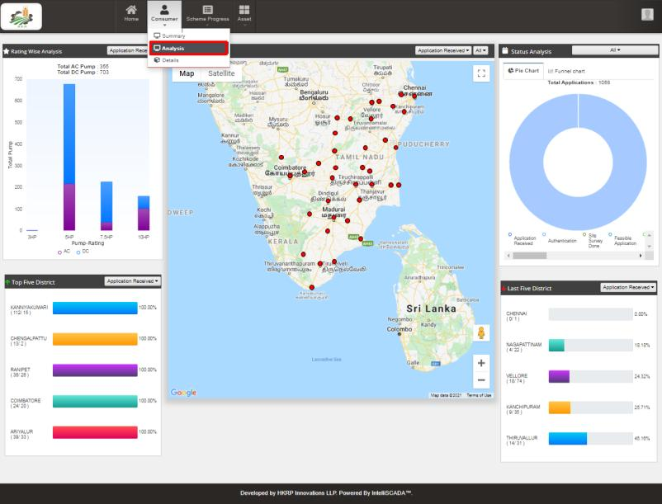
Figure 193 Consumer/Farmer Analysis Dashboard
- The first graphical analysis is for the type of pump, pump rating, and number of pumps allocated or installed as per the registered users. This data is represented in a stacked column chart, the data label of the chart are as follows:
- The y-axis denotes the scale of ‘total pumps
- The x-axis denotes different pump ratings (HP)
- The type of pump (AC / DC) is bifurcated using purple and blue colours respectively.
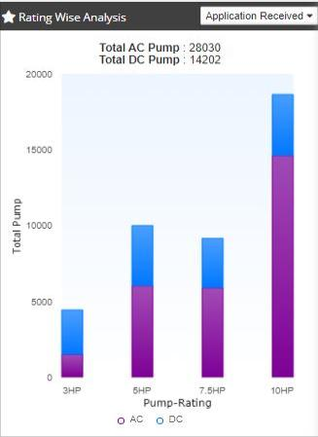
Figure 194 Filter Applied: Application Received
- The following graphical analysis are bar charts listing top 5 districts and last 5 districts, based on various parameters determining the status of application procedure.

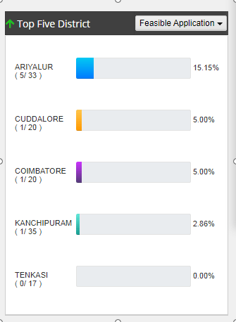
Figure 195 Filter Applied: Feasible Application
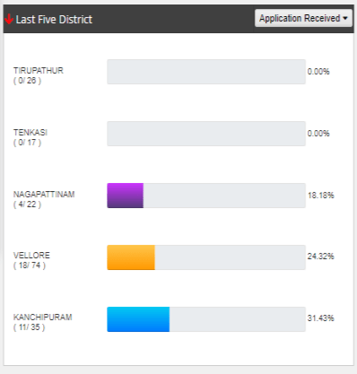
Figure 196 Filter Applied: Application Received
- All the above 3 charts have same filter search option, which is a list of various steps at which a Consumer/Farmer’s application reaches, i.e. from application registration to application completion and equipment allotment.
- Users can choose any of the parameter from the drop-down list and view the details in graphical format.
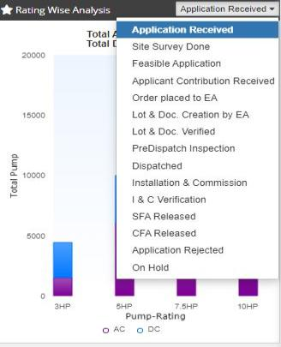
Figure 197 Filter options for Analysis graphs
- The SEDM Consumer/Farmer Management module also offers a more comprehensive graphical view where the users can see a cumulative representation of Application Status stages, covering all the steps of application procedure and statistics in one view, with the help of pie and funnel chart.
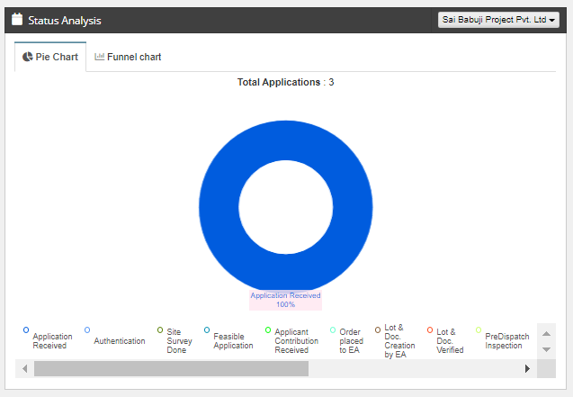  Figure 198 Consumer/Farmer Analysis - Pie Chart | 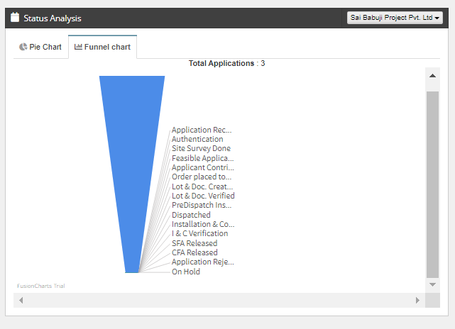  Figure 199 Consumer/Farmer Analysis – Funnel chart
- The users are provided with a filter option to choose the EA for which they want to see the data analysis, this can be selected from the drop-down menu in Status Analysis box.
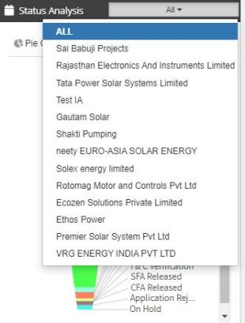  Figure 200 Filter Applied: Shakti Pumping | 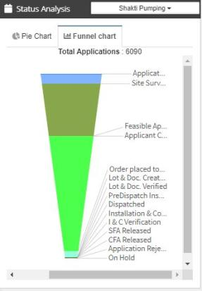  Figure 201 Consumer/Farmer Analysis - Filter options
- The Consumer/Farmer Management Analysis Dashboard hosts a real-time Map view in the centre. In this map, the districts currently covered in the PM-KUSUM project implementation are pinned.
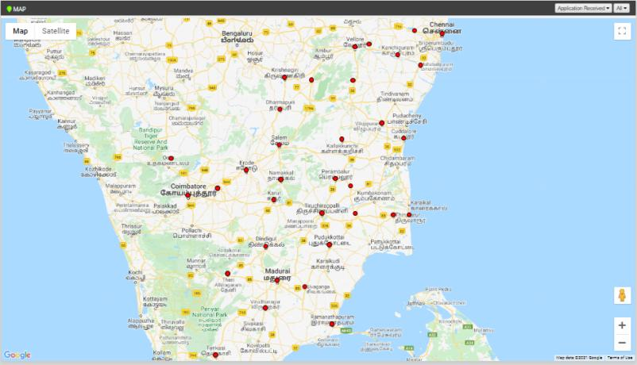
Figure 202 Map View

- The Map also comes with the filter options to narrow down the results based on Application status and the EA (highlighted in red in Figure 203).
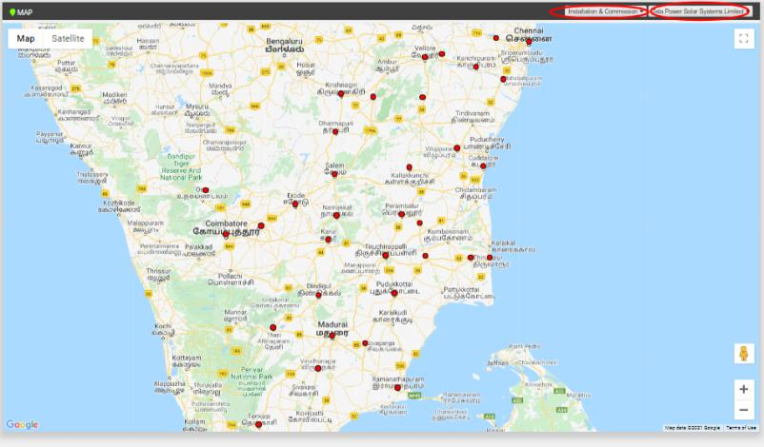
Figure 203 Filter Applied: Installation & Commission, Tata Power Solar Systems Ltd
- The Consumer/Farmer management module also provides a dynamic option of Google Street View of the farmland, which can help to get a bird-eye view of the site field, help in site inspection and check the installation process. User can also manoeuvre the field in any direction and orientation with given options.
- When the user clicks on specific district’s location pin, a pop-up box appears which displays the pump rating wise (AC/DC) analysis as well as complete application stage wise status analysis in the graphical format, to give a brief analysis diagram to the user.
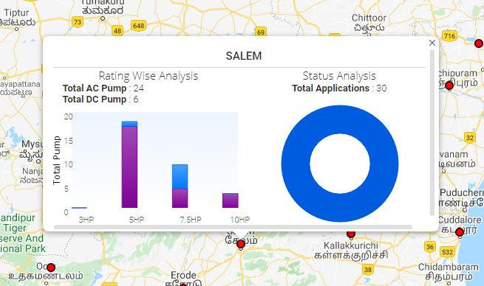
Figure 204 Consumer/Farmer Analysis statistics for district-wise location

SCHEME PROGRESS

- The Scheme Progress Module of SEDM portal helps the users to track the progress of application with detailed information, to understand the user role management, to search for bulk queries, and to generate reports including the progress status and application workflow.

- Navigation Steps: -
- Sign in on the State SEDM Portal
- Click on the ‘Scheme Progress’ option on the Title Bar of the SEDM Portal Dashboard

- Sign In >> Scheme Progress

- Below are the brief points covered under this module:
- Provision to update and track multiple application status for workflow
- 14 primary application status for National Platform requirement
- Based on State state’s requirements ‘Sub Status’ functionality can be added
- Workflow with User and Role Management
- User from State Implementing Agency or Empaneled Agency may update the status of Application with Date
- Access to User and Workflow sequence for sub status may be decided by state implementing agency
- Provision to update Application Status in multiple modes
- Individual Application Status Update
- Bulk Update
- To select multiple Consumer/Farmer application numbers and update the status with date and document reference number
- District wise .csv upload of multiple applications with status dates
- Web or Mobile User Interface to update Application Status from Various Modules
- Provision to auto generate process related documents and reports against various application stages such as Notice to Proceed, Notice for Deposit Payment, Project Completion Report or Joint Commissioning Report etc.

26.1 SCHEME PROGRESS REPORT
- Navigation Steps: -
1. Sign in on the State SEDM Portal
2. Click on the ‘Scheme Progress’ option on the Title Bar of the SEDM Portal Dashboard
3. Click on the ‘Reports’ option from the drop-down menu

- Sign In >> Scheme Progress >> MIS Reports
- With the Report feature in Scheme Progress Module on SEDM portal, the users can view and download various types of reports based on the input parameters of the filters provided.
- Different Types of Reports are:

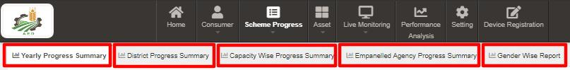
Figure 205 MIS Reports

- YEARLY PROGRESS SUMMARY

- Yearly Progress Summary to show PM-KUSUM scheme progress statistics with respect to years.
- The filter options provided to the users are :
  - Select Empanelled Agency
  - Select District
  - Select Year
  - Result Type
  - Application Status Selection
  - Report View (Tabular/Chart).

- Tabular View

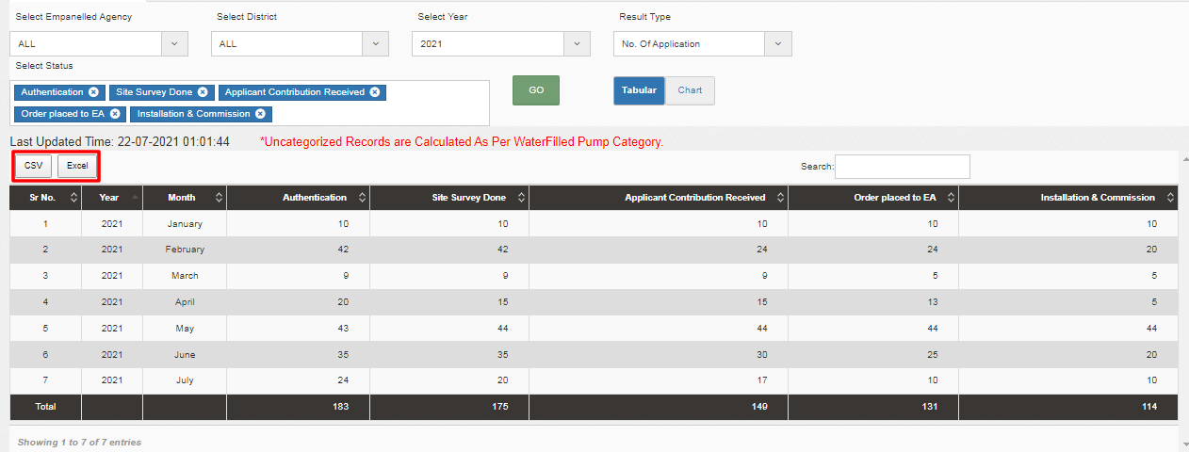
Figure 206 Yearly Progress Summary – Tabular view

- Chart View

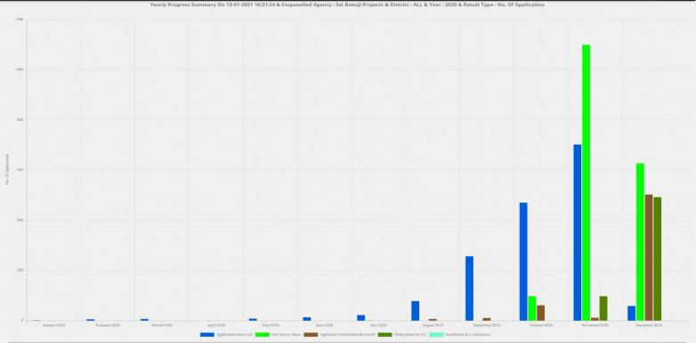
Figure 207 Yearly Progress Summary – Chart view

- District Progress Summary

- District Progress Summary to show PM-KUSUM scheme progress statistics with respect to different districts of State.
- The filter options provided to the users are :
  - Select Empanelled Agency
  - Select Capacity
  - Result Type
  - Application Status Selection
  - Report View (Tabular/Chart)

- Tabular View

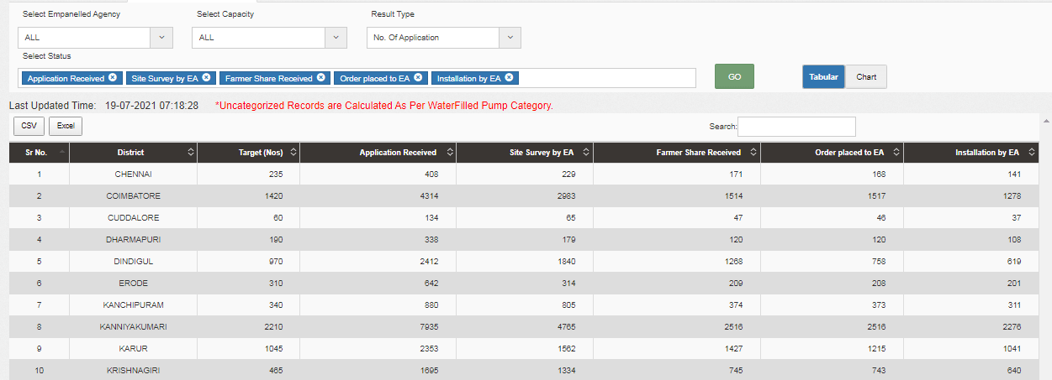
Figure 208 District Progress Summary- tabular view

- Chart View

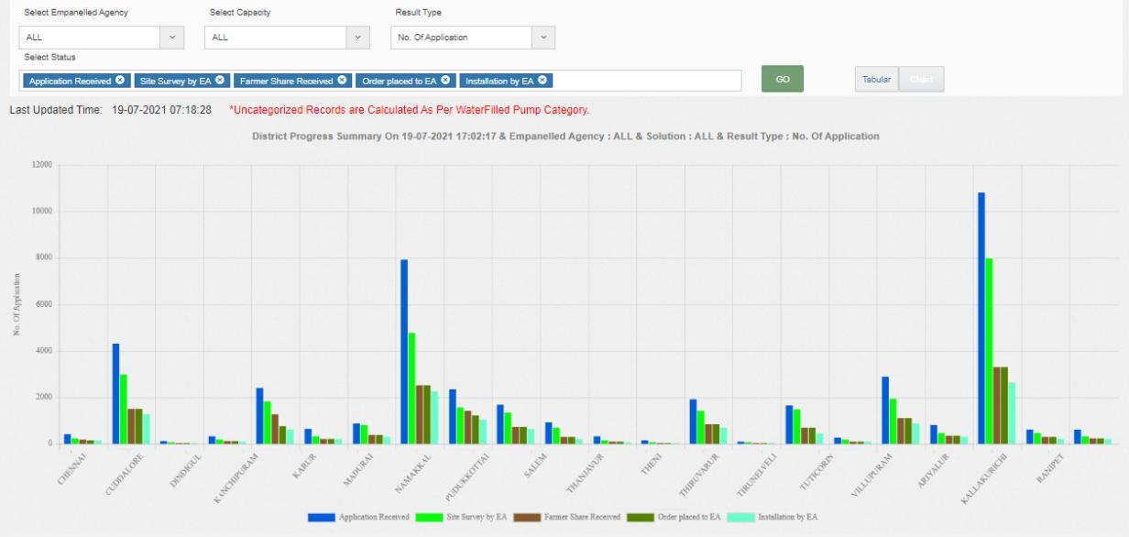
Figure 209 District Progress Summary – Chart view

- Capacity wise Progress SummarY
- The filter options provided to the users are :
- Select Empanelled Agency
- Select District
- Select Pump Capacity
- Select Pump Type
- Select Pump Sub Type
- Select Pump Category
- Result Type
- Application Status Selection
- Report View (Tabular/Chart)

- Tabular View
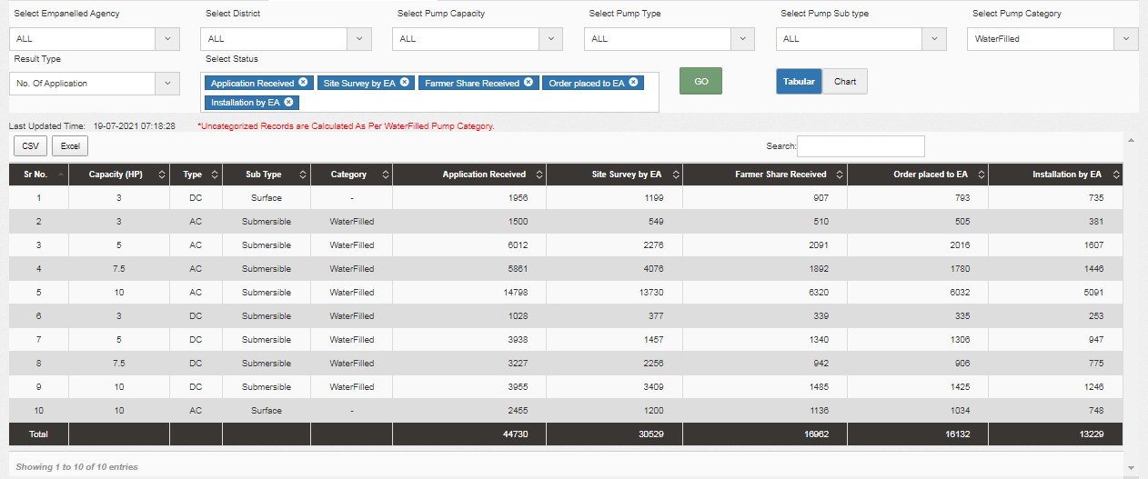
Figure 210 Capacity wise Progress Summary – Tabular view

- Chart View
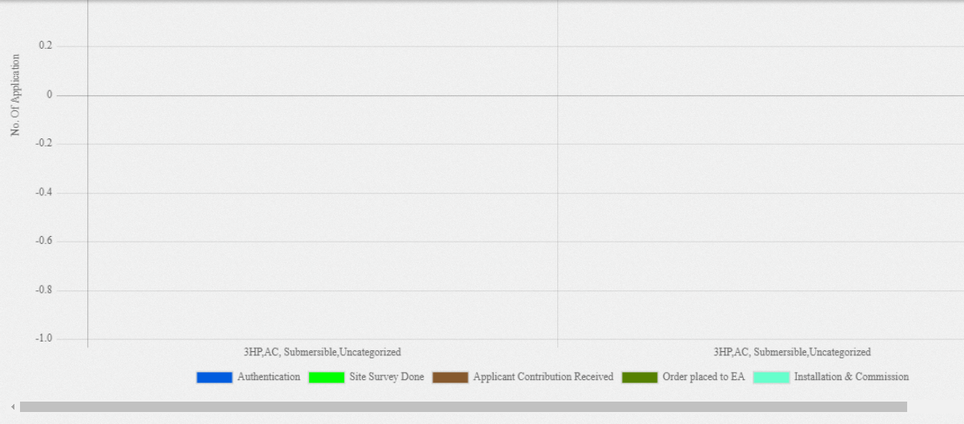
Figure 211 Capacity wise Progress Summary – chart view

- Empanelled Agency Progress Summary
- Empanelled Agency Progress Summary to show PM-KUSUM scheme progress statistics with respect to various EA in State.
  - The data reports are presented in both tabular and graphical chart format.
  - All the reports are available to download in CSV or Excel format, by clicking on the respective buttons in the top left corner of the generated report output.
- The filter options provided to the users are :
  - Select District
  - Select Solution
  - Result Type
  - Application Status Selection
  - Report View (Tabular/Chart)

- Tabular View
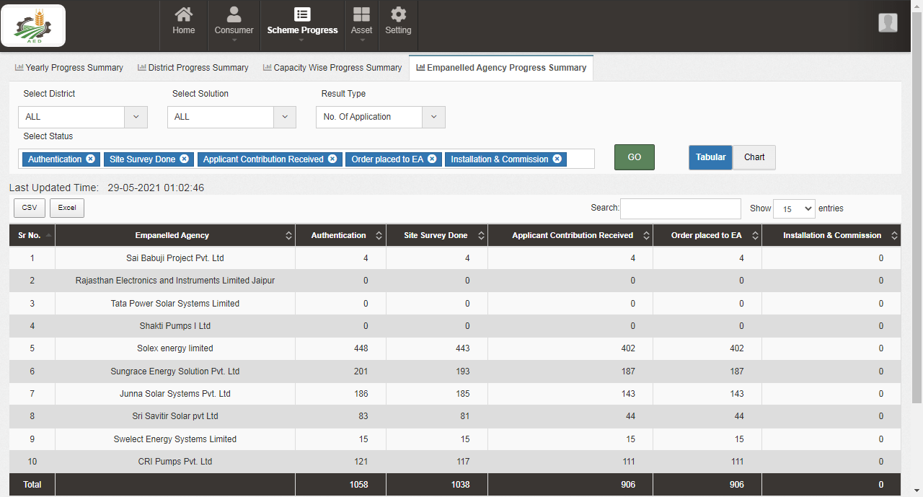
Figure 212 Empanelled Agency Progress Summary – Tabular view

- Chart View
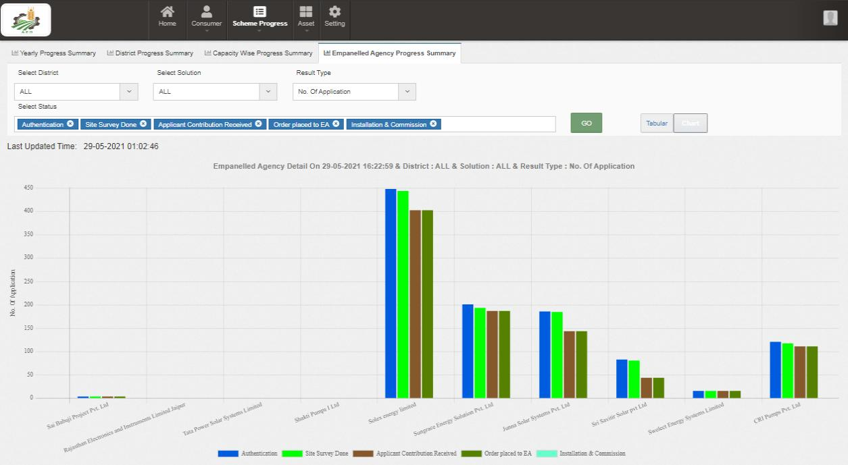
Figure 213 Empanelled Agency Progress Summary – Chart view

- GENDER WISE REPORT
- Gender Wise Report to show PM-KUSUM scheme progress statistics with respect to count of genders, details about loan availability and land coverage in all districts.
- The filter options provided to the users are :
  - Select Empanelled Agency
  - Select Capacity
  - Select Year
  - Result Type

- Tabular View

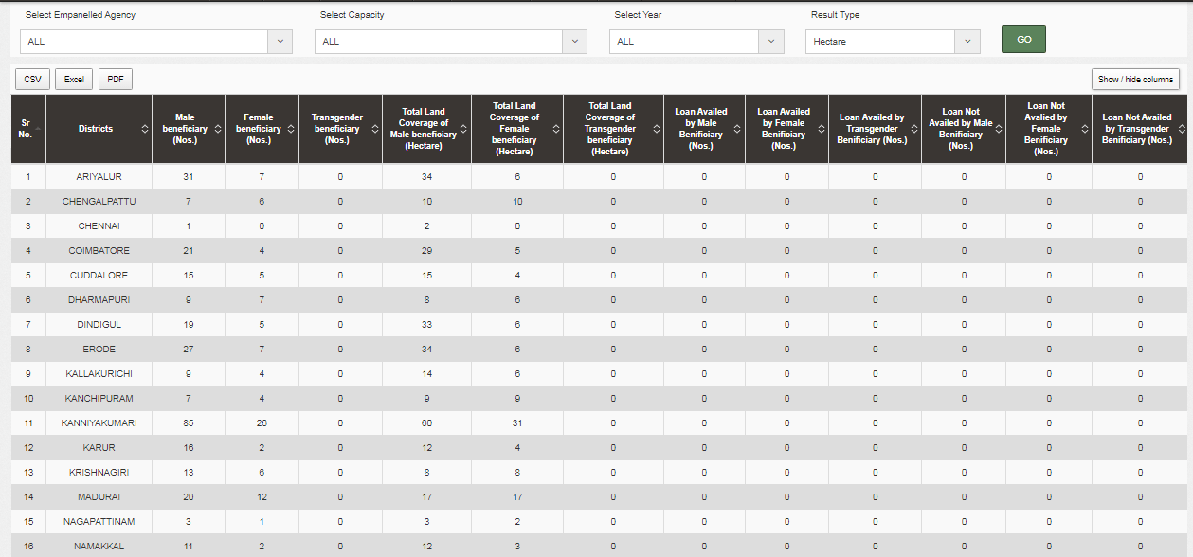
Figure 214 Gender Wise Report – Tabular View

26.2 BULK PROGRESS MAPPING

- State Implementing Agency (SIA) is an authorized user for bulk progress mapping.
- Navigation Steps: -
1. Sign in on the State SEDM Portal
2. Click on the ‘Scheme Progress’ option on the Title Bar of the SEDM Portal Dashboard
3. Click on the ‘Bulk Progress Mapping’ option from the drop-down menu
- Sign In >> Scheme Progress >> Bulk Progress Mapping
- The Bulk Progress Mapping Feature Module helps the users to select multiple Consumer/Farmer applications and update the data or information fields for all of them at one go.
- The users can update the Consumer/Farmer status with corresponding dates and document reference number and can also view chronological specifications and ownership of documents uploaded on the portal, with the Bulk Progress Mapping Dashboard.

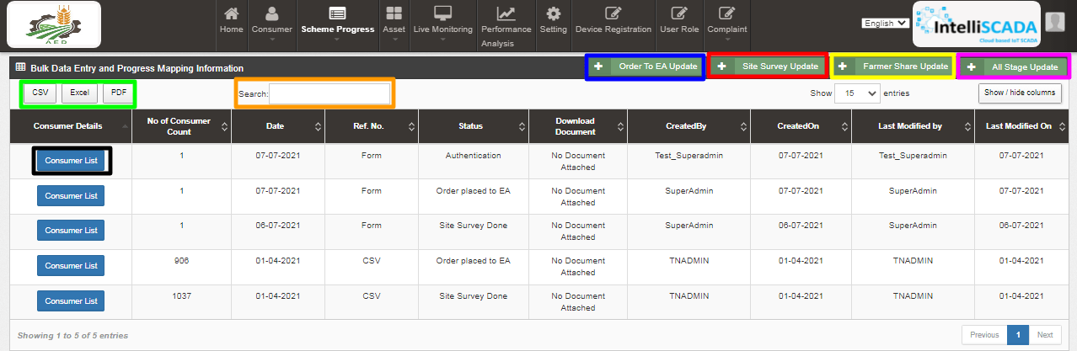
Figure 215 Bulk Progress Mapping Dashboard

BULK PROGRESS MAPPING DASHBOARD DESCRIPTION
Action | Functionality | Highlighted Colour | Type | Description
CSV/Excel/PDF | Download CSV or Excel/ PDF of Consumer/Farmer status details | Green | Button | User can download either CSV or Excel or PDF file of consumer/farmer scheme progress details. (refer Figure 223 and Figure 224)
Search | Search Consumer/Farmer | Orange | Text | Users can refine their results by searching for particular Consumer/Farmer details via “Search” box.
Site Survey Update | Change status “Site Survey Done” of multiple Consumer/Farmer | Red | Button | By clicking this button, a window screen will appear (as shown in Figure 216) where user has to upload a CSV file in order to change the application status “Site Survey Done” of multiple consumers/farmers.
Farmer Share Received | Change status “Farmer Share Received” of multiple Consumer/Farmer | Yellow | Button | By clicking this button, a window screen will appear (as shown in Figure 220) where user has to upload a CSV file in order to change the application status “Farmer Share Received” of multiple consumers/farmers.
Order To EA | Change status “Order To EA” of multiple Consumer/Farmer | Blue | Button | By clicking this button, a window screen will appear (as shown in Figure 218) where user has to upload a CSV file in order to change the application status “Order Placed to EA” of multiple consumers/farmers.
Add Form | Any Status Progress Mapping of Consumer/Farmer in Bulk | Pink | Button | By clicking this button, a window screen appear (as shown in Figure 222) to change the any application status of consumers/farmers in bulk.
Show/Hide Columns | Filter to refine required column | Sky Blue | Drop Down | Users can refine their results by using the “Show/Hide” columns feature on top right corner.
Consumer | Multiple Consumer Details | Black | Button | By clicking on this button, a window screen will appear (as shown in Figure 225) where user can see multiple consumers/farmers whose status has been changed all together.

- Site Survey Bulk Update
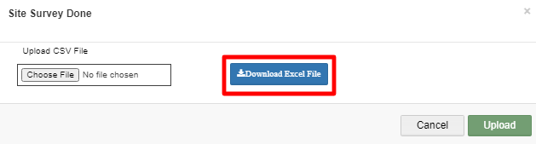
Figure 216 Site Survey Done CSV File Upload

- SIA user can update “Site Survey Done” status in bulk.
- He has to download an excel file format (refer format Figure 217) by clicking on Download Excel File. (red highlighted button in above Figure 216)

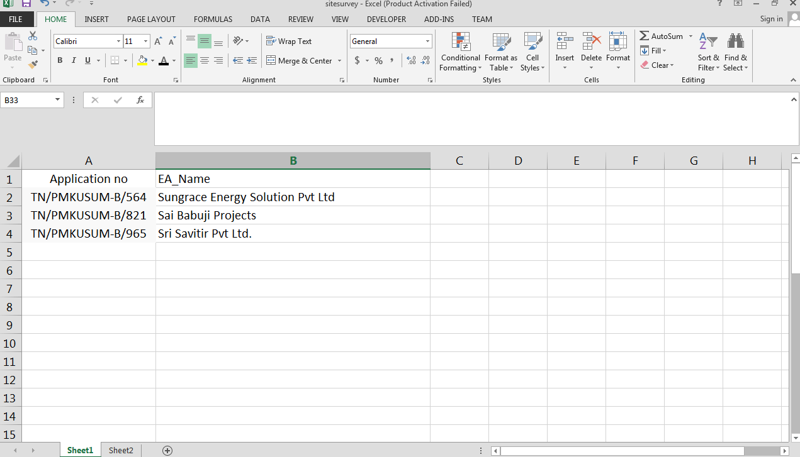
Figure 217 Site Survey Bulk Upload Format
- SIA user has to remove the dummy data and enter his own data with multiple application nos. and name of Empanelled Agencies and save that excel file as “.csv” and upload it on the State SEDM Platform. (as shown in the Figure 216)

- Order Placed to EA Bulk Update

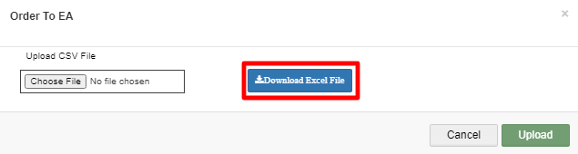
Figure 218 Order to EA CSV File Upload

- SIA user can update “Order Placed to EA” status in bulk.
- He has to download an excel file format (refer format Figure 219) by clicking on Download Excel File. (red highlighted button in above Figure 218)

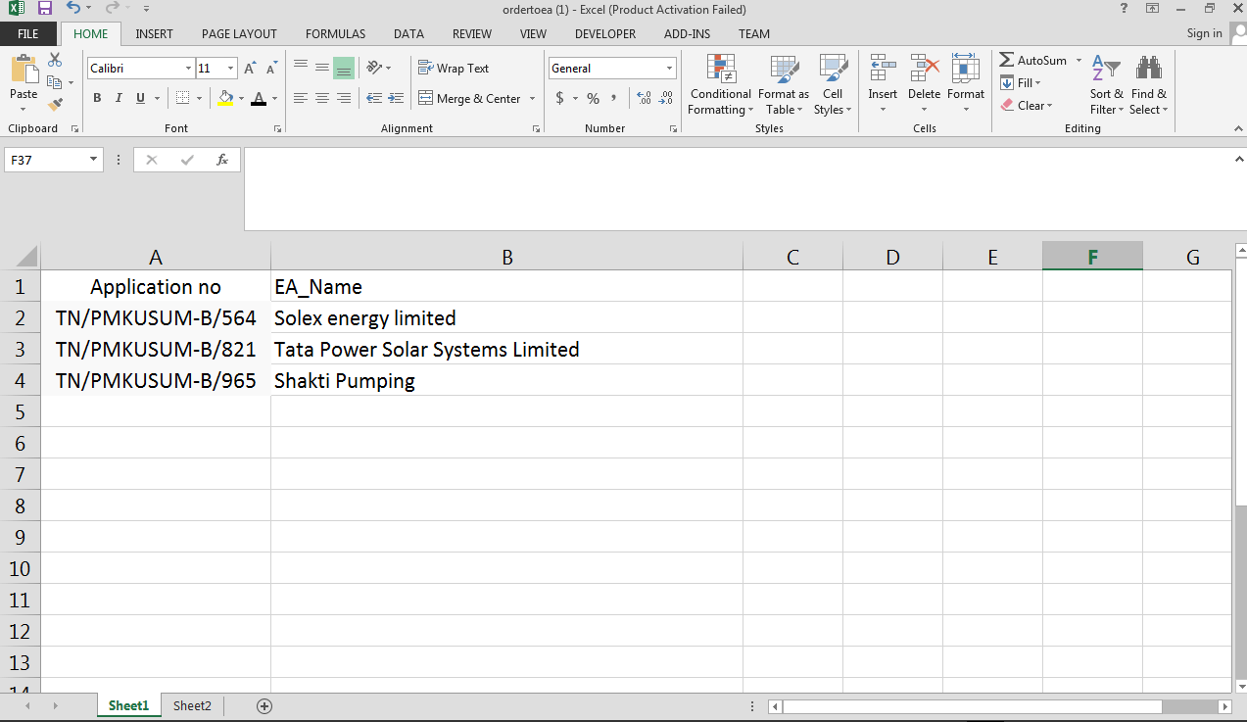

Figure 219 Order Placed to EA Bulk Upload Format
- SIA user has to remove the dummy data (as a format shown in above Figure 219) and enter his own data with multiple application nos. and name of Empanelled Agencies and save that excel file as “.csv” and upload it on the State SEDM Platform. (as shown in the Figure 218)

- Farmer Share Received Bulk Update
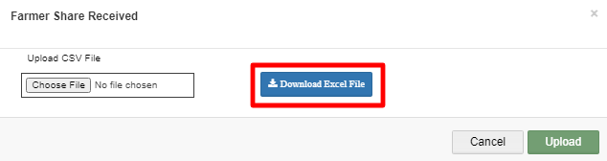
Figure 220 Farmer Share Received CSV File Upload
- SIA user can update “Farmer Share Received” status in bulk.
- He has to download an excel file format (refer format Figure 221) by clicking on Download Excel File. (red highlighted button in above Figure 220)

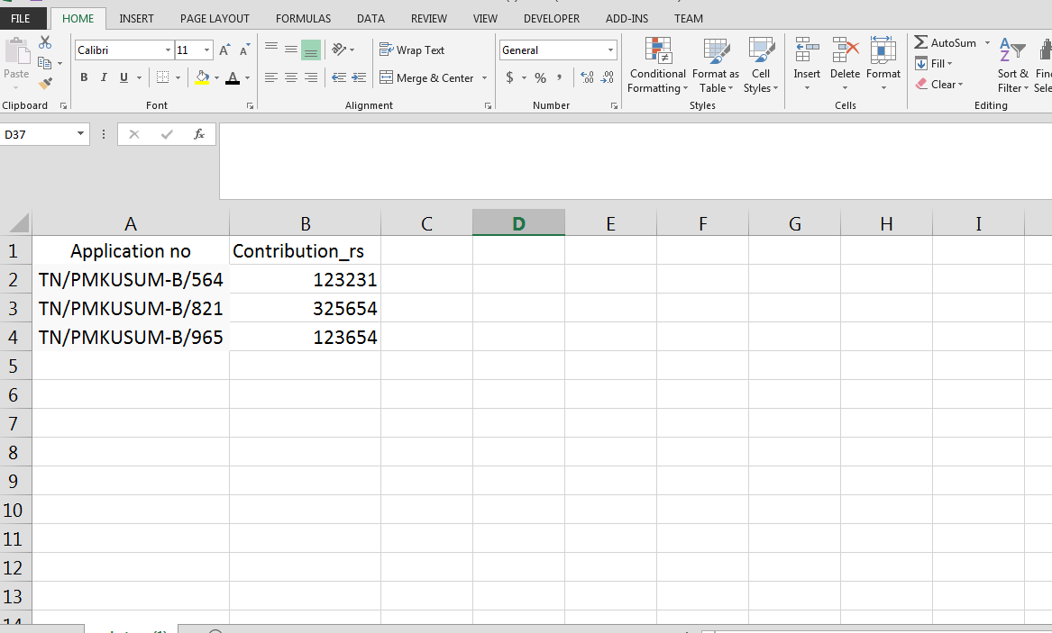
Figure 221 Site Survey Bulk Upload Format
- SIA user has to remove the dummy data (as a format shown in above Figure 221) and enter his own data with multiple application nos. and amount of farmer’s share for Solar Pump installation and has to save that excel file as “.csv” and upload it on the State SEDM Platform. (as shown in the Figure 220)

- On clicking onto the ‘Add Form’ feature a pop-up box appears in which the user must add or update all the necessary details in a Farmer’s application stage along with the reference number.
- Here, the user can also add the details in bulk manner by uploading the relevant file with all Consumer/Farmer details.

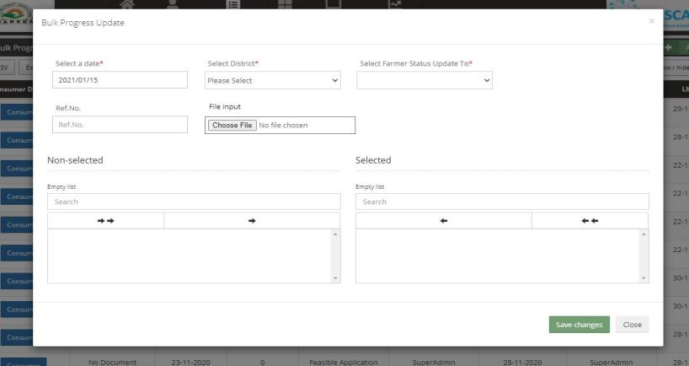
Figure 222 Bulk Progress Update Form
- The “File Input” field is to upload any relevant reference document.
NOTE: Application status “SFA Released” and “CFA Released” can be updated only from here by selecting “SFA” or “CFA” from the “Select Farmer Status Update To” drop down from the above Bulk Progress Update Form. (Refer Figure 222)

- PDF :
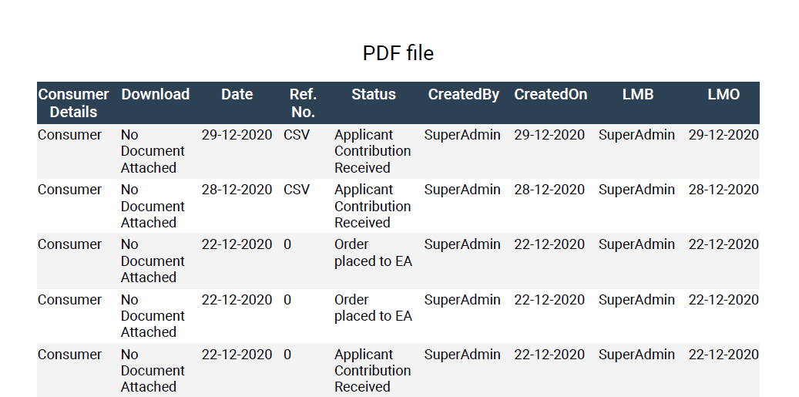
Figure 223 PDF output

- Excel/CSV :
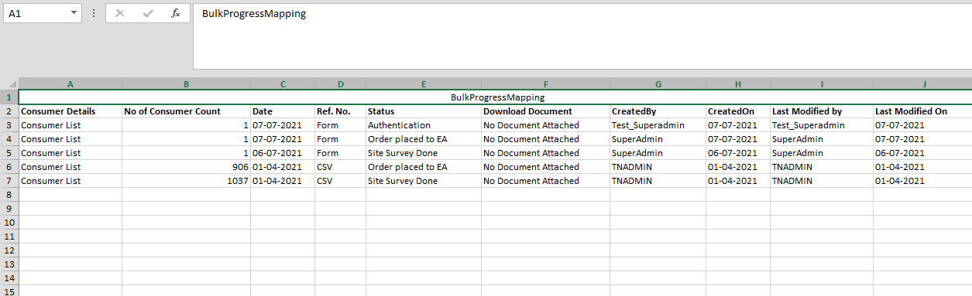
Figure 224 Excel/CSV output

- Consumer List :
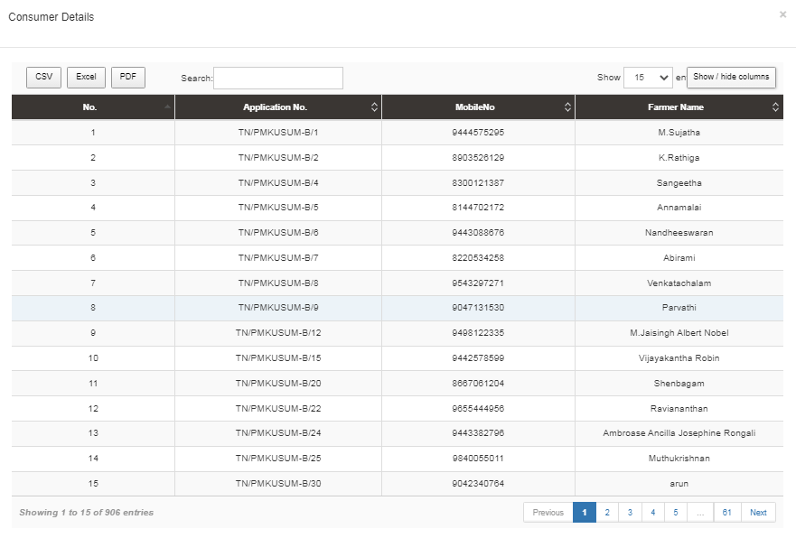
Figure 225 Consumer List

ASSET TRACKING & REPLACEMENT

- ASSET TRACKING

- Navigation Steps: -
1. Sign in on the State SEDM Portal
2. Click on the ‘Asset’ option on the Title Bar of the SEDM Portal Dashboard
3. Click on the ‘Asset Tracking’ option from the drop-down menu

- Sign In >> Asset Management >> Asset Tracking
- The Asset Tracking Feature Module provides the users a coherent view for monitoring the assets and helps in keeping a track of the maintenance or service requests raised by Consumers/farmers.
- The Asset Tracking Dashboard hosts 6 types of views, pertaining to each type of user function:
  - Site Location
  - Field Service Engineer
  - EA Store Under Inspection
  - EA Store
  - SIA Lab
  - SIA Store

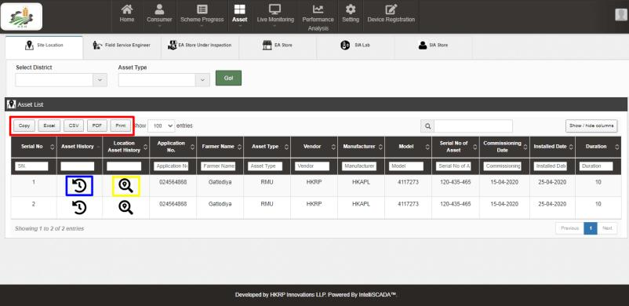

Figure 226 Site Location Dashboard

SITE LOCATION DASHBOARD DESCRIPTION
Action | Functionality | Highlighted Colour | Type | Description
Copy/Excel/CSV/PDF/Print | Download Excel or CSV or PDF or Print the Site Location Details | Red | Button | Users get an option to download in desired format or print the asset tracking reports by selecting any of the button options – Copy / Excel / CSV /PDF /Print
Asset History | View the history of the asset | Blue | Icon Button | The users can view asset history details by clicking onto the icon in the second column of the Site Location Dashboard.
Location Asset History | View the details of the assets | Yellow | Icon Button | By clicking on the icon in the third column of the Site Location Dashboard, users can view the Location Asset History and know the details regarding the vendor, manufacturer, serial no. of asset, commission date, installation date, etc.

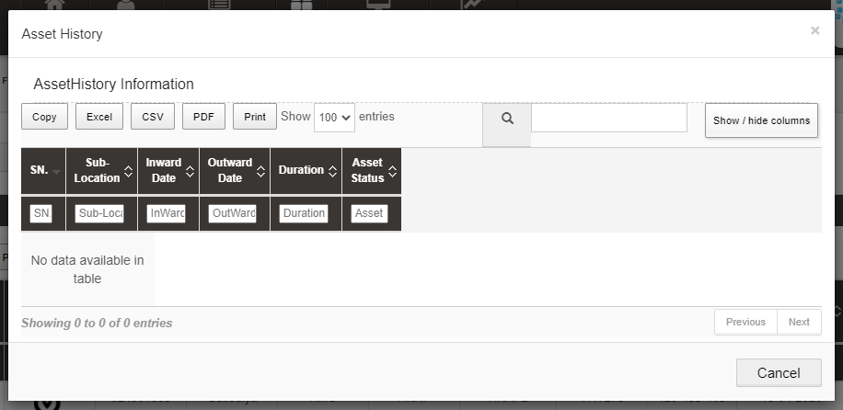
Figure 227 Asset History
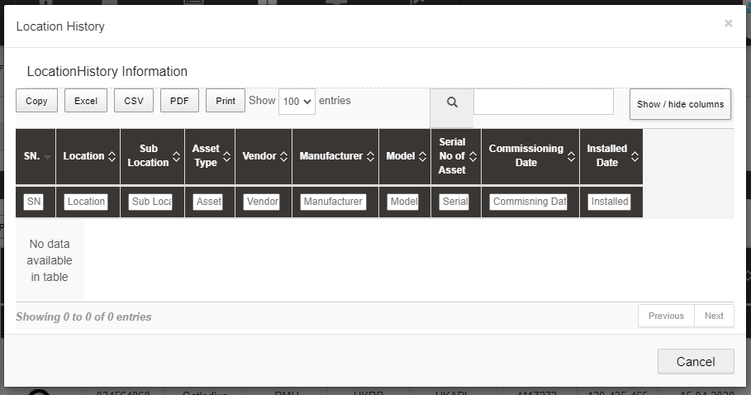
Figure 228 location history
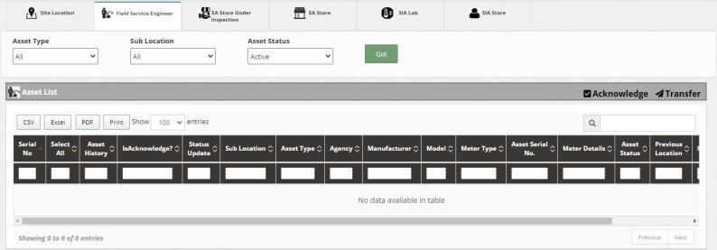
Figure 229 Field Service Engineer Dashboard
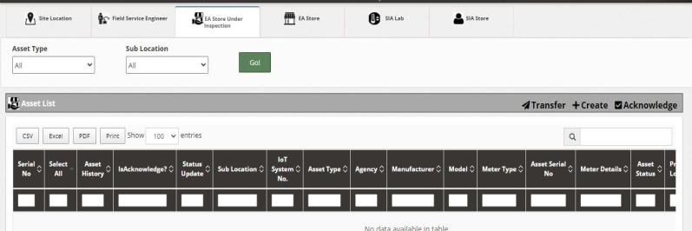
Figure 230 EA Service Store Inspection
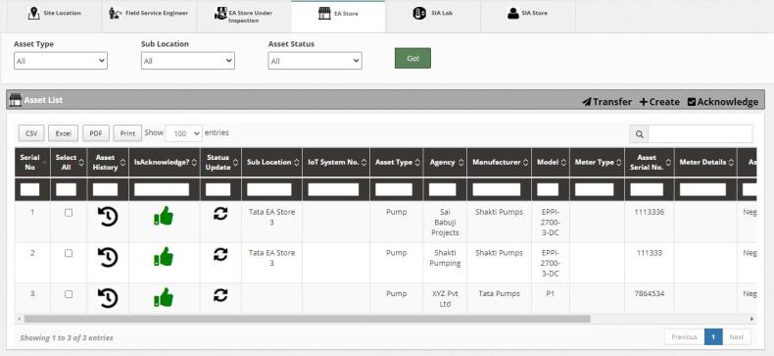
Figure 231 EA Store

EA STORE DASHBOARD DESCRIPTION
Action | Functionality | Highlighted Colour | Type | Description
Transfer | To transfer asset to particular location and sub location | Red | Button | By clicking on the ‘Transfer’ button, a pop-up box appears where user must select the location and sub-location where the assets have to be transferred and then click the save button to store the updated details.
Create | To create & allocate the new asset | Red | Button | The ‘Create’ button on EA store dashboard gives user the feature to create and allocate a new asset by filling in all the required fields in the pop-up box that is generated.
Acknowledge | To acknowledge the application | Red | Button | By clicking on the ‘Acknowledge’ button, selected application will be acknowledged, and a green thumb icon will be displayed in the ‘Is Acknowledged’ column on the EA store dashboard.
Status Update | To update the status of installed assets | Yellow | Icon Button | By clicking onto this icon, a pop-up box appears in which the user can update the status of the installed assets i.e. installed, working, defective, etc.

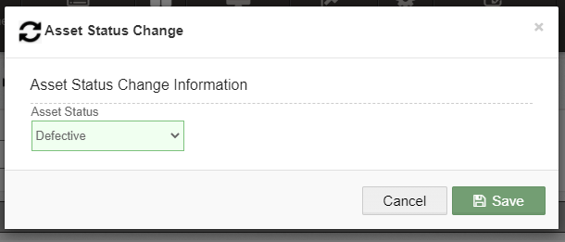
Figure 232 Status Update pop-up box

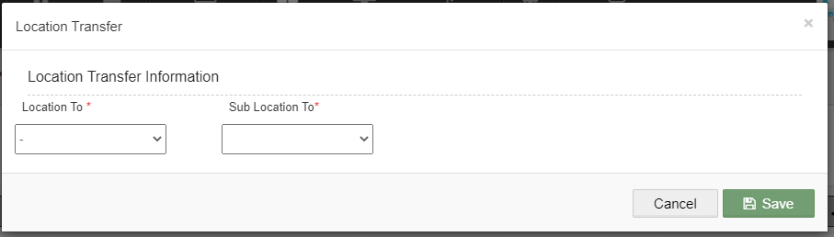
Figure 233 Transfer pop-up box

- The ‘Create’ button on EA store dashboard gives user the feature to create and allocate a new asset by filling in all the required fields in the pop-up box that is generated.
- By clicking on the ‘Acknowledge’ button, selected application will be acknowledged, and a green thumb icon will be displayed in the ‘Is Acknowledged’ column on the EA store dashboard.
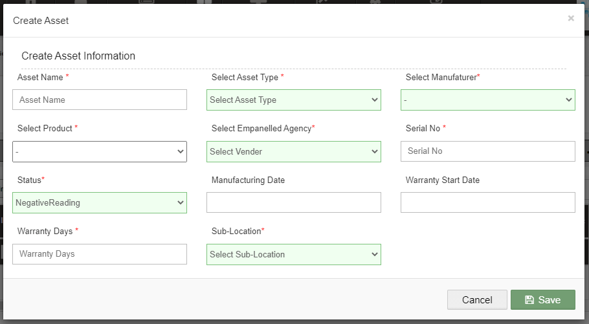
Figure 234 Create pop-up box
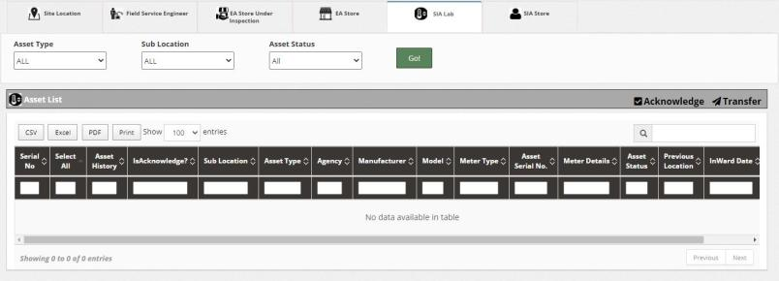
Figure 235 SIA Lab
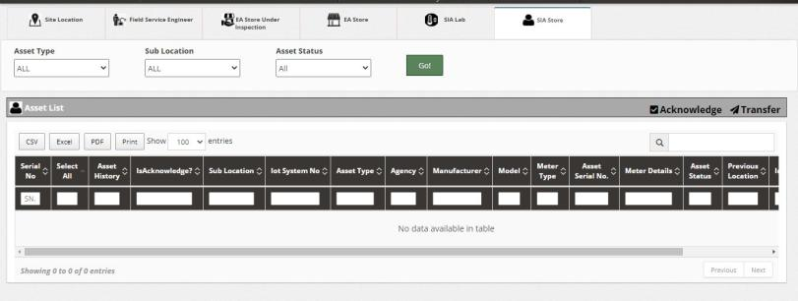
Figure 236 SIA Store

- The above 6 panel’s dashboard outputs can be further filtered by using the 3 provided filters of Asset Type, Sub Location and Asset Status (as shown in Figure 237, Figure 238 and Figure 239)
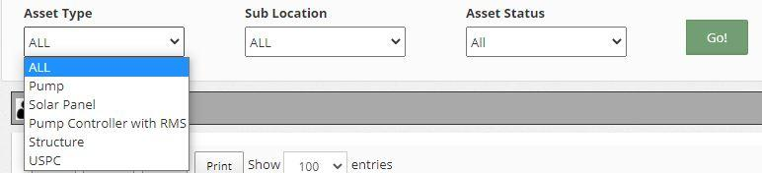
Figure 237 Asset dashboard filter – asset type
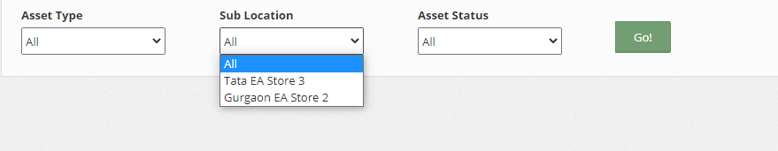

Figure 238 ASSET DASHBOARD FILTER – sub location
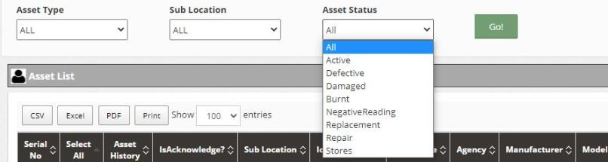

Figure 239 ASSET DASHBOARD FILTER – ASSET status

- ASSET REPLACEMENT
- Empanelled Agency is an authorized user to perform the IMEI replacement functionality.
- He can replace the IMEI no. in case of mapping faulty IMEI no. or consumer/farmer has been replaced with new RMS device with new IMEI no.

- Navigation Steps: -
1. Sign in on the State SEDM Portal
2. Click on the ‘Asset’ option on the Title Bar of the SEDM Portal Dashboard
3. Click on the ‘Asset Mapping by EA’ option from the drop-down menu
- Sign In >> Asset >> Asset Mapping by EA

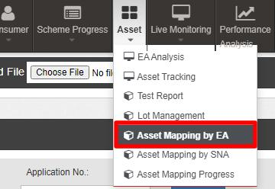
Figure 240 Asset Mapping By EA Option

- EA user can replace IMEI no. through “Asset Mapping by EA”.
- To search consumer/farmer for individual asset serial no or IMEI no mapping, user can search consumer/farmer by two ways i.e. either entering IMEI number (if mapped) or Application number, the corresponding details of the consumer/farmer gets displayed on the Asset Mapping by EA Dashboard or the another way is, by applying four filters i.e. District selection, Empanelled Agency selection, Capacity selection and Application Status selection to get the particular consumer/farmer details.
- Empanelled Agency can view only those consumers/farmers details whose Order is placed to them.

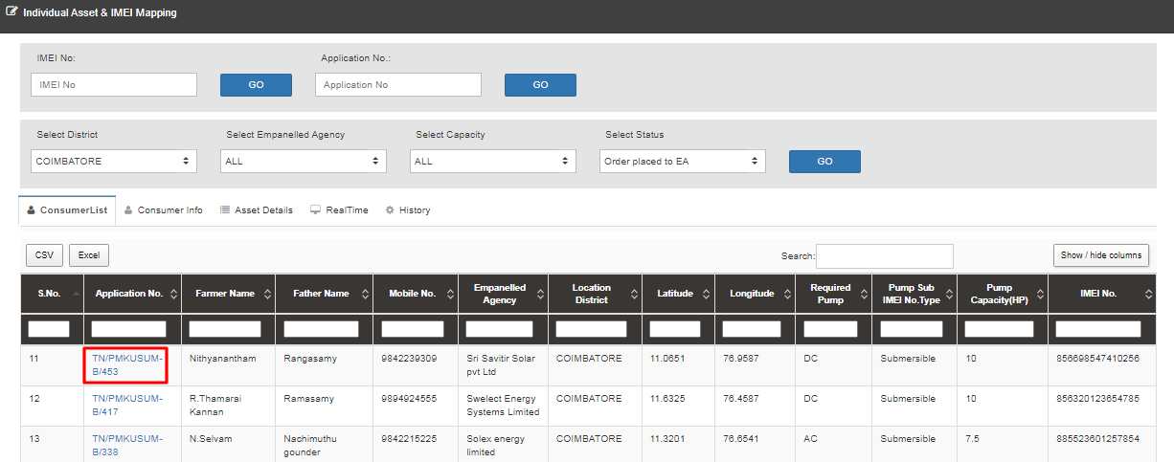

Figure 241 Asset Mapping by EA Dashboard

- After searching for the consumer/farmer details, EA user has to click on the application number (highlighted in red in above Figure 241) to redirect to the “IMEI Replacement” button in consumer info tab. (highlighted in red in below Figure 242)
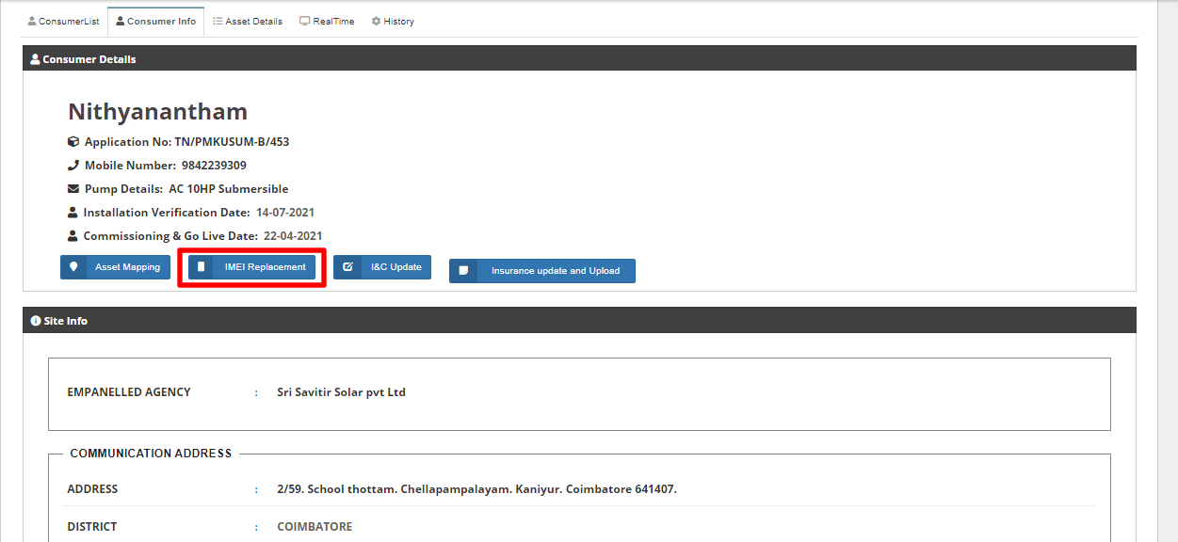
Figure 242 IMEI Replacement Button
- By clicking “IMEI Replacement” button, user can replace and register new IMEI no. all together at once by selecting 1st Option i.e. “By Generating New IMEI No.” (highlighted in red in below Figure 243)
- User just have to enter the new IMEI no. in the IMEI No. field and click on Replace Button to register and replace new IMEI no. together.

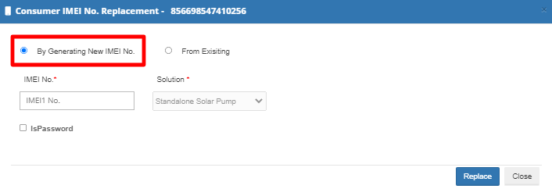
Figure 243 IMEI No. Replacement By Generating New IMEI No.

- User can also replace already registered IMEI no. by selecting 2nd Option i.e. “From Existing” (highlighted in red in below Figure 244)

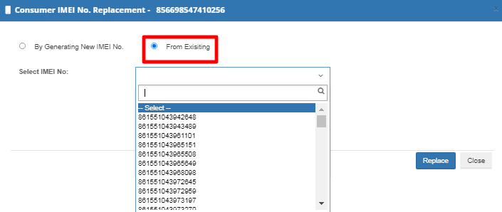

Figure 244 IMEI No. Replacement from Registered IMEI Nos.

SIGN OUT

- The users can log out or sign out from the State SEDM Portal by following 2 methods.
- Either by clicking onto the ‘User’ icon, present at the top right corner on the title bar of the SEDM Portal (pointed in below Figure 245) and then selecting the option of ‘Logout’ (highlighted in red in below Figure 245).

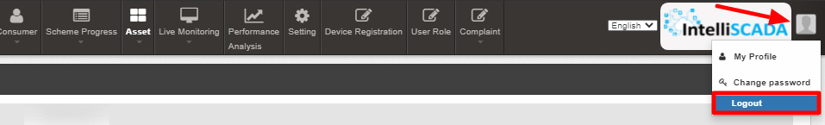

Figure 245 Logout

- The second method is to first click onto the ‘Home’ page button on the title bar of the SEDM Portal (pointed in red in below Figure 246), and then on the Home Page selecting the option of ‘Sign Out’ present in the form of a blue coloured button on the top right corner of the page (highlighted in red in Figure 247)

Figure 246 Home Selected
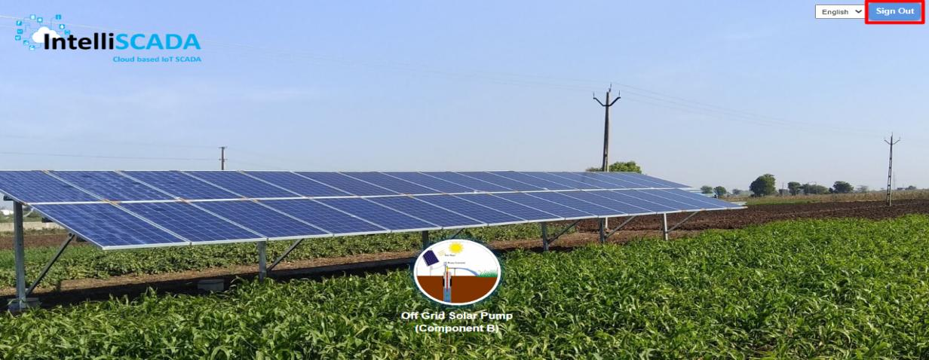

Figure 247 Sign out

SUPPORT TEAM CONTACT DETAILS

Name | Designation | Organization Department | Email | Phone
M.Vallatharasan | Assistant Executive Engineer (AE), i/c | IT Section, SIA | vallatharasan@gmail.com | 9445515634
S. Aravindhn | Assistant Engineer (AE) | SC Section, SIA | sjaravindhan@gmail.com | 9655045045

ANNEXURE-I (SITE SURVEY DONE)

SITE SURVEY DONE

- Empanelled Agency (EA) is the authorized user to change Consumer/Farmer Application status to Site Survey Done.
- After Aadhaar Authentication, authorized users has to change the status “Site Survey Done”.
- For progressing towards Site Survey Stage, there is a separate application provided to Empanelled Agency (EA) to update the Site Survey status of Consumer/Farmer.
- Following are the process to follow in order to complete the Site Survey of Consumer/Farmer.
- Site Survey will be done only by Empanelled Agency (EA)
- URL : https://tntestsitesurvey.hkapl.in

- INTRODUCTION

- Site Survey Mobile Application is designed to Empanelled Agency (EA) the additional feature of mobility to inspect, update or upload data reports, right from their mobile devices.
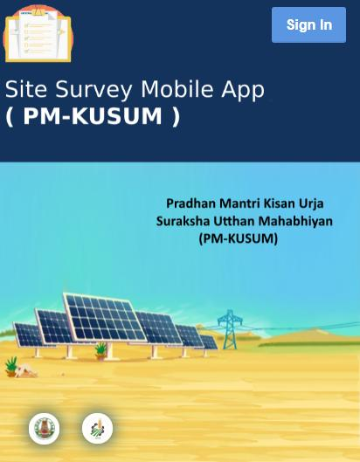

Figure 248 Welcome Page of Site Survey Mobile Application
- SIGN IN

- To sign in on the Site Survey Mobile App, users can click on the ‘Sign In’ button option, present on the top right corner of the Welcome Page.
- This will show a pop-up box where the user has to enter their username and password to sign in into their account.

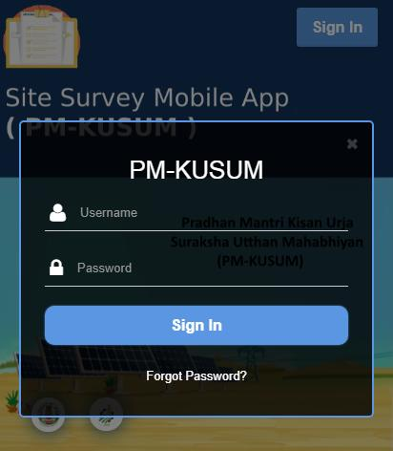

Figure 249 Sign In Box

- SITE SURVEY

- The primary feature of this Mobile Application is termed as ‘Site Survey’. As a user signs in on the mobile app, the next screen that appears is the Site Survey Dashboard.

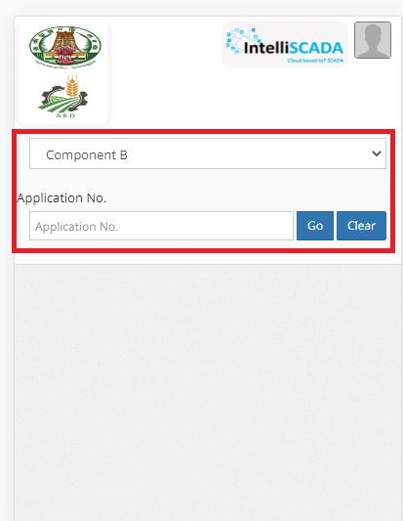

Figure 250 Select Component and Application No

SITE SURVEY FILTERS

Field | Input | Image | Mandatory Field | Sample Value | Description
Component | Drop Down | 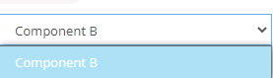 |  | Component B | Selection of Component of PM KUSUM scheme which they need to inspect or update the site details
Application No. | Text | - |  | TN/PM KUSUM/100 | Entering consumer/farmer’s application number , authorized users can view, manage and edit the site management details by using this mobile application

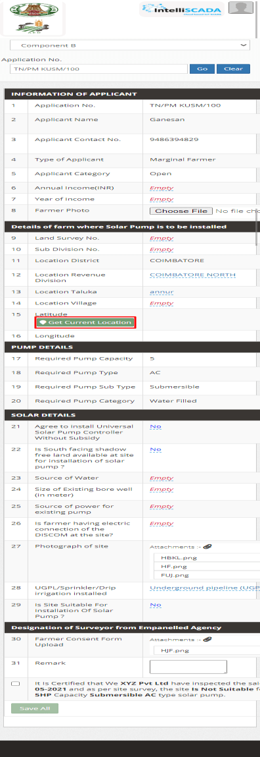

Figure 251 Consumer Site Survey Details

Sr. No. | SITE SURVEY DETAILS
INFORMATION OF APPLICANT
1 | Application No. | TN/PM KUSM/100
2 | Applicant Name | Ganesan
3 | Applicant Contact No. | 9486394829
4 | Type of Applicant | Marginal Farmer
5 | Applicant Category | Open
6 | Annual Income(INR) | 200000 Rs. Pa
7 | Year of Income | 2019
8 | Farmer Photo | Farmerphoto.jpeg
DETAILS OF FARM WHERE SOLAR PUMP IS TO BE INSTALLED
9 | Land Survey No. | 100
10 | Sub Division No. | 150
11 | Location District | COIMBATORE
12 | Location Revenue Division | COIMBATORE NORTH
13 | Location Taluka | Annur
14 | Location Village | -
15 | Latitude | 20.5244
16 | Longitude | 71.2464
PUMP DETAILS
17 | Required Pump Capacity | 5
18 | Required Pump Type | AC
19 | Required Pump Sub Type | Submersible
20 | Required Pump Category | Water Filled
SOLAR DETAILS
21 | Agree to install Universal Solar Pump Controller Without Subsidy? | No
22 | Is South Facing shadow free land available at site for installation of solar pump? | No
23 | Source of Water | Bore Well
24 | Size of Existing bore well | 2
25 | Source of power for existing pump | Diesel
26 | Is farmer having electric connection of the DISCOM at the Site? | No
27 | Photograph of site | Site.png
28 | UGCL/Sprinkler/Drip irrigation installed | Underground pipeline (UGP)
29 | Is Site Suitable for Installation of Solar Pump? | No
DESIGNATION OF SURVEYOR FROM EMPANELLED AGENCY
30 | Farmer Consent From Upload | Form.jpeg
31 | Remark | -

- Some key points to look-out for in the above report are:
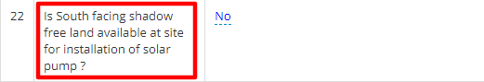
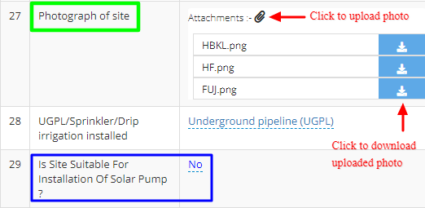
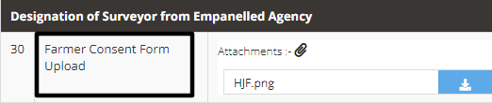

Figure 252 Key Points of Site Survey Details

  - Point 18, Is South facing shadow free land available at site for installation of solar pump? (as shown in Figure 252 highlighted in red)
The site inspection officer checks for the land and sun direction to deem if the site is feasible for solar plant installation or not.

  - Point 24, Photograph of site (as shown in Figure 252 highlighted in green)
After the inspection, the EA officer also uploads the relevant pictures of the land on the portal for District Officer or EA team to review.

  - Point 26, Is Site Suitable for Installation of Solar Pump? (as shown in Figure 252, highlighted in blue)
The site is reviewed to be fit for solar pump installation by checking the water supply features and other parameters necessary to install a pump at that site.
  - Point 27, Farmer Consent Form (as shown in Figure 252, highlighted in black)
After the survey inspection is done and all parameters are approved by the reviewing EA officer then a photo of the signed documents and also of the farm land along with the farmer and EA officer are clicked, and then uploaded onto the SEDM portal for verification purposes in the future.

  - Point 29 & 30, Latitude and Longitude
When the farmer uses the Site Survey Mobile Application, the live coordinates of his farm location are synced from that app and updated in the SEDM portal.
By clicking on the below highlighted button “Get Current Location” , user will get the current Latitude and Longitude of the installed Pump.
It will be used to verify the location provided during registration with this current location whether both are same or not.
- In the Site Survey report that gets generated the user can get the site’s current geographical location by clicking on the ‘Get Current Location’ as shown in the red box in below Figure 253.

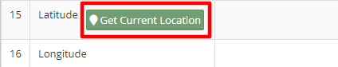
Figure 253 Get Current Location Button

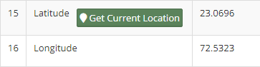
Figure 254 Latitude-Longitude

- SIGN OUT
- The users can log out or sign out from the Site Survey Mobile Application in the following way:
- By clicking onto the ‘User’ icon (highlighted in red in Figure 255), present at the top right corner on the title bar of the Site Survey Mobile App Dashboard and then selecting the option of ‘Logout’.
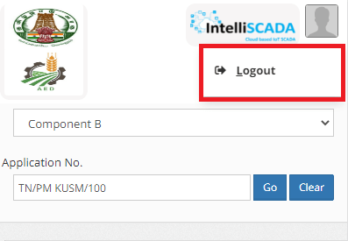
Figure 255 Logout Button

NOTE : To update status “Site Survey Done” in bulk i.e. of multiple consumers/farmers at once, click here to know more.

ANNEXURE-II (IMEI NUMBER REGISTRATION)

IMEI NUMBER REGISTRATION
- Navigation Steps: -
1. Sign in on the State SEDM Portal
2. Click on the “Device Registration” option on the Title Bar of the SEDM Portal Dashboard

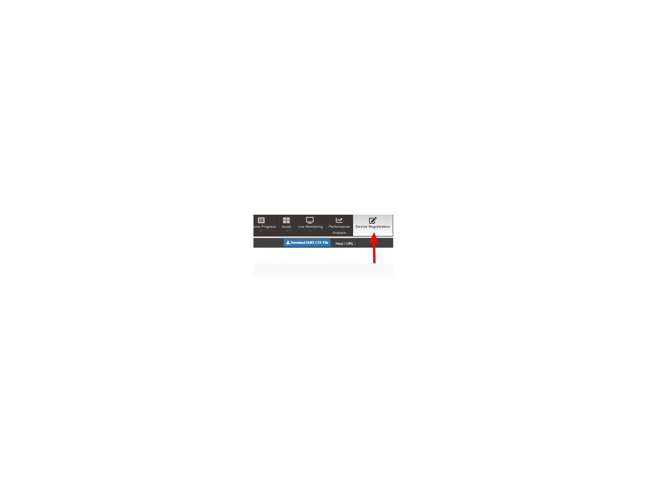

Figure 256 Device Registration

- IMEI no. can be registered in two ways :
  - Bulk Registration of IMEI nos. by uploading CSV file.
  - Registration of single IMEI no.

- Bulk Registration of IMEI nos. by Uploading CSV file :

- To upload the CSV file for bulk registration of IMEI nos., EA user can download the format of CSV file by clicking on the “Download IMEI CSV File” blue button from the Device Registration dashboard. (highlighted in red in below Figure 257)

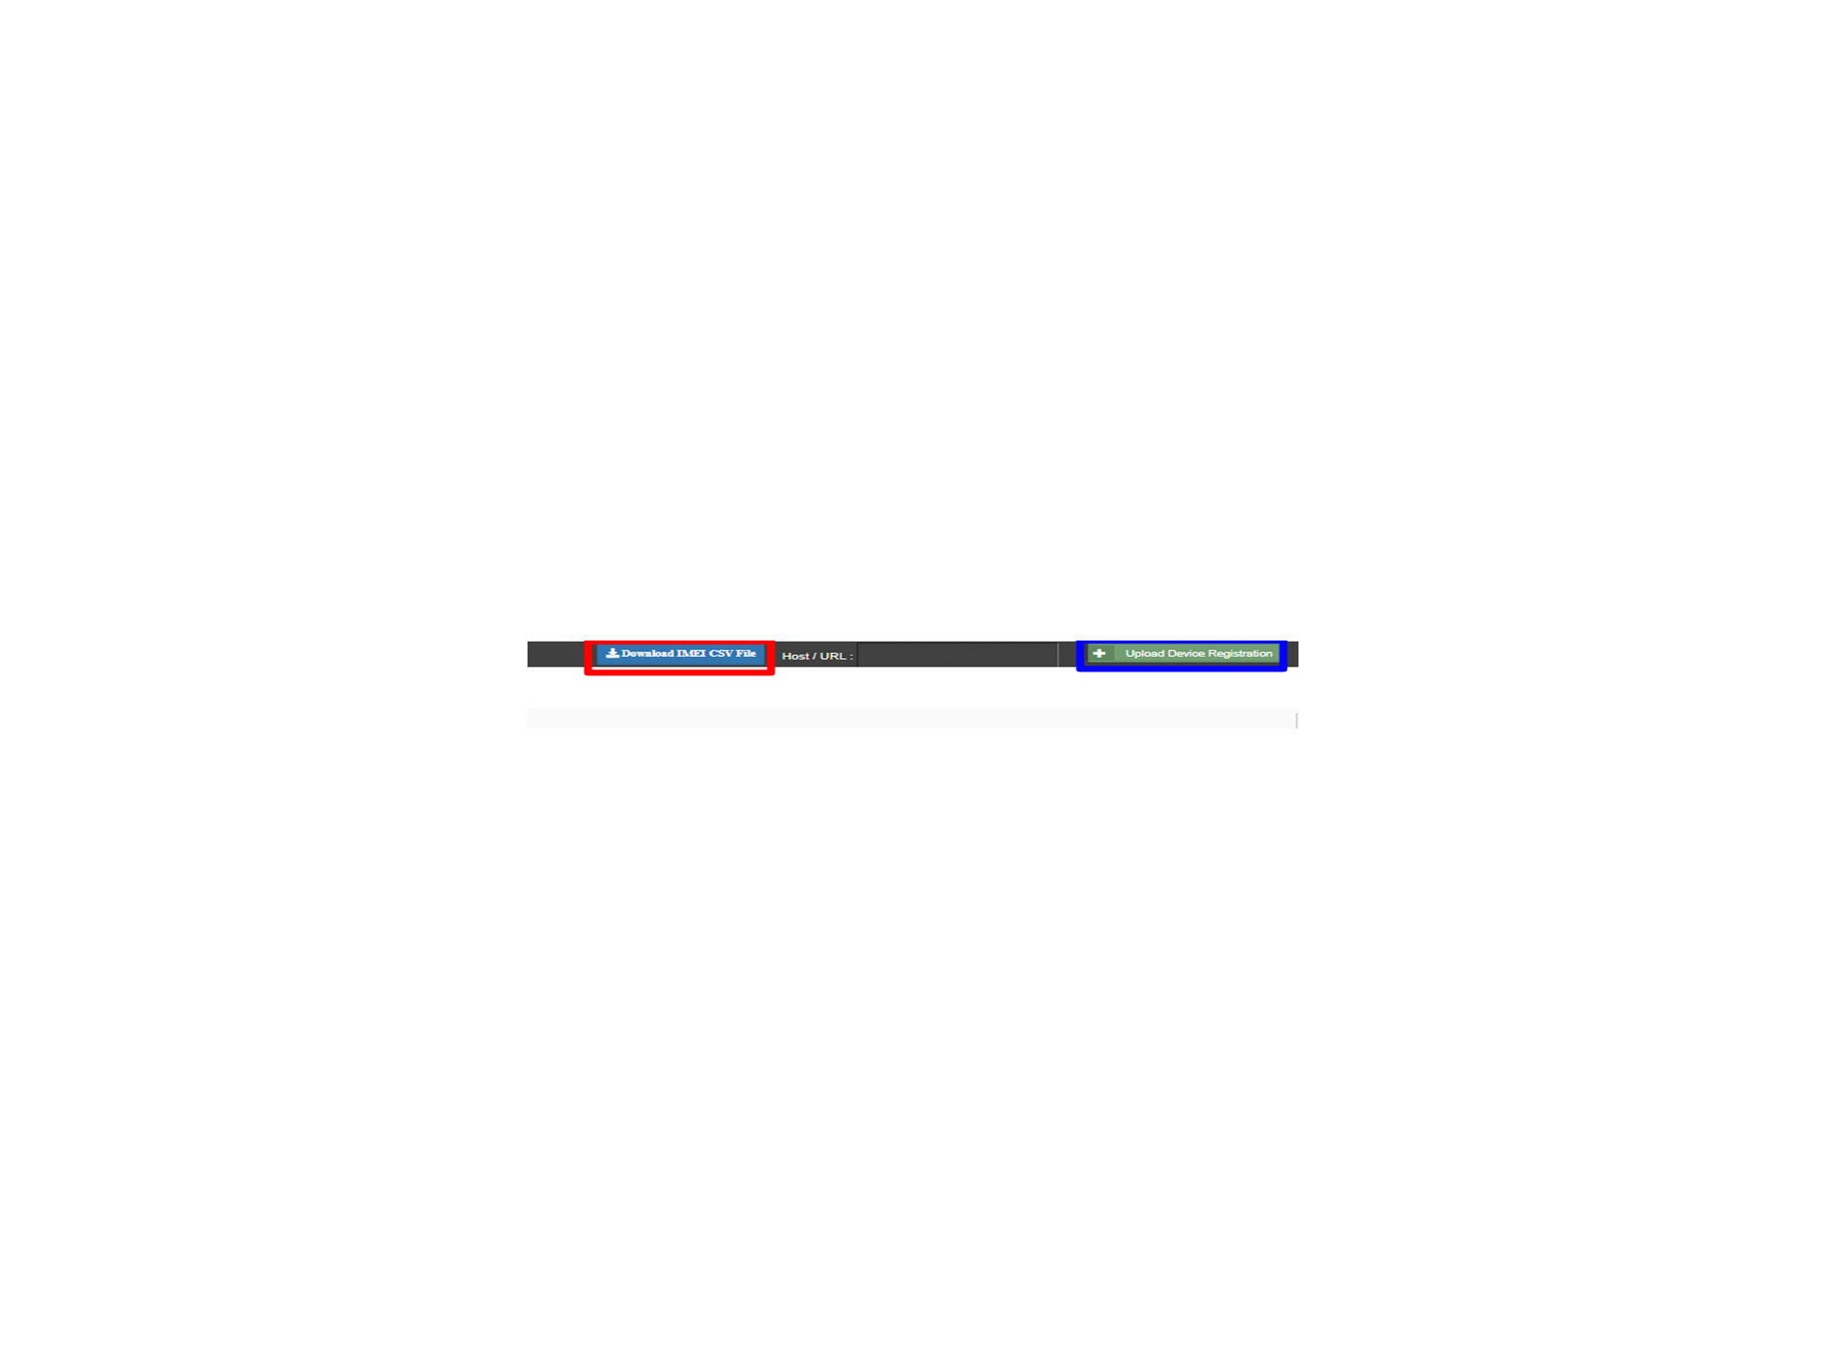
Figure 257 IMEI Bulk Upload

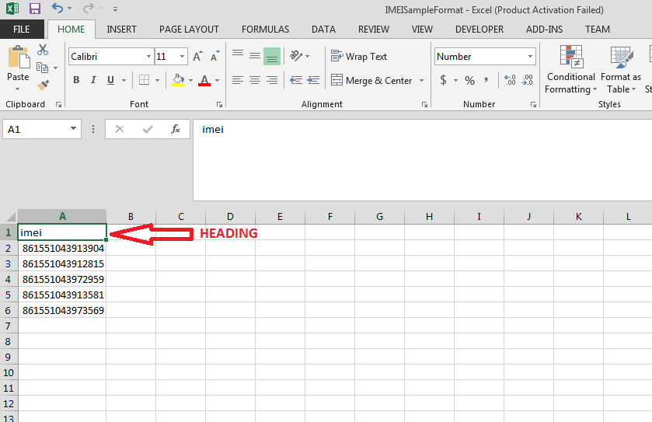

Figure 258 IMEI No. CSV Format

- The above image is the CSV file format of IMEI nos.
- EA user has to keep the heading “imei” as shown in the first row of CSV file and has to enter their own IMEI nos. starting from the 2nd row as shown in the above Figure 258.
- After creating the CSV file carrying IMEI nos., user has to click on the “Upload Device Registration” button as highlighted in blue in Figure 257: “IMEI bulk upload”.
- A window screen will appear to upload the CSV file carrying IMEI nos. as shown in below Figure 259.

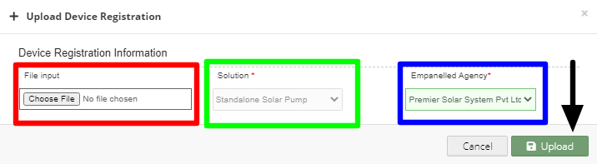

Figure 259 Upload IMEI No. CSV
- In above screen, EA user can upload IMEI csv file by clicking on the “Choose File” button. (highlighted in red in above Figure 259)
- The above screen arrives with the two filters which is by default selected i.e. “Solution” and “Empanelled Agency”
- EA user can see by default his Empanelled Agency name. (highlighted in blue in above Figure 259)

- Registration of single IMEI no.

- EA user can also register single IMEI no, manually by clicking on the “Add New Device Registration” button from the Device Registration Dashboard. (pointed in below Figure 260)
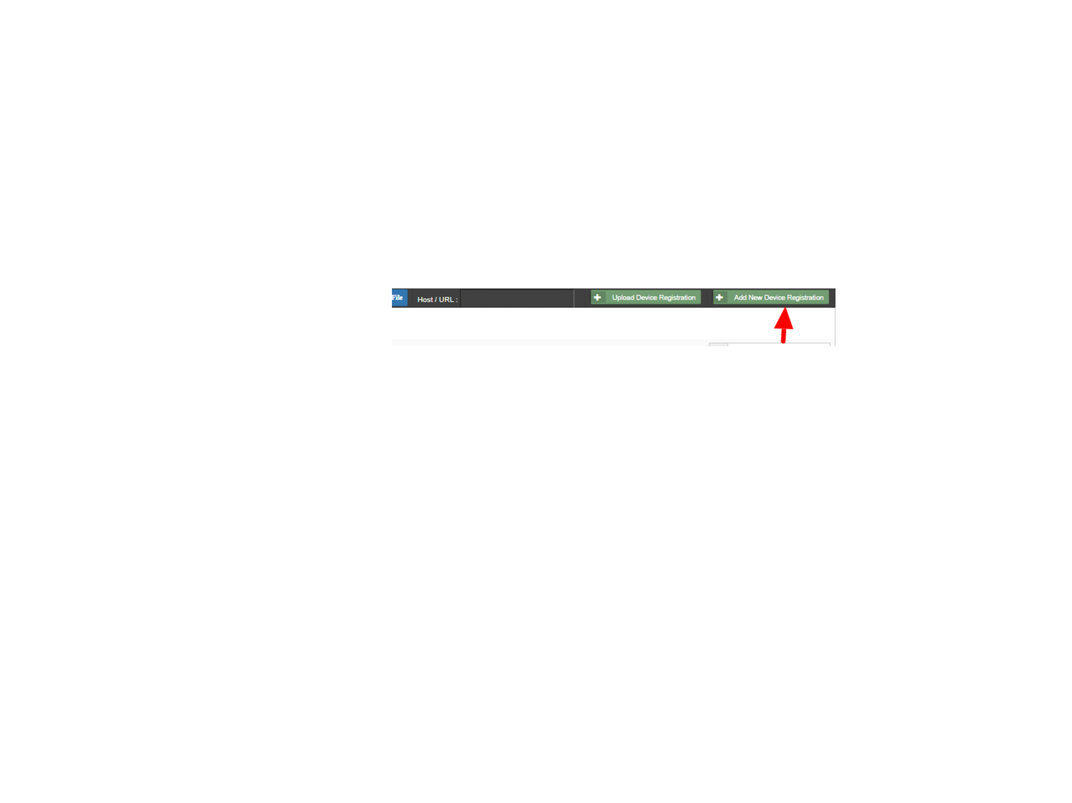
Figure 260 Add New Device Registration Button

- When EA user will click on the “Add New Device Registration” button, a window screen will appear to enter the 15 digit IMEI no. (as shown in below Figure 261)
- When the user select “Is Password” option (highlighted in red in below Figure 261), it will generate the SSL certificates in the Device Registration dashboard, if not selected then it won’t generate the certificates.
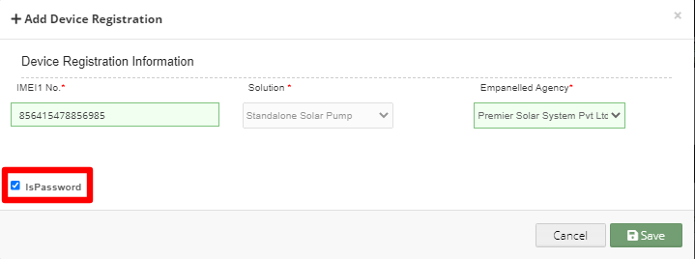

Figure 261 Add Device Registration

- After entering IMEI no., user has to click on the save button and IMEI no. will be registered on the portal and is ready to map with necessary consumer/farm18er.
Disclaimer

- Nothing in this report constitutes a valuation or legal advice.
- HKRP has not verified the reliability or accuracy of any information obtained in the course of its work, other than in the limited circumstances set out in the Services Contract.
- In connection with the report or any part thereof, HKRP does not owe duty of care (whether in contract or in tort or under statute or otherwise) to any person or party to whom the report is circulated to and HKRP shall not be liable to any party who uses or relies on this report. HKRP thus disclaims all responsibility or liability for any costs, damages, losses, liabilities, expenses incurred by such third party arising out of or in connection with the report or any part thereof.

